Name:___________________ Date:_____________
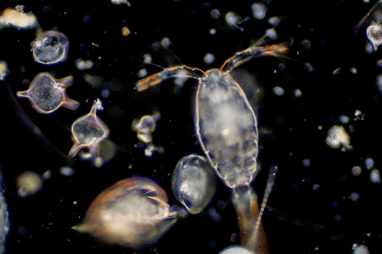
What’s In a Drop of Lake
Water?
Exploring & Identifying
zooplankton

Introduction: There are over 8.7 billion species that we know of on the planet and so as you may imagine we need some way of organizing them so they are easier to study and understand. We have been studying classification of organisms and how organisms are grouped together into the 5 kingdoms based on their shared characteristics. Today you will be looking at some distant relatives of yours also present in the animal kingdom; the zooplankton. These tiny critters feed on algae or other smaller zooplankton and are found in both lakes and oceans across the globe.
Objective: Students will use microscopes to observe and identify zooplankton.
Procedure: Taking your sample and Dissecting Microscope (MAY WANT TO GET RID OF THIS OR GET WELL SLIDES IT IS REALLY HARD TO SEE)
- Take a piece of pre-cut black paper and place it on the stage of the dissecting microscope. Use the stage clips to hold it in place.
- Take 2 pipettes full of Lake water and add them to your petri dish.
- Carefully place the petri dish under the dissecting microscope.
- Using a combination of gently moving the petri dish, rotating the dissecting microscope and adjusting your focus to find zooplankton. Some of them you can see without the dissecting microscope as little specks look for those first.
Hint: Zooplankton avoid light so try changing the amount of light you are using if you are having trouble seeing them… this is also why we used dark paper.
While observing your sample:
- How many different looking species were you able to find?

- Make some observations about how the organisms you see look, include shape, size, color, are any swimming/how do they swim?

Procedure: Compound Light Microscope (I HAD TO PREPREPARE A BUNCH)
- Take your pipette and draw up a small area WHERE YOU SEE SOME ZOOPLANKTON from your petri dish. The more concentrated meaning the highest ratio of zooplankton to water, the more likely you will see them under the microscope.
- Prepare a wet mount slide of your zooplankton
  - Put 4-5 drops on the glass slide
  - Place the cover slip on at a 45 DO NOT PRESS DOWN
Warning: if you press down or use too much water the water will spill out the sides of the coverslip. We want to avoid this.
- Let the slide sit for 5 minutes to dry out some before looking at it under the microscope.
- Put your slide under the compound light microscope and search for zooplankton on scanning power.
- When you find something of interest and want a closer look switch to low power (10x). Note some zooplankton are very small and you may not even see them unless under low power(10x).
Data: Find and diagram at least 2 different zooplankton, you should use low (10x) or high power (40x) objectives. Include color and be very detailed. Once you make the diagram, use the chromebook to identify the species using the taxonomic key provided. You should be able to at least get the family of the organism, but some you can get down to the species. http://cfb.unh.edu/cfbkey/html/begin.html Zooplankton Key First follows by image then by dichotomous key (THEY WERE ABLE TO GET THIS FAIRLY WELL WITH THE VISIBLE SPECIMEN)

Total magnification:________ Total Magnification:___________

K:
P:
C:
O:
F:
K:
P:
C:
O:
F:

Scientific Name Scientific Name:
G: G:
s: s:

Conclusion Questions:
- What characteristics did you use to determine what the species of your organism was? List at least 2.

- Explain the characteristics of zooplankton using the characteristics of the animal kingdom.

- Of the zooplankton you saw which was your favorite and why?

