**Unit 7: Factoring**

**Lesson 5: Simplifying Radicals & Rational/Irrational Numbers**

**Objectives:**

* I can identify the subsets of real numbers.
* I can identify the subsets of real numbers that a number belongs to
* I can simplify radicals.

**Agenda:**

* Video
* Practice
* Application

**Focus Questions:**

* What are the subsets of real numbers?
* What are the differences between these subsets?
* How can simplify radicals using perfect squares?

**Vocabulary:**

* **Natural numbers, whole numbers, integers, rationals, real numbers, Radicals, Radican, index.**

**Homework: HW 7-5**

[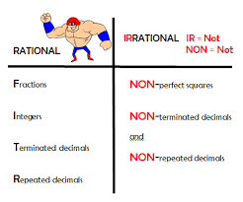](https://www.google.com/imgres?imgurl=https://sites.google.com/a/dysart.org/math-with-mr-t/_/rsrc/1408942720077/7th-grade/rational-vs-irrational-numbers/Rational%20and%20Irrational.PNG&imgrefurl=https://sites.google.com/a/dysart.org/math-with-mr-t/7th-grade/rational-vs-irrational-numbers&docid=E2CH51PPdPqysM&tbnid=kxHd1dxUpEY31M:&vet=10ahUKEwjew7C-jcTZAhUsm-AKHWzoBaoQMwioASg-MD4..i&w=403&h=335&bih=933&biw=1280&q=rational%20irrationa;&ved=0ahUKEwjew7C-jcTZAhUsm-AKHWzoBaoQMwioASg-MD4&iact=mrc&uact=8)[](https://www.google.com/imgres?imgurl=https://lh3.ggpht.com/WdfWkPOnm90tdAHD9iv5ISvn9f4VdpZEi6pp9iTs1LAcaCYeMXCvaq8EmoRLNz55d7c%3Dw300&imgrefurl=https://www.tes.com/lessons/trOFvcS66L7org/simplifying-radicals&docid=3Dm1IJdD_O0DtM&tbnid=hESeHdE1q41h4M:&vet=10ahUKEwiXlYKpjcTZAhWkSt8KHbIwAbgQMwiSAigYMBg..i&w=300&h=300&itg=1&bih=933&biw=1280&q=radicals&ved=0ahUKEwiXlYKpjcTZAhWkSt8KHbIwAbgQMwiSAigYMBg&iact=mrc&uact=8)[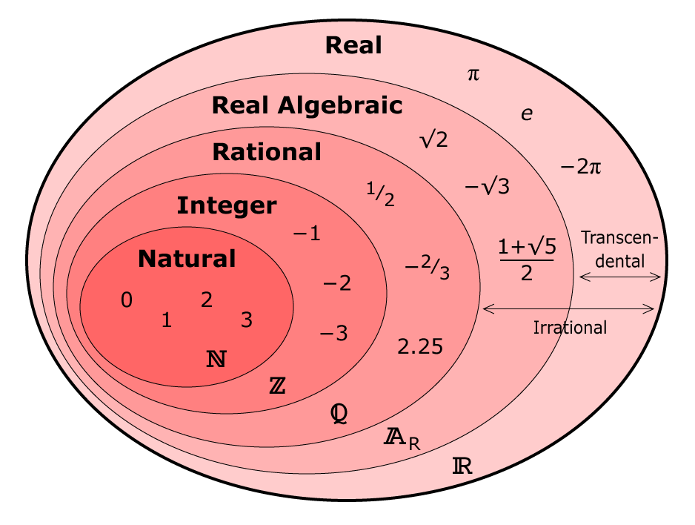](https://www.google.com/url?sa=i&rct=j&q=&esrc=s&source=images&cd=&cad=rja&uact=8&ved=2ahUKEwjr39nLjcTZAhWqmeAKHQSzAwIQjRx6BAgAEAY&url=https://socratic.org/questions/is-2-real-number-rational-number-whole-number-integer-irrational-number&psig=AOvVaw0qznMuce0GbhpOvfC6YVpZ&ust=1519752529510816)

PLAY THE POWER POINT; **Sets of Real Numbers:**

**Simplifying Radicals**: <https://www.youtube.com/watch?v=u2Z1hoXSrXk>

**Practice: Now let’s simplify the following square roots: Lesson 7-5**

1. $\sqrt{75}$ 2. 3. 4. 

1. 6.7. 8.

9. 10. 11. 12.

13. 14. 15. 16.

17.  18. 19.20.

**Open the link below and follow the practice**

<https://mathbitsnotebook.com/Algebra1/Radicals/RADSimpPractice.html>

**Name: _____________ Date: Homework 7-5**

1. 2. **3.** **4.**

5)Simplify the following Radicals: Remember to look for the largest perfect square and the irrational number should end up on the left of the perfect square.

a. b. c.

6. Factor completely the following expressions:

a) $8x^{3}+24x^{2}-80x$ b) $x^{4}-16$ c) ${8x}^{2}-14x-15$

d) ${3x}^{2}+16x+5$ e) $10x^{2}+15x-10$ f) $3x^{2}-21x+36$

Please continue on your flip booklet, you should work on page 7 tonight { 3 examples}