MAIN MEALS:

Costco Pizza: Costco Hot Dog:
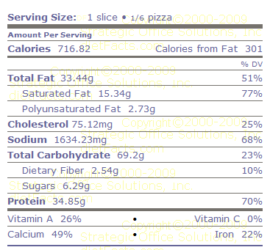
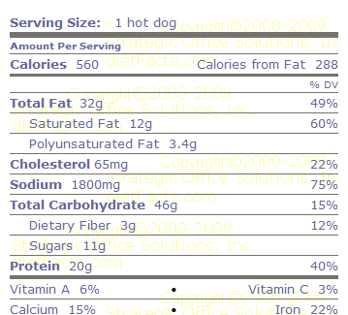

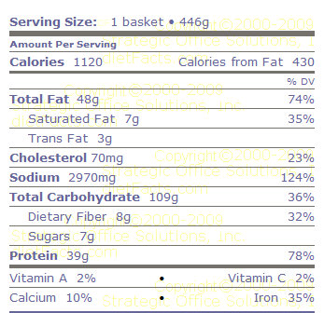
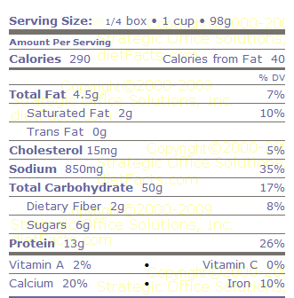
Dairy Queen Chicken Strip Basket: Kraft Mac n' Cheese:

Lasagna: Croissan’wich

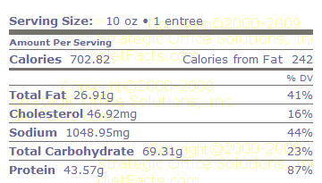
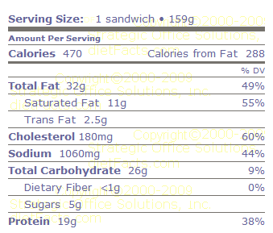

Chicken McGrill: Crispy Chicken
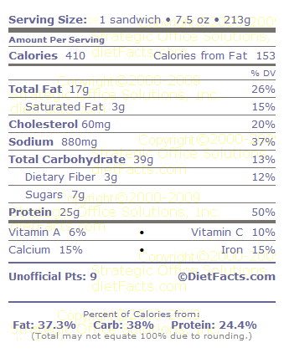
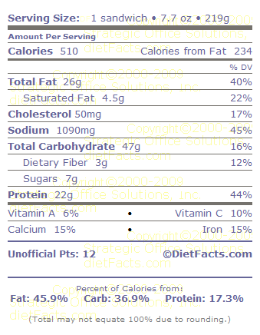

Creamy Caesar Dressing: Ranch: Cobb:
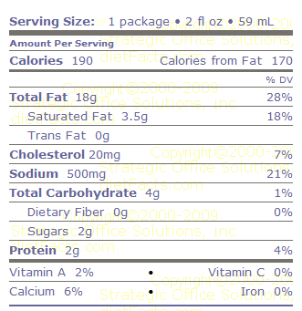
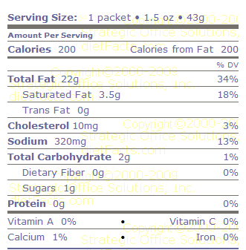
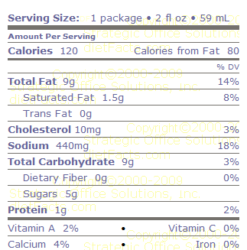

McDonald's Southwest Salad with Grilled Chicken McDonald's Big and Tasty Burger

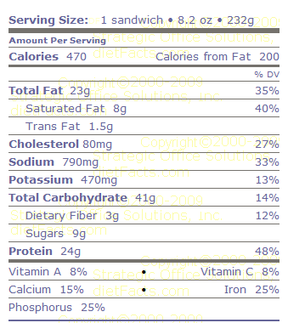
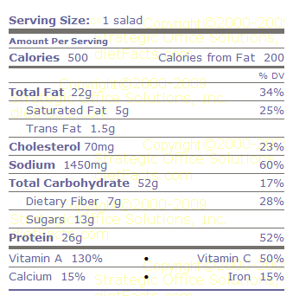

BEVERAGES:

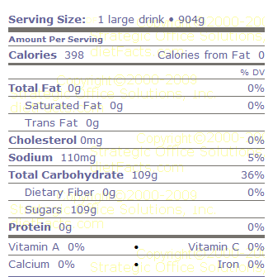
Large Coke: Mountain Dew:
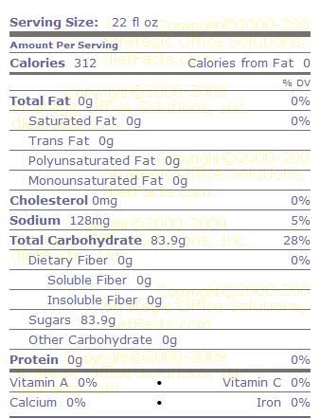

16 ounces of whole milk: 16 ounces of lowfat - 2% milk

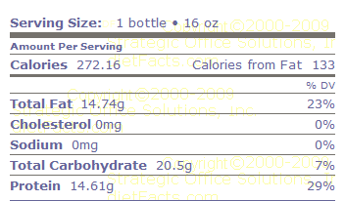
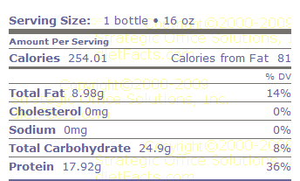

Large Chocolate Shake: Starbuck's Caramel Frappuccino - Venti
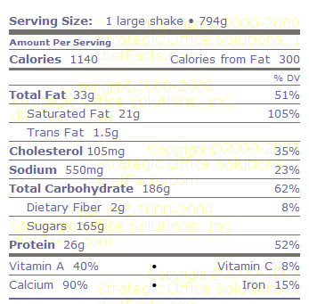
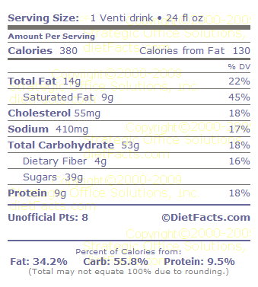

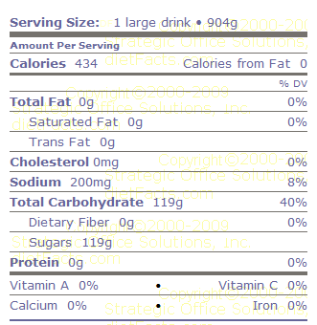
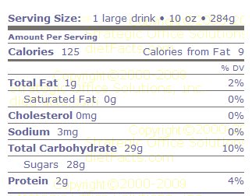
Large Orange Soda: Large Orange Juice:

BREAKFAST:

Jumbo Muffin (multiply everything by 3 if you eat it all!!) Glazed doughnut
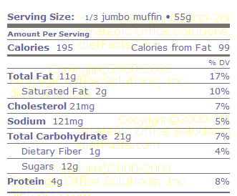
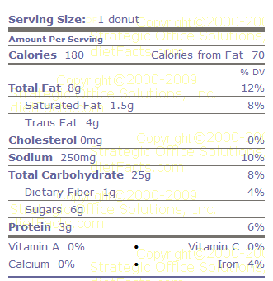

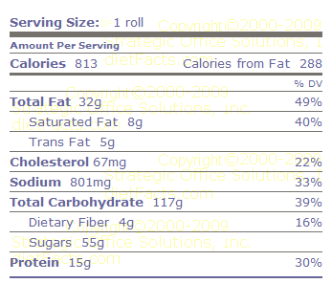
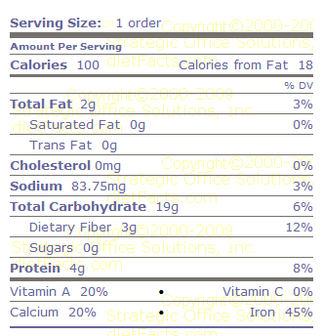
Cinnabon Instant Oatmeal

4 slices of Bacon 1 Link Sausage
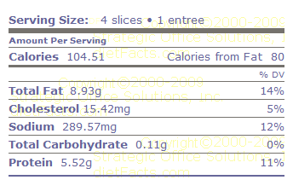
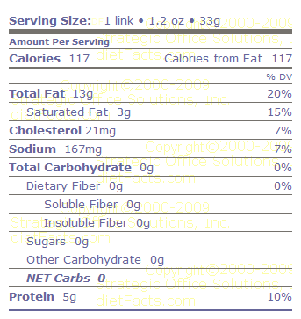

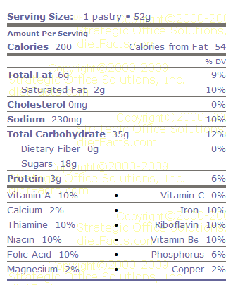
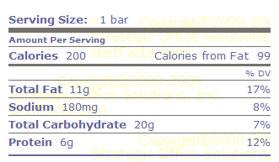
1 Kellogg's Chocolate Chip Poptart Carnation Breakfast Bar

DESSERTS:

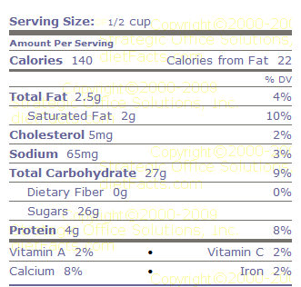
Ben and Jerry's Cherry Garcia Frozen Yogurt Ben and Jerry's Double Chocolate Fudge Ice-Cream
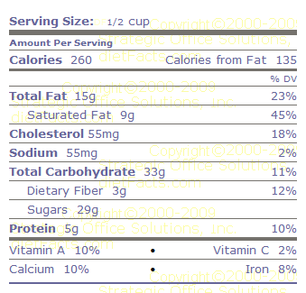

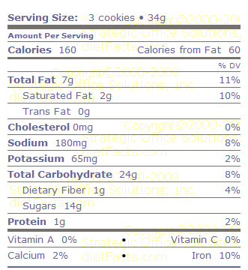
Hershey's Cherry Twizzlers 3 Nabisco Oreo Cookies
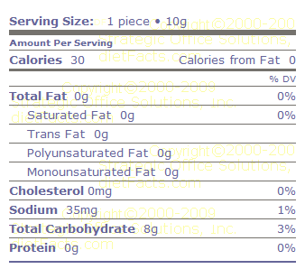

Mar's Snicker Candy Bar Blueberry Cheesecake

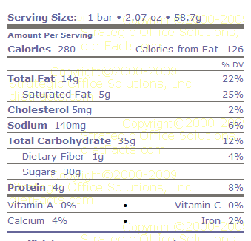
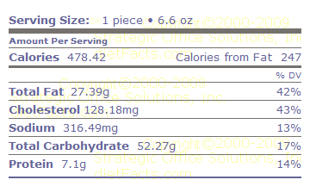

SNACKS:

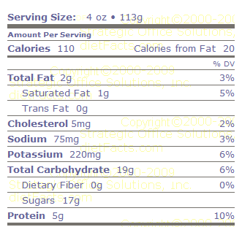
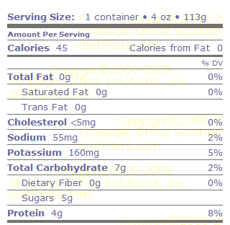
Dannon Light Yogurt Dannon Regular Blueberry Yogurt

Banana Ruffles Potato Chips
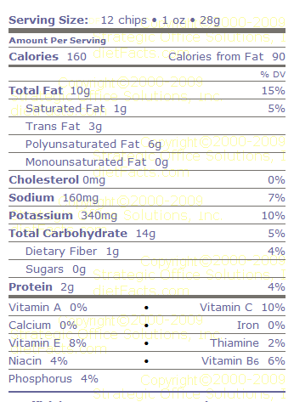
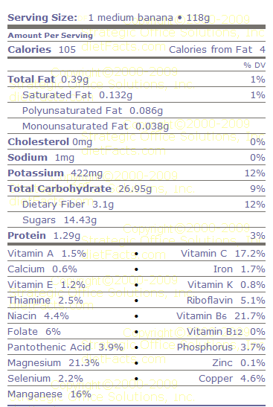

Almonds Microwave Popcorn
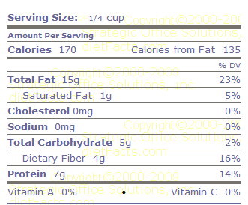
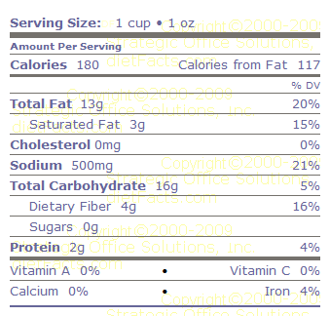

Beef Jerky
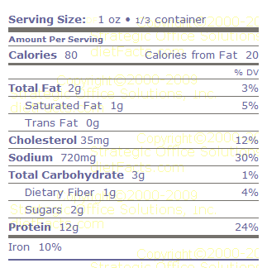

Food Label Scavenger Hunt: Name:________________________________________ Block_________

BLUE – MAIN MEALS

1. Which one has less Calories? Costco pizza, or a Costco hot dog for lunch. ______________________

2. People with high blood pressure should watch their sodium. The maximum per day is 2400 mg. Compare the Sodium in these 2 foods:

DQ Chicken Strip Basket:___________mg._ Kraft Macaroni and Cheese:_____________mg_

3. What % fat are the following foods?: (put Calories from Fat into your calculator and divide by Calories
Lasagna:_________% Healthy? Circle: yes or no (hint: no more than 35% of total daily calories should come from fat)

Croissan’wich:________ % Healthy? Circle: yes or no (hint: no more than 35% of total daily calories should come from fat)

4. Which has less total fat – Chicken McGrill or Crispy Chicken? ________________________

5. I want to have salad dressing on my salad at McDonalds. Which one has the least amount of both Calories and Total Fat? 1) Creamy Caesar, 2) Ranch, or 3) Cobb ________________________

6. Which of all the Main Meals in this section has the highest number of Calories?:_________________

7. Is McDonald salad less or more calories than a Big and Tasty burger? List calories here:
Salad Calories:_____________ Big and Tasty Burger: ____________

BLACK – BEVERAGES

1. Let’s compare Coke and Mt. Dew: Which one has:
more Calories:______________ more Sugar?______________ more Sodium?_____________

2. The ingredient to worry about in beverages is SUGAR! How many teaspoons of sugar are actually in the Chocolate Shake? _______tsp. (Hint: Put Sugar Grams into your calculator divide by 4)

3. How many teaspoons of sugar are in each of the following foods?: (Sugar Grams divided by 4)

Caramel Frappuccino:___________ teaspoons Orange Juice:__________________ teaspoons

Coca Cola:____________________ teaspoons Orange Soda ______________ teaspoons

ORANGE – BREAKFAST

1. Circle which has the higher % fat: (Hint: put Calories from Fat into calculator and divide by
Total Cal.) Circle: Banana Nut Muffin or Glazed Yeast Doughnut

2. How many packets of Instant Oatmeal could I eat + still have less Calories than the Cinnabon?:_________(Hint: Put Cinnabon Calories into your calculator and divide by Calories in 1 packet of Oatmeal)

3. Let’s compare bacon and sausage. Are the serving sizes similar? Circle: yes or no.

Which has more Calories?______________. If you ate 4 sausages, how many Calories would
you eat?__________ (Hint: multiply Calories by 4)

4. We should get some Carbohydrates for energy in the morning-would a PopTart be a good source?

What % of the Pop-Tarts’s Total Carbs are sugar? (hint: put Sugars into your calculator and divide by Total Carbs):__________ % Are PopTarts healthy? Circle: yes or no

(Hint: no more than 10 % Total Carbs per day should come from sugars)

5. What % fat is the Carnation Breakfast Bar?:_______% (Hint: put Calories from Fat into your calculator + divide by Calories) Healthy? : Circle: yes or no (hint: no more than 35%)

PURPLE – DESSERTS

1. Which of the all the desserts has the highest number of Calories?______________________

2. How many Calories less is Ben & Jerry’s Frozen Yogurt compared to B & J’s Double Chocolate? _______ Is a 1/2 cup of ice-cream a realistic serving size for you? Circle: yes or no

3. How much Total Fat do the Cherry Twizzlers have? __________g People often think food with no fat is automatically good for them, but if I love Twizzlers and I eat 20 of them, how many Calories will I eat? _______________. {REMEMBER: low-fat doesn’t mean low calorie}

4. When I start eating Oreos, I can’t stop!. If I eat 12 cookies, how many Calories will I eat?____________ (Did you do it right - Hint: 3 cookies is one serving, so multiply by 4…)
And how much Total Fat will I eat if I eat 12 Oreos?_________________g

5. I’m deciding between a Snickers and piece of Cheese Cake. Which one has less Calories?_________

BROWN – SNACKS

1. Let’s say I am a vegetarian and I don’t eat meat. I need to read my food labels and make sure I get enough Protein. Which of all snacks has the most Protein in one serving? __________________

2. I am deciding between Dannon Light Yogurt and Dannon regular Blueberry, they are both 4 oz. Which one should I choose and give 3 reasons why? Choose: ________________________ because: 1. _____________________ 2. _______________________________
3. _______________________________ It’s all about making wise choices. Reading labels can SAVE YOU CALORIES & FAT!!

3. A banana is only a few calories less than 12 potato chips, but why else is it a healthier choice than Ruffles Potato Chips?_______________________________________________

4. Which has less Saturated Fat (the bad kind!) Almonds or Microwave Popcorn: ________________________

