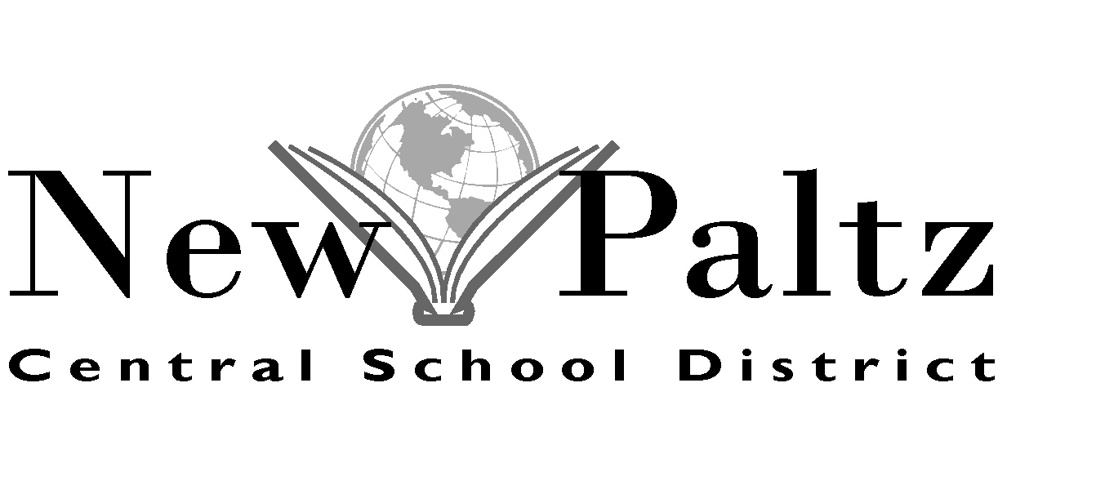

196 Main Street, New Paltz, New York 12561 • Phone: (845)256-4070 • Fax: (845)256-4079 • www.newpaltz.k12.ny.us

Kelli Ricci | Maureen Ryan | Jean Bain
Assistant Director of Transportation | Director of Transportation | School Bus Dispatcher

2018/2019 TRANSPORTATION REQUEST FOR PRIVATE/PAROCHIAL SCHOOLS

In accordance with the Laws of the State of New York, I hereby formally request

transportation for my child to the ______________________________ School.

Child's Name ___________________________________________________

DOB ____/____/____ Grade Entering_________ Age _____________

Address: House # and Street ____________________________________
(PO Box Numbers Unacceptable; Please Indicate House # and Street)

City, State, Zip ___________________________________

Home Telephone # __________________________

Emergency Telephone # ______________________

THE NEW PALTZ CENTRAL SCHOOL DISTRICT DOES NOT TRANSPORT TO PRIVATE/PAROCHIAL SCHOOLS ON DAYS IN WHICH THE DISTRICT IS CLOSED FOR STUDENTS.

A request must be completed for each child and submitted on or before April 2, 2018 as established by Education Law Section 3635. Students who register for Kindergarten must meet the same requirements as students attending New Paltz Central School District.

SCHOOL ATTENDED BY YOUR CHILD IN THE 2017/2018 SCHOOL YEAR _______________________________

PARENT/GUARDIAN SIGNATURE _________________________________________

DATE ______/______/_____

______________________________________________________________________________________________________
(FOR TRANSPORTATION OFFICE USE)

DATE RECEIVED _____/_____/_____

MILEAGE DISTANCE FROM HOME TO SCHOOL 15 MILES AND UNDER____ MORE THAN 15 MILES____

IF MORE THAN 15 MILES, STATE MILEAGE HERE_____

TRANSPORTATION APPROVED______________ DISAPPROVED_____________
revised 12/18/17

