Studio In Photography
Mr. Martin
Assignment #5
Self Portrait
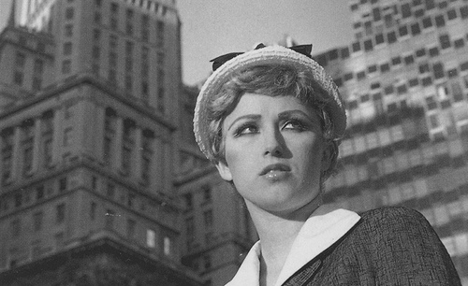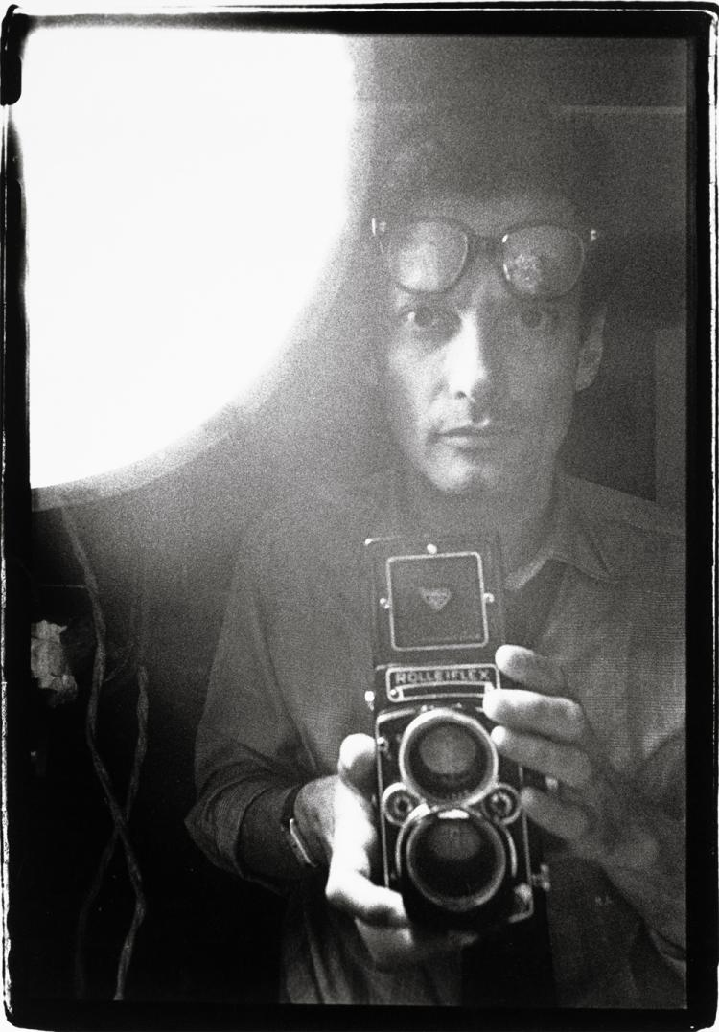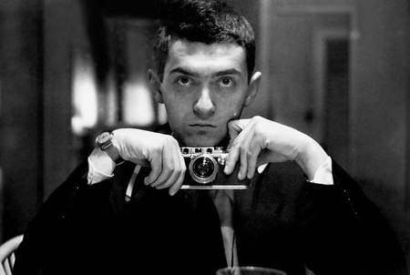

Isn’t it strange? We live in a body all our lives and never really get to see it from the outside. I remember as a child what this “I” was—my body and face or my mind and its ideas. Self portrait photography gives the artist a way to use the body to express the mind and give evidence to its ideas. People who turn the camera on themselves do so for a variety of reasons - - they range from role playing to photographing the physical state of the body to using images to examine the self and our relationship to the world around us.

They are asking simple questions which are often the most profound:
Who am I? Why am I here? Is there a plan? What is my part in this plan?

I find selfhood the most interesting arena to explore as it is always changing. We alter slightly with different people and in different situations – growth is about keeping parts of yourself that you like and changing the rest, always asking…
Who am I and who can I become?

-Anne McDonald

Shooting assignment

Self-Reflection in your 3-Ring Binder: 10 Descriptive words that answer the questions above.

Shoot one roll of film exploring a making of a portrait – of you.
The only rule - you must be the one to trip the shutter.

Suggested Techniques
Use of a mirror Reflective Surfaces
Use of a self-timer Shadows
Use of a cable release Symbolic or Representational Objects
Time Exposure Environment as part of portrait
Pinhole Camera Parts of Yourself

Consider
Lighting Techniques Direction of your glance
Psychological Viewpoints Message – Impact on your viewer
Composition- cropping, vignette Depth of Filed, Motion Control etc.
Rule of Thirds

