Studio In Photography
Mr. Martin
Assignment #6
Silhouette
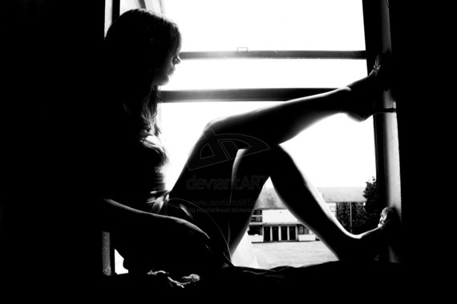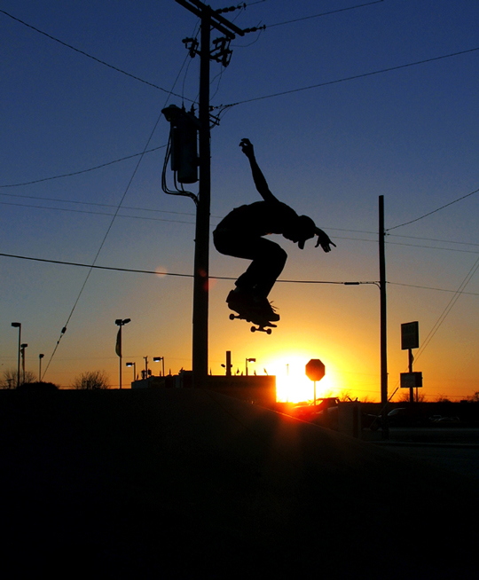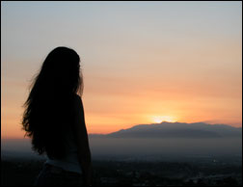

Silhouette images show an outline (a silhouette) of the subject in black against a more detailed background. The effect can be artistic and convey an image more powerful than one in which the subject is presented in detail.
The approach is fairly simple. It requires lighting behind the subject (Backlighting) we wish to show in silhouette (typically provided by the sun), and metering for the background behind the image. When shooting silhouette images, we essentially attempt to significantly underexpose the subject.
Contre-jour means 'against the light' and refers to pictures taken when the camera is pointing towards (or roughly towards) the main light source.
Portraits taken contre-jour will show a bright halo of light in the hair. Fill in light will be needed to show detail in the face, or it can be kept dark to give a silhouette.
Strong light shining towards the camera has a tendency to produce flare; you should normally use a lens hood to exclude light from outside the pictures area.
The name silhouette comes from the French politician, Etienne de Silhouette (1709-67) who was briefly and unpopularly in charge of tax collection, and was probably meant as a satirical reference to the brevity of his holding office.

Shooting Assignment: A photographic shoot that studies shape and form by underexposing a subject against a light source.

Suggested techniques:
Look for interesting shapes – profiles, trees, figures …
Use of the sky – interesting clouds, environment…
Putting the subject in a doorway or window – curtains, blinds for texture
Shoot from a darkened room towards a figure in the doorway of a light room. Meter off the background – bracket for underexposed subject.

