Activity 5.6 Physical Property Analysis

Introduction
What do you need to know about a product before it is built? Would you need to know its volume, surface area, or weight? Would the product weigh less if it were made of aluminum or mild steel? What about copper, brass, or cast iron? How could this information impact the product design?

How can you find the properties of a product before it is built? You can calculate them mathematically, providing you have the material specifications, but it will take time. In today’s busy, fast-paced world, engineers use solid modeling software programs to speed up the calculating process. However, the user of the software must understand what the software is doing in order to estimate the answers and to be able to recognize a possible error.

Equipment
- Engineering notebook
- Pencil
- Computer with 3D CAD solid modeling software
- Calculator

Procedure
In this activity you will calculate the volume of a part and the surface area; you will look up the density of the material and then calculate the mass. Next, you will check your work using a 3D solid modeling software program. After you have learned how to calculate the physical properties of the example parts provided, you will then do an analysis on a puzzle cube piece and parts of your Automoblox vehicle or other consumer product.

Aluminum Object Example 1

The aluminum example is provided as an isometric drawing that will need to be created as a solid model. The grid spacing for the object shown is 0.25 inch. Using the grid, determine the measurements for each facet of the part. Recreate the isometric sketch and record each facet’s dimensions in your engineering notebook. Then calculate the volume and surface area of the object. Show your work in your engineering notebook. Next, create a model of the object with the required geometry using the 3D solid modeling software. You will assign aluminum as the object’s material and perform a physical property analysis to determine the answers to the questions. Print a copy of the CAD Physical property values and insert into your engineering notebook. When you have completed the physical property analysis, answer the questions below.

You may need to review your notes and the Physical Properties PowerPoint to recall how to generate the physical properties of a part.

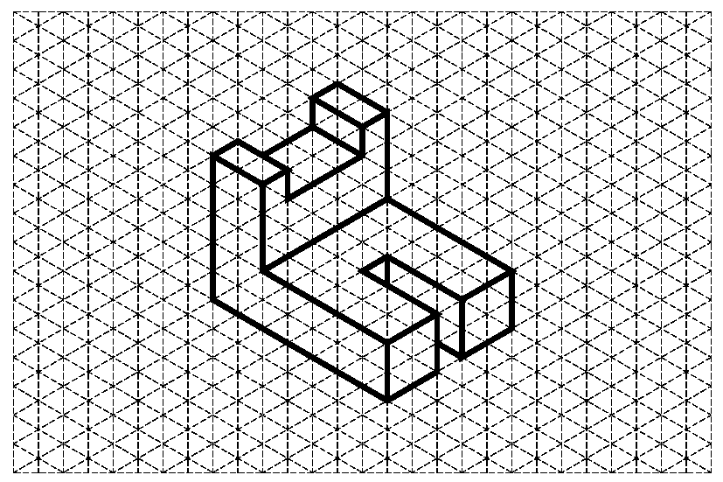
Figure 1: Isometric drawing of Aluminum Object One with 0.25” grid

Questions for Aluminum Object One

Directions: Complete the calculation by hand. Show all work below and select the appropriate answer based on your calculations. Check your work using the 3D modeling software. If your answers differ, explain why you think they are different where appropriate.

- What is the volume of the part?

- 1.875 In.³
- 1.125 In.³
- 1.375 In.³
- 2.125 In.³

SHOW WORK:

- What is the density of aluminum in grams per cubic centimeter? (This may require research. Be sure to document your source.)

- What is the density of aluminum in pounds per cubic inch? Show your work including all conversion factors.

- Find the mass of the object (in pounds) if it is made of aluminum.
- 0.125 lb
- 0.135 lb
- 0.257 lb
- 0.312 lb

SHOW WORK:

- What is the surface area of the part?
- 7.250 In.²
- 8.250 In.²
- 9.250 In.²
- 10.250 In.²

SHOW WORK:

- What are the physical properties presented in the CAD software? Include units.

A. Density _______________
B. Mass _______________
C. Surface Area _______________
D. Volume _______________

If physical properties are different from hand calculated values, explain why you think they differ.

- If one quart of cleaning solution will clean 14400 in.², how many quarts will be required to clean 3000 parts? Use 3D software physical properties.

- 2.000
- 1.500
- 2.135
- 2.145

SHOW WORK:

Brass Object Example 2

An isometric drawing of a brass part is provided. The grid spacing for the object shown is 0.25 inch. Using the grid, determine the measurements for each facet of the part. Recreate the isometric sketch and record each facet’s dimensions in your engineering notebook. Calculate the volume, mass, and surface area of the object and record below. Next, create a model of the object with the required geometry using the 3D solid modeling software. You will assign brass as the object’s material and perform a physical property analysis to determine the answers to the questions. Print a copy of the CAD physical property values and insert into your engineering notebook. When you have completed the physical property analysis, answer the questions below.

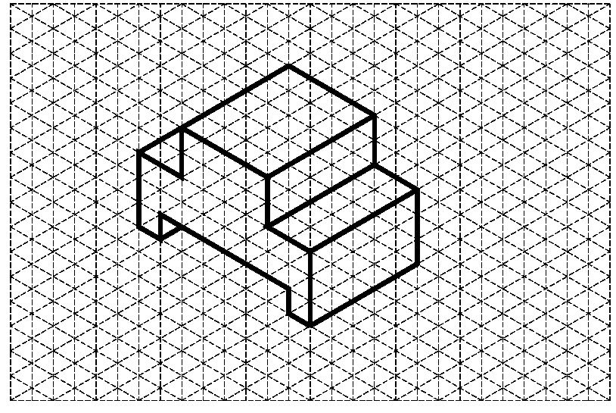
Figure 2: Isometric drawing of Brass Object One with 0.25” grid

Questions for Brass Object One

Directions: Complete the calculation by hand. Show all work below and select the appropriate answer based on your calculations. Check your work using the 3D modeling software. If your answers differ, explain why you think they are different where appropriate.

- What is the volume of the part?

- 2.375 In.³
- 3.125 In.³
- 2.031 In.³
- 4.125 In.³

SHOW WORK:

- What is the density of brass in grams per cubic inch?

- What is the density of brass in pounds per cubic inch? Show your work including all conversion factors.

- Find the mass of the object if it is made of brass.

- 0.621 lb.
- 0.547 lb.
- 0.257 lb.
- 0.312 lb.

SHOW WORK:

- What is the surface area of the part?

- 6.000 in.²
- 8.000 in.²
- 0.250 in.²
- 12.000 in.²

SHOW WORK:

- What are the physical properties presented in the CAD software? Include units.
  - Density _______________
  - Mass ___________________
  - Surface Area ___________________
d. Volume ___________________

If physical properties are different from hand-calculated values, explain why you think they differ.

- What will be the total cost to ship 100 brass parts if the shipping rate is $4.25 per pound? Use the physical properties from the CAD analysis. SHOW WORK.

High Density Polyethylene Example 3

You will begin by using Figure 2 isometric drawing to create a solid model. The grid spacing for the object shown is 1 cm. Recreate the isometric sketch and record each facet’s dimensions in your engineering notebook. Next, create a model of the object with the required geometry using the 3D solid modeling software. (Hint: Use subtractive modeling by creating a rectangular solid, and then use the Loft tool to cut the V-notch.) Remember to use a metric part file template. Assign high density polyetheylene as the object’s material and perform a physical property analysis. Insert a copy of the CAD physical property values into your engineering notebook adjacent to the sketch. When you have completed the physical property analysis, answer the questions below.

Figure 3: Isometric drawing of High Density Polyethylene Object using a 1 cm grid

- What are the physical properties presented in the CAD software? Include units.
A. Density ___________________
B. Mass ___________________
C. Surface Area ___________________
D. Volume ___________________

- What is the surface area in square centimeters? SHOW WORK.

- What is the volume in cubic centimeters? SHOW WORK.

- What is the mass of the high density polyethylene part in pounds? Show your work and include all conversion factors.

- How many parts can be made from 152 pounds of high density polyethylene? SHOW WORK.

Physical Property Analysis of Your Puzzle Cube

What if the material you plan to use is not listed in the software? There may be times that you will need to create a new material in the software and add the material specifications before you can perform the physical property analysis of a part. As in industry, there will be times that you need to “teach yourself” through use of the software tutorials and help menus.

Create a new material in the software called Hardwood Puzzle. To accomplish this task, you will independently research and discover how to customize a 3D modeling software application to add a new material and its properties. Use the density for the puzzle cube wood found in Activity 5.4 Calculating Properties of Solids. You may use the properties of birch for the other physical properties of the wood (therefore you may choose to create a copy of Birch and rename it).

You will conduct a physical property analysis on one part of your puzzle cube. Choose any one of your puzzle pieces, open the CAD part file, create a new material, and perform a physical property analysis using the new Hardwood Puzzle material. Record the information below.

Print an isometric view of your chosen puzzle piece and a copy of the CAD physical property values and insert both into your engineering notebook.

- What are the physical properties presented in the CAD software? Include units.
  - Density (from Activity 5.4) ___________________
  - Mass ___________________
  - Surface Area ___________________
  - Volume ___________________

If the physical properties are different from hand-calculated values in Activity 5.4 Calculating Properties of Solids, explain why you think they differ.

Physical Property Analysis of Automoblox Vehicle
Use the 3D CAD software to perform a physical property analysis of the connector piece of your Automoblox vehicle. Create a new material in the software called Automoblox Plastic. Use the density you found for the connector and people in Activity 5.3 Determining Density and the other physical properties of ABS plastic.
Record the information below.

Print an isometric view of your connector piece and a copy of the CAD physical property values. Insert both into your engineering notebook.

- What are the physical properties presented in the CAD software? Include units.
  - Density (from Activity 5.3) ___________________
  - Mass ___________________
  - Surface Area ___________________
  - Volume ___________________

- If there is a 4% loss of material in the manufacturing process, how much material should be purchased to produce 10,000 connector pieces? SHOW WORK.

- If the cost of the plastic to manufacture the connector parts is $0.015 per cubic inch of material, what is the cost to manufacture 10,000 connector pieces? SHOW WORK.

Conclusion
- What do you need to know in order to perform a physical property analysis?

- Why is it important to understand the mathematics used in physical property analysis?

- Why is it important to perform a physical property analysis prior to producing a part?

- The clear enclosure piece and the wheels of the Automoblox are manufactured from polycarbonate. Do you think that the connector pieces are also manufactured from polycarbonate? Justify your answer.

