Name_______________
DDP 2015-2016 Midterm Review
Use your class notes to complete the questions below. If you are missing information, review the Power Points on my website under notes and other important information.
Color Theory
List the primary colors:  1.  2.  3. | List the secondary colors:  1.  2.  3. | List the tertiary colors:  1.  2.  3.

List warm colors:

List cool colors:
What is monochromatic color?

What is analogous color?

List three sets of complimentary colors. | 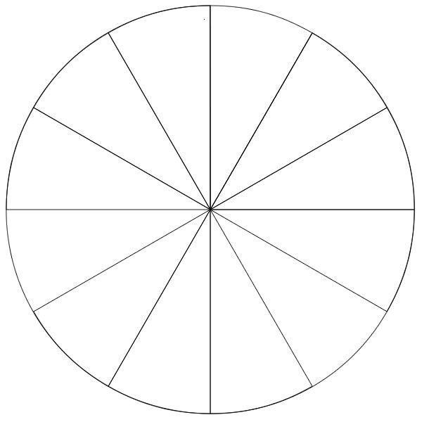
Label the color wheel on the right.

