Name_______________
DDP 2015-2016 Midterm Review
Use your class notes to complete the questions below. If you are missing information, review the Power Points on my website under notes and other important information.
The Design Process
- What is the definition of design?

- List the steps in the design process. Begin with defining the problem.

Die Cut Boxes | 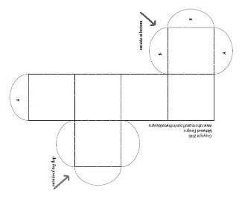

- What is the definition of die cut?

- When making a die cut box, a dotted line means you should do what?

- A solid line means you should do what?

- What is scoring?

- What is perforation?

- What is ergonomics?

