Name_______________
DDP 2015-2016 Midterm Review
Use your class notes to complete the questions below. If you are missing information, review the Power Points on my website under notes and other important information.
Oblique
- An oblique pictorial starts with a straight-on view of one of the object’s faces, which is often the front face.
- Angled, parallel lines are drawn to one side to represent the object’s depth. Common oblique angles include 30°, 45°, and 60°.
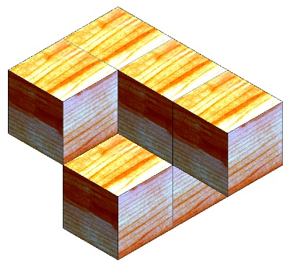Sample object | 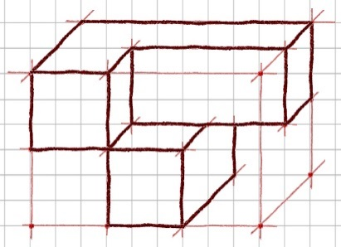  Sample drawn in oblique

Draw and render the shape in oblique. (Render means to add value or shade it.)
Isometric
Isometric means equal measure.
- Three adjacent faces on a cube will share a single point
- Edges converge at one point will appear as 120 degree angles or 30 degrees from the horizon line.
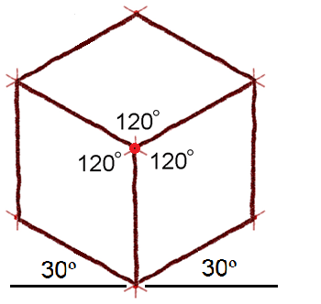 | 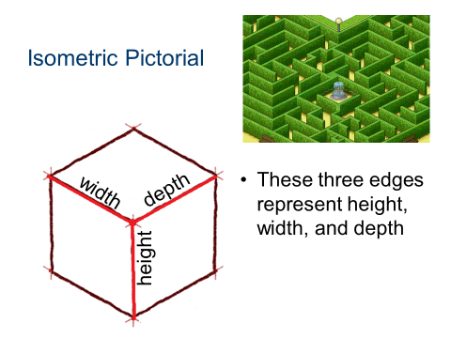

Draw and render the shape in isometrics. (Render means to add value or shade it.)

