AP Euro Art etc.

From Audrey:
Giotto di Bondone (1267-1337)
- He was a painter and architect from Florence.
- Giotto is considered the father of Renaissance painters.
- Giotto broke away from the style of Byzantine painters which was unnatural, stiff, lacked emotion and human interaction. He brought a naturalism to his work. This is visible in his painting Meeting At the Golden Gate where a couple is shown in an affectionate embrace. He also used landscape to intensify his paintings and bring more attention to the figures he painted.
- Giotto's most famous work are his paintings in the Scrovegni Chapel (Arena Chapel) in Padua, which he did sometime between 1303 and 1310. He painted 37 scenes arranged on three tiers showing the life of the virgin's parents, the life of Mary, and the life of Jesus.
- A common theme throughout his work is salvation. Most of his work depicts various religious scenes.
Donatello (1386-1466)
- Donatello was an artist and sculptor from Florence.
- He's known for his innovative techniques in sculpture like his shallow relief sculpture.
- Donatello's most famous work is his bronze David. Cosimo de Medici, one of the primary art patrons at the time commisioned Donatello to do the sculpture for the Medici court around 1430. The statue has been controversial because David, just a boy is shown naked standing in a distinctly feminine pose.
Massacio (1401-1428)
- Massacio was the first artist to use scientific perspective in his work. He also used correct proportions and vanishing point bringing a greater realism to his art. In his fresco The Holy Trinity one can clearly see his use of scientific perspective. The people shown closer in the scene look larger than Jesus Christ who is depicted crucified towards the back of the scene.
- Through his paintings you can see Giotto's influence on him. He continued the development of naturalism in painting. The figures in his work look more life like than those in Giotto's.
- Massacio work was predominantly frescos in various churches.
- Among his most famous works are the Tribute Money and the Expulsion from the Garden of Eden. Unfortunately, many of his works have been destroyed likely from fires.
Botticelli (1445-1510)
- Botticelli was yet another Italian Renaissance painter from Florence.
- His name means "the little barrel."
- His most famous works include the Birth of Venus, Primavera, and Allegory of Spring. Differing from artists before him like Giotto and Massacio his artwork features more paegan themes.
- In his later work figures are distorted, the scale is not accurate, and he used non naturalistic colors. This work of Botticelli's is reminiscent of artists from centuries prior, and doesn't reflect the style of the renaissance.
Leonardo da Vinci (1452-1519)
- Da Vinci was basically an Italian everything... He was an artist, an extroardinary one, as well as a mathematician, engineer, scientist, inventor, botanist, musican, and writer. In many ways he's similar to the ideal Renaissance man Castiglione described.
- In his work is an amazing quality of detail, in his many sketches and paintings this is visible. In his sketch Age and Youth one can see every one of the old man's wrinkles and the many curls in the young boy's hair.
- In Da Vinci's work an even greater level of naturalism than that of Massacio is achieved. His consideration of anatomy, light and botany can all be seen in his work.
- His most famous work is the Mona Lisa. The "mystery woman" as some call her is utterly captivating and seductive. It is argued who the portrait is of, and it will be most likely be debated forever.
Michelangelo (1475-1564)
- Michelangelo like Da Vinci was also a true Renaissance man. He was a painter, sculptor, poet, architect and engineer.
- Inspired by Donatello, Michelangelo sculpted a marble David. He sculpted it in the very early 16th century at the young age of 26. His version of David is more masculine than Donatello's, but remains controversial
- His most famous work are his paintings decorating the ceiling of the Sistine Chapel, this enormous task took him a mere four years. His most well known frescos on the ceiling are the Creation of Adam, and Adam and Eve in the Garden. In these paintings he uses very natural colors and human emotions are very clearly shown on the faces of the figures, making the works more relatable.
- His artwork led to the mannerism art movement occuring betweening 1520 through 1580. This movement is characterized by its restrained naturalism and intellectual sophistication.
Raphael (1483-1520)
- He was an Italian painter and architect. His work displays grace and is deemed to be close to perfect.
- He became an orphan at age eleven.
- In the School of Athens, Raphael represents the Seven Liberal Arts and secular learning. Many great philosophers including Plato and Aristotle are shown in the work. Raphael even put himself in the painting. The School of Athens reflects the Renaissance time period because scholasticism was being rejects and more secular ideas accepted.
- Raphael's portrait of Baldassare Castiglione is reminiscent of Da Vinci's Mona Lisa in that the eyes are very alive and seem to meet yours. In Raphael's work ultimate naturalism is being reached.
- He also did many Madonna and child paintings.
- Raphael's early death at 37 is considered a tragedy. It will never be known how his artwork would have evolved had he lived longer.
Titian (1490-1576)
- Fellow painters referenced him as "the sun amidst stars."
- His use of color and versatility are often noted. His work has been influential to future generations of western art.
- He often worked for popes or other religious officials.
- His painting the Venus of Urbino was painted in 1538 for the Duke Guiobaldo II. It is sensual and feels intimate. He uses intense colors like red to represent passion. Most everything in the painting was probably planned and thought out. The use of a dog, which was sleeping implied the woman was unfaithful.
- His most famous works include Assunta, and the Death of Acteon.
- He was a perfectionist. While some deem him a genius, others may have viewed him as psychotic. Sometimes he kept paintings 10 years or more. He edited some until he destroyed them.
- His mature works were more violent and dark. It is said this reflected his personal life which went downhill as he aged.
- The last 25 years of his life he worked primarily as portrait painter for Philip II of Spain.

From Chris:
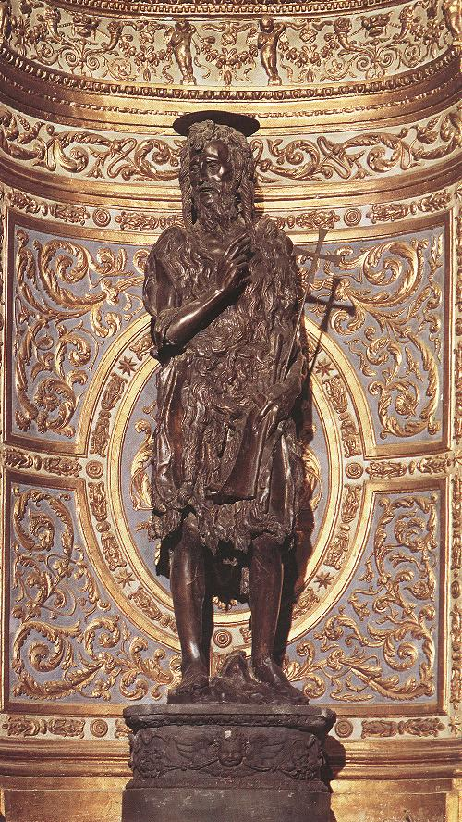
- Donatello, trained by Lorenzo Ghiberti started his career in art in 1406.
- This is a Statue of St. John the Baptist, commissioned by in the Duomo di Siena. This fantastic sculpture is carved from wood. Since it is inside a building, it is protected from the elements that cause wood to ferment, so it has lasted for over 600 years.
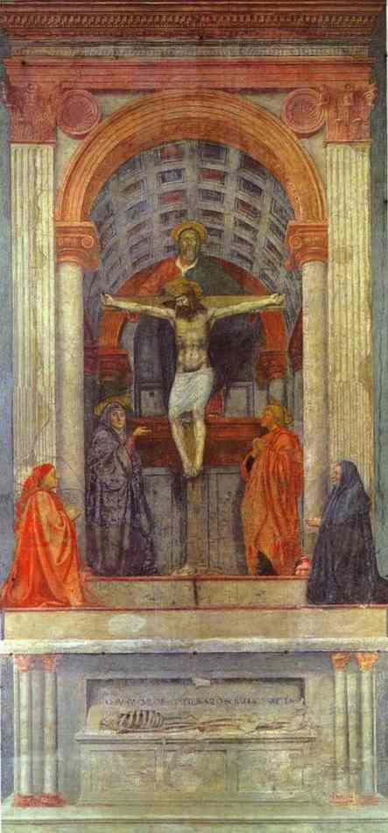
- Masaccio started his career as an artist in 1422.
- His “Holy Trinity” is possibly one of the most important works of the early Renaissance. He uses a vanishing point in many of his works.
- The fresco above was rediscovered about 120 years ago because it was hidden behind an altar piece in the Santa Maria Novella Cathedral in Florence, Italy.
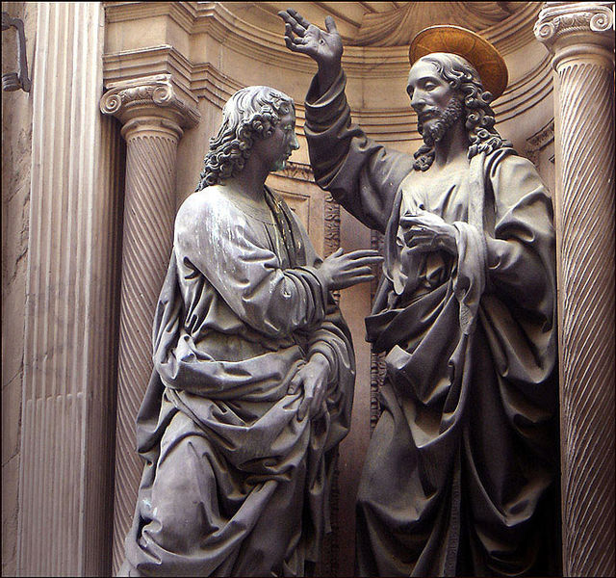
- Verrocchio started his artistic career in 1465.
- In 1466 the Guild of Traders of Florence commissioned from Verrocchio a bronze group entitled “Christ and St. Thomas” for an external niche of the church of Orsanmichele.
- This fine detailed work is so well done, one can see the lines on the palms of the men and individual locks of hair.

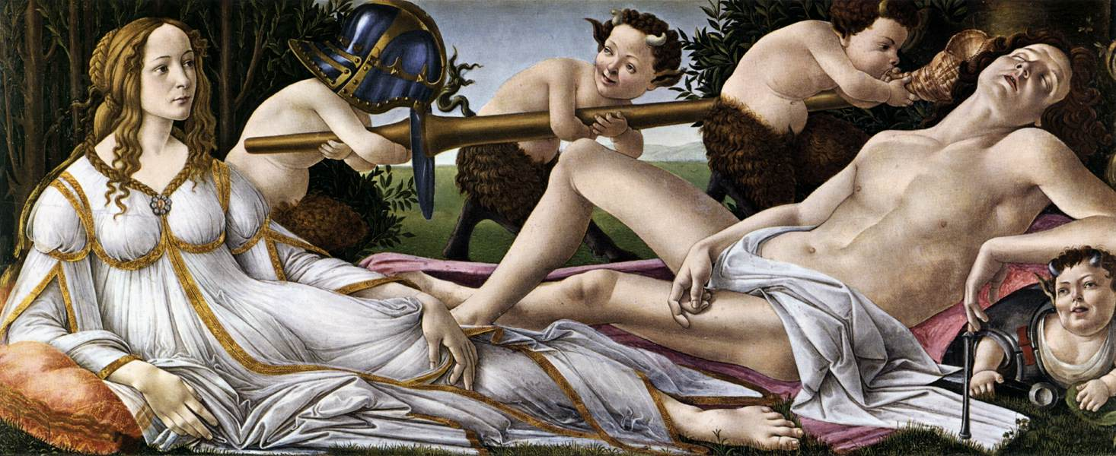
- Sandro Botticelli started his career in 1470.
- He created “Venus and Mars” in 1483.
- It was commissioned by the Vespucci family as an inspiring bedroom piece.
- Botticelli and many other renaissance artists tried to realistically depict scenes but still throw in the somewhat imaginative creatures and ideas.

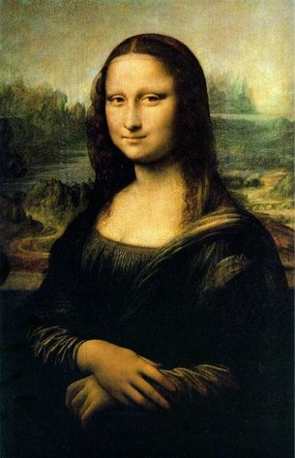
- Leonardo da Vinci started his chase for the title Renaissance Man in 1472.
- He painted the “Mona Lisa” in 1505.
- The subject is thought to be a young Florentine woman, Monna (or Mona) Lisa, who in 1495 married the well-known figure, Francesco del Giocondo, and thus came to be known as “La Gioconda”.
- Da Vinci’s Mona Lisa is one of the best know art works anywhere in the world because of its simple elegance.

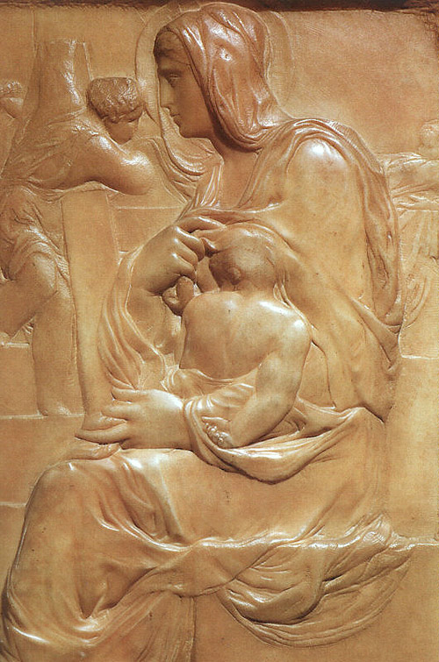
- Michelangelo started his artistic work in 1491.
- This relief “Madonna of the Steps” was his very first work finished in 1491, carved from a waxy, translucent slab that is similar to alabaster.
- It was commissioned by Lorenzo de Medici.
- It shows a classical renaissance depiction of a child (uncharacteristically proportioned like a tiny man, less like a child).

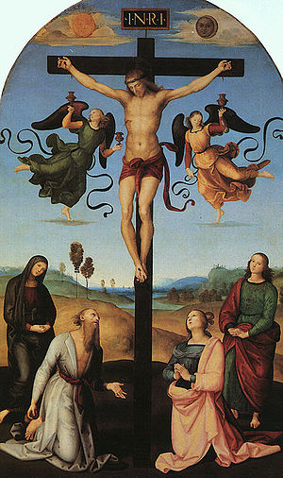
- Raphael Sanzio (better known as Raphaello) started his artistic career in 1501.
- One of his first works “Mond Crucifixion” was finished in 1503.
- This oil painting was greatly influenced by Perugino, and it served as the altarpiece of the side chapel in S. Domenico in Città di Castello
- Raphael was enormously productive, and despite his death at thirty-seven, a large body of his work remains. Many of his works are found in the Apostolic Palace of The Vatican.

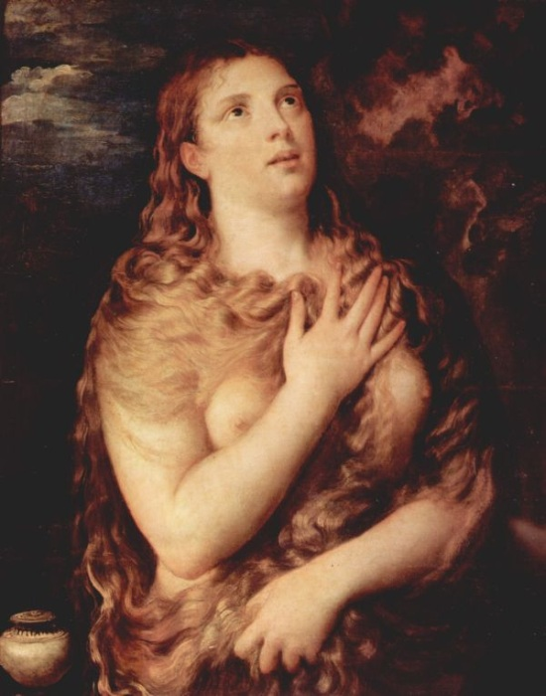
- Titian, (Tiziano Vecellio) began his work in the field of art in 1507.
- His oil painting “Sacred Prostitute,” was started in 1530 and finished in 1535.
- It is a portrait of Mary Magdalene, praying nude to find the answer to her unexplained pregnancy while away from her husband Joseph.

Info. Sheet
Jaci Hart, Clare Profous, Anna Gilmore

- The Medici Family
  - The bank was founded in the 14th century
  - Also founded by Cosimo de’ Medici
  - They thought of the double entry book-keeping system, and was first used by workers of the Medici family.
    - Way to keep track of credit and debits.
  - The Medici family was responsible for most of the banking during the Renaissance.
  - Their rise to power was due to an inter-connection between wealthy families and marriages and other connections like that.

- Fugger Family banking
  - Was a German banking system of the age of exploration
    - 15th and 16th centuries
  - They were from Augsburg, Germany.
  - Originally weavers and they grasped power by marriages and friends; like the Medici family.
  - Used similar ideas of the Medici family.
*the Medici banking system falls in 1743
  - The Fugger family gains power due to the explorations of other places

- The Lloyds of London
  - The Lloyds was not a family but, in fact an organization of bankers in London.
  - The first establishment was meant for merchant sailors in 1688
  - Most of the business at first was just discussions of insurance policies and other financial business.
  - The bank later built up to be a well recognized bank of the 17th century.
    - The organization of bankers still exists today.

Madeline Harrington
Mr. Bartlett
AP Euro
5 November 2009

Raphaello→1501 →1510-1511 School of Athens
- The School of Athens was painted by the 27 year old Raphael for Pope Julius II. In his painting The School of Athens, he reflected the classical influence upon Renaissance art, but he also paid tribute to the men who inspired him by using the faces of da Vinci, Bramante and Michelangelo as philosophers participating in the debate between Plato and Aristotle. Raphael (his full name Raffaello Sanzi or Santi), Italian painter and architect of the Italian High Renaissance. Raphael is best known for his Madonnas and for his large figure compositions in the Vatican in Rome. His work is admired for its clarity of form and ease of composition.
Donatello→1406 →1430-1432 David in Florence
- Donatello master of sculpture in both marble and bronze, one of the greatest of all Italian Renaissance artists. Donatello's genius made him an important figure in the early Italian Renaissance period like Masaccio, Donatello was one of the earliest artists working with the idea of perspective. His method was sculpture and he brought dramatic shapes to life with his skills. He never married and he seems to have been a man of simple tastes. It has been claimed that the statue is based on perfect mathematical proportions, but it is impossible to prove this since the decoration on top of the helmet has been broken off at some point.
Leonardo da Vinci →1460→1489-1490 Lady with Ermine
- Leonardo da Vinci was a Florentine artist, one of the great masters of the High Renaissance, who was also known as a painter, sculptor, architect, engineer, and scientist. This painting is one of only four female portraits painted by Leonardo, the others being the Mona Lisa, the portrait of Ginevra de’ Benci and La Belle Ferroniere . During his lifetime Leonardo was valued as an engineer. For much of his life, Leonardo was fascinated by the phenomenon of flight, producing many studies of the flight of birds, including his c. 1505 Codex on the Flight of Birds, as well as plans for several flying machines, including a helicopter and a light Hang Glider.

- Michelangelo→1480→1501-1504 David

- Michelangelo was a skilled painter who spent many years completing the wonderful paintings in the Sistine Chapel. Michelangelo had trained as a sculptor and created two of the world's greatest statues--the enormous David and the emotional Pieta Michelangelo) was born at Caprese, a village in Florentine. The statue of David that is seventeen feet tall. The mythical figure of David is supposed to be the giant-killer —yet, in view of his size, Florentines spontaneously called this David "The Giant." With that, the whole meaning of David's victory is altered. No longer does he represent a fable whose moral is "the bigger they come, the harder they fall."
- Botticelli→1470→1482 Birth of Venus
- Italian painter, born Alessandro di Moriano Filipepi, Botticelli is one of the outstanding geniuses in the history of Western art. He began his training under Filippo Lippi, alongside Filippino, and seemingly worked for a time with Leonardo in Verrocchio's workshop
“We see the story's birth with the winds, Zephyr and Aura, who, on the first day of Creation, elevated this shell bearing Venus' triumphant nudity from the unknown depths of the sea. And, approaching the earth on which she will assume her true role, her true power, she is suddenly modest, and we should note the stance, which Botticelli borrowed directly from the beautiful examples of the antique Venus Pudicae that were being discovered at that time. He really painted her like a Venus Pudica.”-World Art Treasures. This is one analysis of “The Birth of Venus”
- Giotto→1288 →1302-1305 Marrige of the Virgin
- Florentine painter and architect. He was already recognized by Dante as the leading artist of his day. His significance to the Renaissance can be gauged from the fact that not only the leaders in the early 15th-century transformation of the arts, such as Masaccio, but the key figures of the High Renaissance, such as Raphael and Michelangelo
- Massacio→1422→1423The Tribute Money
- Perhaps one of the most influential artists of the Renaissance. Historians claim that he, along with Donatello and Brunelleschi, inspired the style of art that typifies art of the period. In his 27 years on the planet, he developed a style that used perspective in a way that created an illusion of three-dimensions
He was the first great painter of the Italian Renaissance, whose innovations in the use of scientific perspective inaugurated the modern era in painting.
Masaccio, was born in San Giovanni Valdarno, near Florence, on December 21, 1401. He joined the painters guild in Florence in 1422. His remarkably individual style owed little to other painters, except possibly the great 14th-century master Giotto.

- Titian→ 1508→1538 Venus Of Urbino
He was proficient not only in a variety of art forms, but also in math and sciences. Trained by Giovanni Bellini, He was noted for use of color and for the use of thick, dramatic brush strokes.
** The image of a dog usually symbolizes faithfulness, and the fact that it is asleep hints that the woman portrayed is unfaithful.

