**Name:___________________________________ Date:_______________**

**Geometry Unit 5 Day 6 Geometric Mean of similar right triangles**

**Show work to support your answers**!!

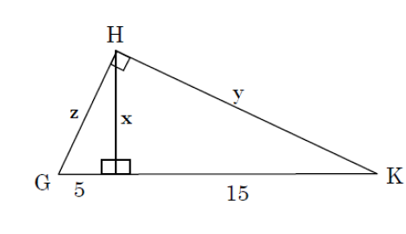

1)

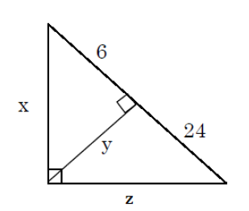

2)

**.**

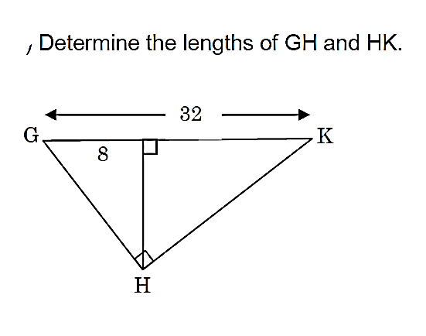**3)**

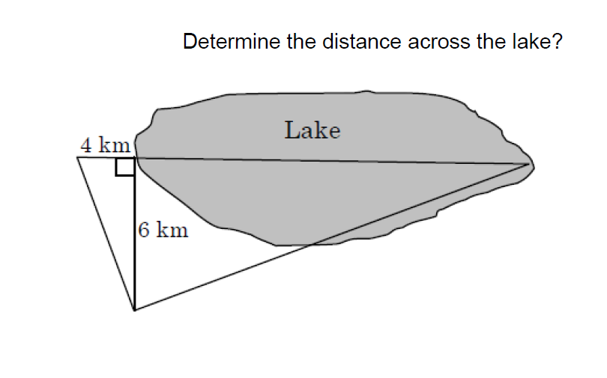

**4)**

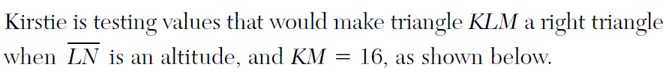

**5)**

