Name:__________________________ Date:_______________
GCC Geometry Unit #5 Day 8 Similarity and Dilations

- Graph the image of quadrilateral PQRS after D_{Origin, ½}

- Graph the image of quadrilateral PQRS after D_{(-6, 4), ½}
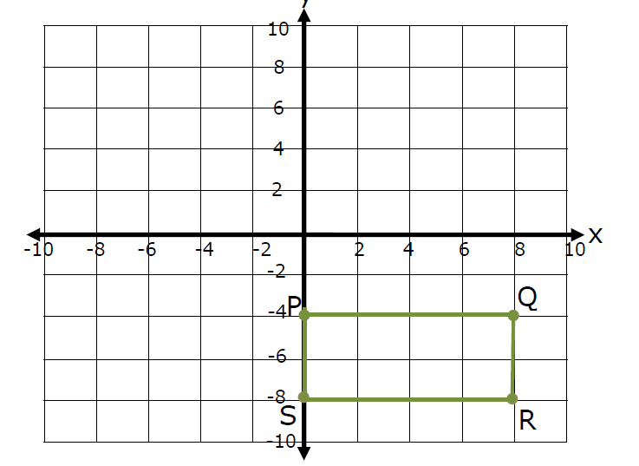

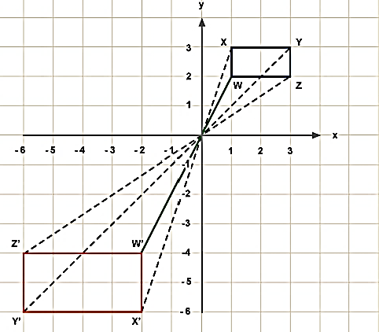
2) a) What is the scale factor of this dilation? _________
b) Rewrite with a positive scale factor as a
composition of transformations.
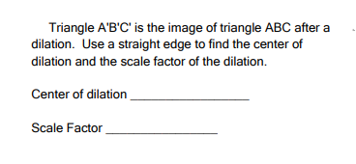
3)

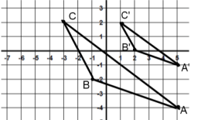

4) D(-3, -3) E(-3, 3) F(2,3) G(2,0)
a) Graph the image of quadrilateral DEFG after D_{Origin,3}
- Graph the image of quadrilateral DEFG after D_{Origin,-2}

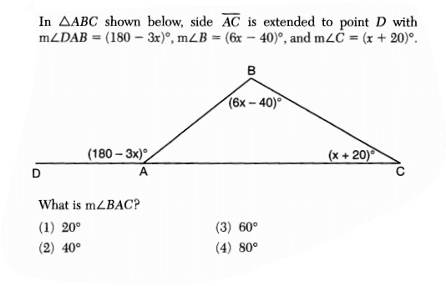
5)

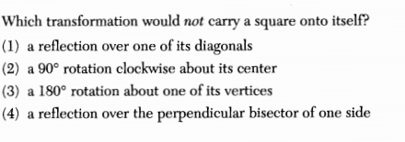
6)

