Name:_________________________ Date:_________________  
**ORGANIC MOLECULES NOTES**

**Carbohydrates**

Chemical formulae

|  |  |  |
| --- | --- | --- |
| Molecular Formula | Empirical formula | Structural Formula**recognize it |
| C6H12O6 | CH2O | Has a ___________________ |

**Composition and uses**

|  |  |  |  |
| --- | --- | --- | --- |
| **Elements Present** | **Used by organisms for** | | **Building Blocks** |
| Carbon  Hydrogen  Oxygen | _________  See starch and glycogen below | __________  See Chitin and cellulose below | _________________ (simple sugars  Ex: glucose THIS IS THE BODIES quick cheap energy supply |
| **Examples & Functions / Related terms & info**  _____________________ = 2 connected monosaccharides  Polysaccharide = __________ connected monosaccharides   * Starch – polysaccharide stored in plants used as energy reserve * Glycogen - ____________________________________________________________ * Chitin – makes up the exoskeleton (provides support) of arthropods which are invertebrates. * Cellulose – _____________________________________________________________   Names of carbohydrates usually end in _______ ex: | | | |

**Indicators**

Lugols iodine solution turns from ___________ to _________________ when ________________ is present.

Benedicts solution turns from _________ to ___________ when ____________ is present with the addition of heat.

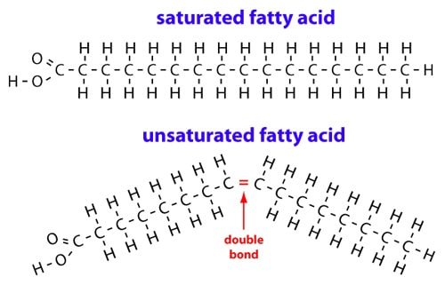

**Lipids**

**Composition and uses**

|  |  |  |  |  |  |
| --- | --- | --- | --- | --- | --- |
| **Elements Present** | | **Used by organisms for** | | **Types of Fats** | |
| Carbon  Hydrogen  Oxygen  NO SPECIFIC RATIO OF H:O | | Stored ________  See types of fats | Structure  & cell membrane | **Saturated fats**  All ___________ bonds C-C  _________ chain  Solid at room temperature  FATS  Mostly animals  **Unsaturated Fats**  Some _________ C=C bonds or triple bonds  _________ chain  Liquids at room temp  OILS  Mostly plant  **Cholesterol C27H46O**  Component of ______________ and _____________  **Triglycerides –_ _________** not used right away converted to this for ________ in fat cells | |
| **Building Blocks**  **Of Lipids**  Carboxyl Group = COOH    3 fatty acids    1 glycerol | | | |
| Uses explained | **THE CELL MEMBRANE** = ____________________________ = selectively permeable  Having the right amount of lipids aka “The Fat goldilocks theory”  __________________ of multiple _________ of fats each has role in how _______________ the gaps in the cell membrane are.  **Saturated fats =** tightly bonded TOO MUCH: TOO LITTLE:  **Unsaturated fats =** bent molecules TOO MUCH: TOO LITTLE:  **Cholesterol =** very large & takes up space TOO MUCH: TOO LITTLE:  BUT JUST RIGHT= combination of three types of fats that results in enough “gaps” to allow for ___________ crucial molecules (ie _______ and ________) to pass through but not larger bulky molecules (ie _________) **selectively permeable – only some stuff can pass through.** | | | |

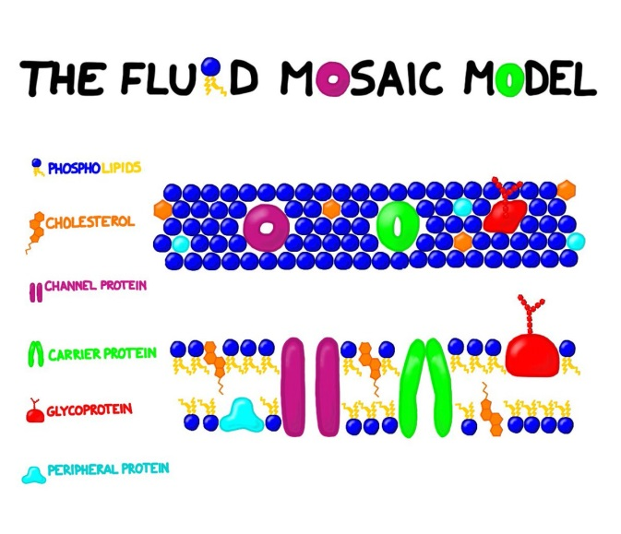

Side view / Cross section

Outside View

**ProteiNs**

|  |  |  |
| --- | --- | --- |
| **Elements Present** | **Used by organisms for** | **Related Terms & Info** |
| Carbon  Hydrogen  Oxygen  **_____________** | Structure and movement (muscles)  Enzymes  Antibodies  Hormones  Pigments | Peptide bond- bond between 2 Amino Acids  Dipeptide – 2 amino acids bonded  Polypeptide = long chanin of AA bonded |
| **Building Block= Amino Acids (AA)**  R= Side chain.. varies among amino acids    Related image | | |

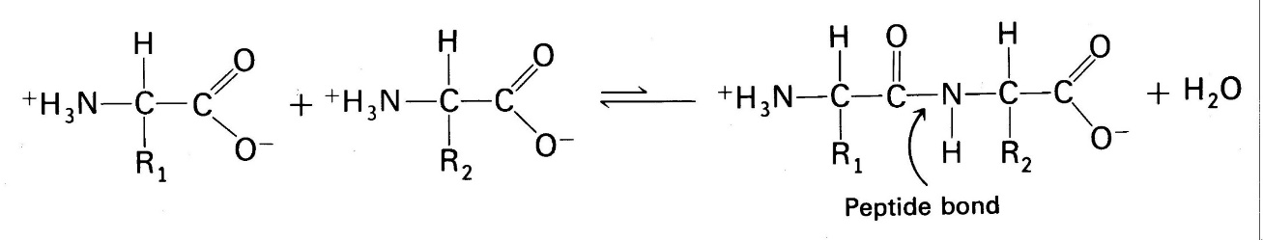**Making Proteins ... Dehydration Synthesis**

***Important proteins and functions:***

Enzymes- _____________________________________

Antibodies – __________________________________

Hormones – __________________ ____________ that affect _____________ in separate area of body

Muscle and Movement – component of all tissues and organs, provides higher and more sustained energy

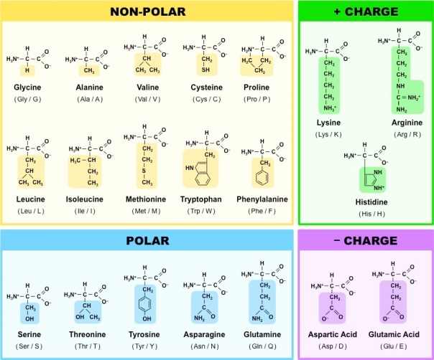*** Shape of the protein 🡪 Determines Function See next page

Other Information:

20 Amino Acids

9 essential amino acids = cannot be made by body.. must be ingested.

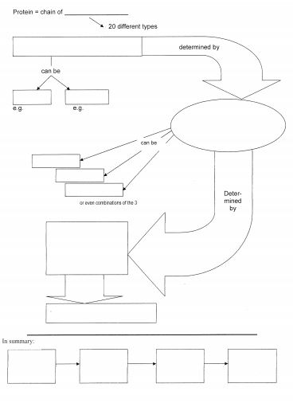

**Nucleic Acids**

Building block= ______________________________

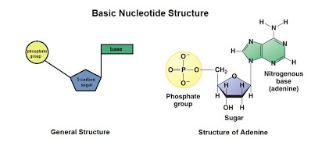

**Two Types:**

|  |  |  |
| --- | --- | --- |
|  | DNA | RNA |
| Full Name | Deoxyribonucleic acid | Ribonucleic acid |
| Basic Structure | 2 long twisting strands of nucleotides in the form of a __________________ | 1 Single strand of nucleotides |
| Nucleotide sugar | deoxyribose | Ribose |
| Notrogenous bases | Guanine (G)  Cytosine (C)  Adenine (A)  **Thymine (T)** | Guanine (G)  Cytosine (C)  Adenine (A)  **Uracil (U)** |
| Location in cell | Nucleus (the chromosomes) | Cytoplasm and ribosomes |
| Function |  |  |

