Name:____________________ Date:____________
Fossil Friday
Directions: Look at the fossils/pictures of fossils at each of the lab tables. Fill in the table below based on the information provided on the sticky notes and the geologic time scale provided.
Name of Fossil/Description | Age of the fossil (millions of years ago) The most recent age estimate | Geologic Time period | Fossil Type (mold, cast, petrified, fossil, amber or imprint)

In the last 5 minutes put any 5 of the fossils in relative dating order. Then answer the question on the back of the page.
Name of fossil and its period/relative age
_____________________________________________
_____________________________________________
_____________________________________________
_____________________________________________
_____________________________________________

- How does the geologic time scale show both relative and absolute dating?

__________________________________________________________________________________________________________________________________________________________________________________________________________________________________________________________________________________________________________________________________________________________________________________________________________________

- Choose two types of fossils and create a chart showing, the type of fossil, how they were formed and an example of each.

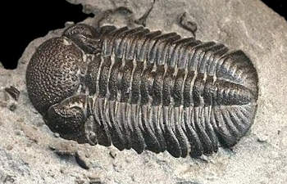
Trilobite fossil

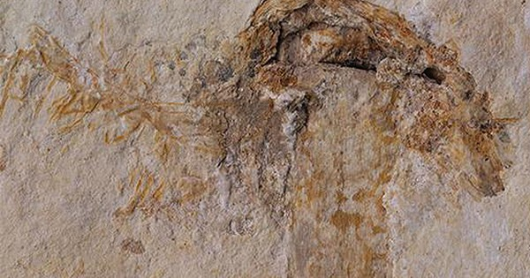
The first mushroom. It is hard to tell but the mushroom decayed and the rock has hollowed out.

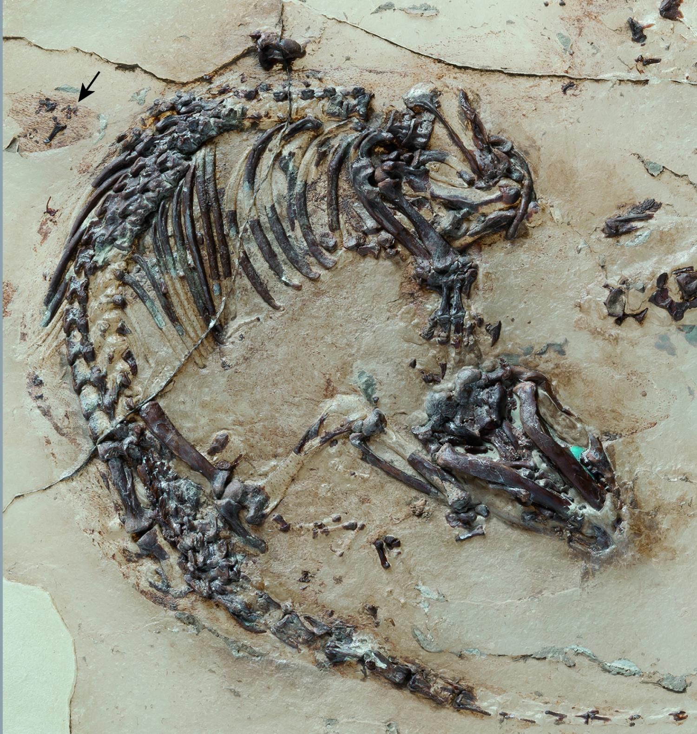
Say hello to your oldest mammal ancestor. Eomaia was a rodent that walked the earth with many large retiles like dinosaurs. Aren’t you so proud of your ancestor!

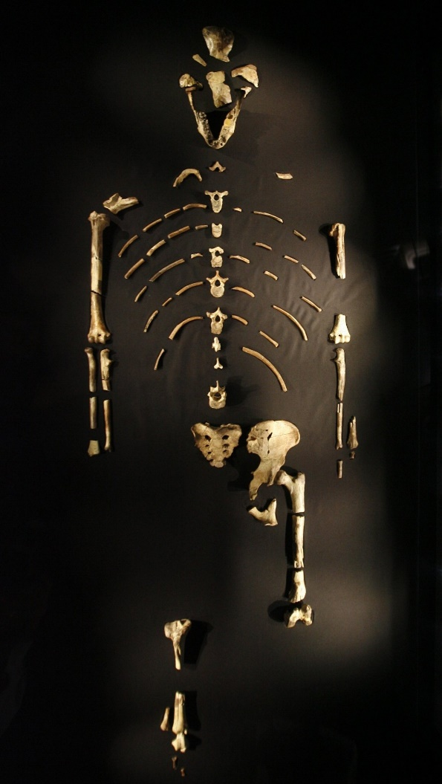
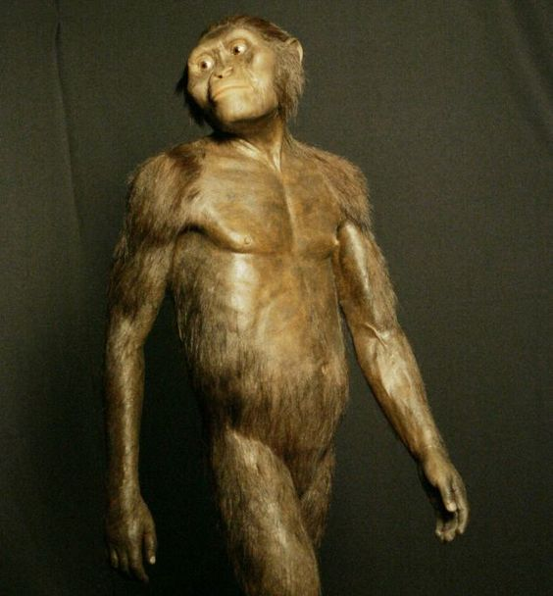
This is “Lucy” she is one of the earliest human species or Hominin species. The name of the species is Australopithecus afarensis.
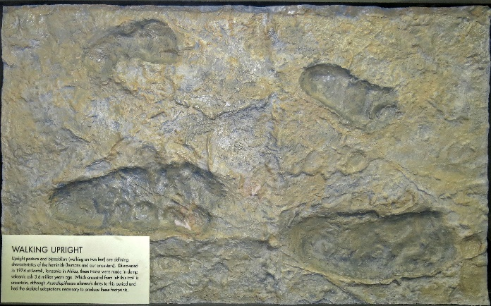

Here is a footprint of Australopithecus afarensis

