Persepolis: The Story of a Childhood, by Marjane Satrapi
Identity and Social Justice Unit
Ms. Kamrass
English 9
Essential Questions:
- Why is childhood an important time of life? When does it end?
- How do people cope when their lives are changed by forces they cannot control?
- Persepolis is a graphic novel. Why do you think Satrapi chose this genre to tell her story?
I. Literary terms:
mood – the effect of literature on the reader: it is usually controlled by imagery
allusion - in literature, an implied or indirect reference to a person, event, or thing or to a part of another text. Most allusions are based on the assumption that there is a body of knowledge that is shared by the author and the reader and that therefore the reader will understand the author's referent
dialogue – lines spoken by characters in a play, or in this case, a comic book
graphic novel – a full-length novel that presents serious subject matter in comic-book form.
A. Terms and Concepts for Graphic Novels
Layout
panel – a distinct segment of the comic, containing a combination of image and text in endless variety.
frame – the lines and borders that contain the panels.
gutter – the space between framed panels
foreground – the panel closest to the viewer
Figures - Faces can be portrayed in different ways. Some depict an actual person, others can represent an idea, or group of people.
Text - captions – these are boxes containing a variety of text elements. They can add narration, or describe the physical setting or the scene.
speech balloons – these enclose dialogue that comes from a specific speaker’s mouth. These can show external dialogue, or internal thoughts (usually represented by circles that lead to the balloon).
B. Other Terms Used in the Text, or that can Help with Analysis

historical context - reflects the time in which something takes place or was created and how that influences how you interpret it.

secular - of or pertaining to worldly things or to things that are not regarded as religious, spiritual, or sacred

theocracy - a form of government in which God or a deity is recognized as the supreme civil ruler, the God's or deity's laws being interpreted by the ecclesiastical authorities

The West – Countries in the western hemisphere including the United States, and Western Europe

HOMEWORK
II. Characters, Events and Allusions in the Text
Directions: In order to fully understand the events and references in Persepolis, you need to know about these important people, places, and ideas. You will research to find valid information about each of the terms listed below (1-5). For each, write down just a few sentences and the name of your source. Also, read through the rest of the terms so that you are prepared for reading.

- Persepolis –

- capitalism –

- socialism (or Marxism) –

- dialectical materialism –

- totalitarianism –

the Shah - (formerly, in Iran) king; sovereign. There were two, the original Shah’s son was overthrown in the 1979 Islamic Revolution.

Islamic Revolution – Iran 1979 – a state of revolt when the Iranian Shah was overthrown and an Islamic theocracy was put in place.

Zarathustra - 6th century b.c., Persian religious teacher.

Fidel Castro - A Cuban political leader of the twentieth century. He led the revolution that in 1959 overthrew the dictator of Cuba, who had the support of the United States. Castro then presided over his country's transformation into a communist state.

Che Guevara - Theoretician and tactician of guerrilla warfare and prominent figure in Fidel Castro's revolution in Cuba (1956–59).

Trotsky, Leon, 1879-1940, Russian Communist revolutionary, one of the principal leaders in the establishment of the USSR

Hossein Fatemi, PhD - was a famous politician of Iran, born in 1919 in Nain and was executed on 10 November 1954. He proposed the thesis of nationalization of Iranian oil and gas assets to Premiere Mossadegh

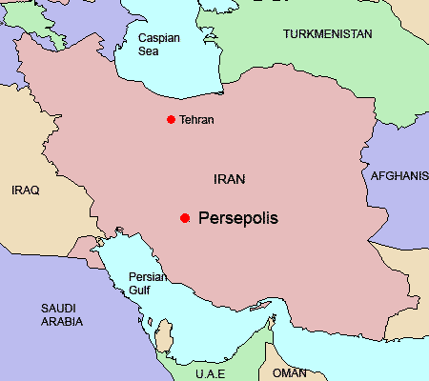

Write down any ideas or words that come to mind when you think about Iran.

Iran remains central in world affairs. It is a country with a controversial theocracy and a public that continues to stand up for individual freedoms.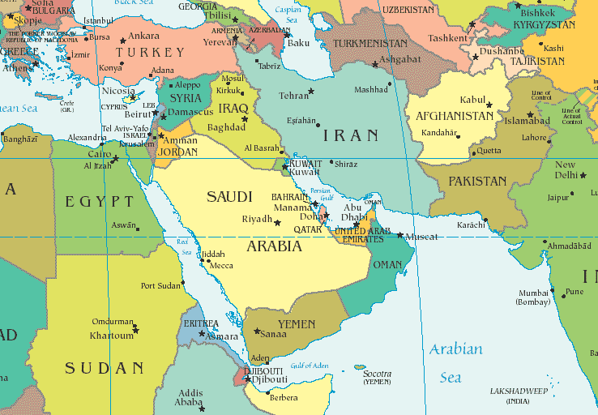
From: http://www.globalresearch.ca/coverStoryPictures2/25718.jpg

Persepolis Chapter Questions
“Introduction”
- According to the introduction, what stereotypical image is Satrapi trying to dispel?

- The author indicates two motives for writing Persepolis What are they?

“The Veil”
- How was education affected by the new regime? Why?

- What did the veil symbolize?

- What did bilingual schools represent to the new regime?

- How do women respond to the veil?

- Why was a picture of Marjane’s mother published in the newspaper? How did her mother respond? Why?

- Describe the symbolism and conflict represented in the picture on the top left of page 6.

- Why does Marji want to be a prophet? (3 reasons)

- Who is Zarathustra, and what are his three rules for living?

- How do others respond to Marji’s religious calling?

“The Bicycle”
- Who are Che Guevara, Fidel, and Trotsky? (Look them up!) Why are they important?

- How does Marji’s relationship with God begin to change?

- What happens at the Rex Cinema? What does the Shah say? What do Marjane’s parents know?

“The Water Cell”
- According to Marji, how was a king chosen? What was her rationale?

- Why did Marji’s parents react to her statement about the Shah (hint: her family history)?

- What was Marji’s grandfather’s job under Reza? How did his beliefs change, and how did his life change?

- Why does God return after a long absence?

“Persepolis”
- How did the new Shah’s rule compare to his father’s?

- Describe the symbolism of the image at the top of page 28.

- What did Marji’s father do every day that makes her mother so nervous? Why is this activity strictly forbidden?

“The Letter”
- What causes Marji to feel so ashamed? Why?

- How does Marji view Mehri? How does Mehri view Marji?

- What did Marji do for six months to help Mehri? Why?

- What is the outcome when the news of Mehri’s clandestine affair reaches Marji’s father? Why did it end up that way?

- What is Marji’s reaction to the break-up?

- What happened on Black Friday? Why? What painful lesson did Marji learn?

“The Party”
- How does the Shah attempt to appease the people? Why did he fail?

- How had the U.S. changed its public policy toward Iran?

- According to Marji’s dad, why will the Middle East never have peace? What do you think?

- What contributes to Marji’s anger and confusion when she returns to school?

- What two lessons does Marji learn from her mother?

“The Heroes”
- Where had Siamak and Mohsen been for the last several years? Why?

- Who led the training in torture practices?

- According to Marji, what makes a hero?

“Moscow”
- Who is Anoosh? How does Marji feel about him? Why?

- Who is Fereydoon? What was his goal?

- Where did Anoosh go after Fereydoon’s arrest? How would you characterize him?

- When he had to leave, where did he go?

- What does Anoosh study in the USSR?

- What gift does Anoosh give to Marji? What might it symbolize?

“The Sheep”
- What is the significance of the title? How does it help to characterize the people of Iran?

- According to Anoosh, why is it nearly impossible to persuade the population to follow Marxism?

- What was the reported outcome of the elections? How does Marji’s father explain these results?

- Why do Marji’s parents subject themselves to a political upheaval and refuse to leave Iran? What is their opinion of those who left?

- What makes Marji suspect that something has happened to Anoosh?

- What is Anoosh’s final wish? Why?

- Who comes to visit Marji after Anoosh’s death? What is Marji’s reaction?

“The Trip”
- What do the fundamentalist students do? How does this event affect Marji’s plans?

- Why does the new regime close the universities?

- What event causes Marji’s mom to take to her bed for several days?

- What does the illustration on pg. 77 reveal about Marji’s feelings about the vacation?

- What does Saddam Hussein do at the end of this chapter? Why?

- How does Marji feel about the new war?

“The F-14’s”
- Does Marji’s father intend to fight against the Iraqis? Why?

- What is humorous about the sequence at the bottom of pg 81?

- How does Marji reflect the common stereotypical thinking of other Iranians? How
does Marji’s dad cut through her propaganda induced thinking?

66. The last frame on page 81 reflects an idea about war: describe what the illustration seems to say.

67. What does Pardisse describe in her paper? How does Marji try to console her friend?
What is Pardisse’s response? What does Marji learn from this experience?

“The Jewels”
68 What is one of the ramifications of the nation’s political conflict?

69. What criticism does Marji’s mom make of capitalism? What confusing thing does she suggest as they leave the store?

70. Describe the symbolism in the picture at the bottom of page 89.

72. Besides their possessions, what else have refugee families lost?

“The Key”
73. What was the primary difference between the Iranian and Iraqi armies?

74. What might be the purpose of publishing Iran’s “martyrs”?

75. Comment on the picture on page 95.

76. Why was Marji’s generation so rebellious? What does the teacher blame?

77. What injustices do the parents see in the educational system? Which restriction is
particularly ironic?

79. Who does the government recruit to serve on the front lines of the war? How do they
persuade them? Can you think of another time when this practice has been used?

“The Wine”
81. How did the interior of their homes reflect the external changes that were occurring?
What two things did they need to protect themselves against?

82. What forbidden items did the government find at the house of Timoosh’s dad? What
was his punishment? When have you seen this in our country?

83. Why did Marji’s family continue to hold parties despite the danger?

84. Even though Mrs Nassrin’s comments on page 106 bring humor, how are her actions
also symbolic?

85. Name one violation that Marji’s dad is guilty of at the traffic stop. How does his wife
respond to the situation? What is a condition of their release?

86. What story does Marji’s grandmother use to stall the officers? What is she really
planning to do? Ultimately, how did they get rid of the officer?

“The Cigarette”
87. What did the local news report about the war? What does Marji realize about this information?

88 What was Marji’s motive for breaking her parents’ rules?

89. What was Marji’s destination? What was its reputation? How do you think it was able to survive the regime’s repression?

90. How would you describe the relationship between Marji and her mother?

91. Describe the efforts made toward bringing an end to the war between Iran and Iraq.

92. What was the motivation for launching an attack on Karbala?

93. What did the survival of the regime depend upon? What was the human cost of this
survival?

94. How did the regime become more repressive?

95. What was Marji’s symbolic act of rebellion? Describe her interesting response.

96. In what ways has Marji become an adult?

“The Passport”
97. What had become a bigger conflict than the war against Iraq? How does this manifest
itself?

98. How long were the borders of Iran closed?

100. What surprising philosophical comment does Marji make to her parents? What is your
reaction to her statement? (see page 119)

101. In front of the hospital, what request is made of the Iranian people? What is the double
meaning here?

102. People in need of hospital care face a dilemma: describe this problem.

103. How did the government delegate positions of power? Describe the encounter between
Marji’s aunt and the Minister of Health.

104. Where did many of the seriously wounded travel for treatment? Why is this ironic?

107. What is Taher’s only wish? What prevents him form realizing his dream? Ironically
what happens three weeks later?

“Kim Wilde”
108. When did Marji’s parents receive their passports? What was one provision listed?

109. What problem do Marji’s parents face as they return from their trip to Istanbul? How
does Marji’s mom show her ingenuity?

110. How does Marji’s reaction to the Kim Wilde poster reinforce an existing conflict?

111. How did Marji’s mother compare to other Iranian mothers? How does Marji’s
relationship with her mother seem to reflect typical parent-child issues?

112. How had Iran’s food shortage been resolved? What was appealing about Gandhi
Avenue?

113. What was the purpose of the Guardians of the Revolution? What happens when they
encounter Marji? How does Marji respond?

114. Why will Marji have to go before the Committee? What would happen there? How
does Marji avoid going before the Committee?

115. Analyze Marji’s behavior when she returns home.

“The Shabbat”
116. What was the new strategy? How does the author characterize Iranians? How does she
characterize her father? Her mother?

117. What did the sirens signify? What did Marji realize for the first time? What does this
show?

118. How does the picture on the top of page 137 reflect the mood? Where does Marji’s
only hope lie?

119. What motivated the Baba-Levy family to stay in Iran? Why is this so unusual? What
was Neda’s dream? What ultimately happens to her and her family?

120. What happened to Iran’s economy during the war? Is this unusual?

121. How does Marji’s mother attempt to protect her daughter? How does Marji discover
the truth? What does the last frame on page 142 reflect?

“The Dowry”
122. How did Marji’s life change after Neda’s death? How did she behave in school?

123. What did Satrapi learn about the government in her new school? How did she respond?

125. What happened to Niloufar? Why? How do you know? What is Marji’s reaction?

126. Where do Marji’s parents decide to send their daughter? Why? What is Marji’s
reaction?

127. What is her grandmother’s advice to her?

128. Who made up a large segment of those leaving the country?

129. What is Marji’s last memory of her parents before leaving?

