Name _______________________________ Date ____________________ Block _______________________________ America: An Immigrant Nation
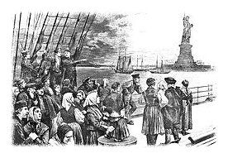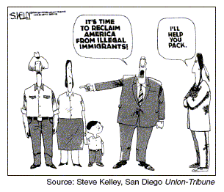
Essential Questions
- Why have people immigrated and continue to immigrate to the United States?
- How has the move to the United States been challenging for those who have immigrated?
- Why has there been a pattern of resentment and resistance by Americans towards immigrants?
- How has the political debate regarding immigration changed from the Gilded Age to today?

1st Word Wall (Gilded Age 1865- 1901)
Old Immigrants New Immigrants Push Immigration Pull Immigration
Ellis Island Naturalization The Know Nothing Party Emma Lazarus Poem
Steerage Ghettos Tenement Houses Assimilation Acculturation
Nativism Immigration Restriction League Xenophobia Chinese Exclusion Act
Hull House Jacob Riis Sweatshops Labor Unions Populist Party

Tasks: Answer the following in your notebooks.

- Compare where people moving to the United States came from during the Gilded Age to where people are moving from today.

- Research how many people have moved to the United States and from where between
  - 1800-1860
  - 1870- 1910
  - 1920- 1950
  - 1990- 2019

- Identify three reasons why people immigrated to the United States
  - During the Gilded Age (1865- 1901)
  - The last 30 years
  - Create a Venn diagram comparing parts a and b

2nd Word Wall
Gentlemen’s Agreement Literacy Tests Emergency Quota Act National Origins Acts (1924, 1927) Palmer Raids Sacco and Vanzetti Trial Ku Klux Klan Immigration Act of 1965 Immigration Control and Reform Act of 1986 Illegal Immigrants Post 9/11 Immigration Debate

- Create a visual on America: An Immigrant Nation

- Find a case study (individual story) about an immigrant’s move to the United States (then or now) and prepare to share that story in a small group.
  - Print and highlight
  - Take notes
  - Identify Source
  - Share

- Discuss how the move to the United States been challenging for those who have immigrated.
- Socially
- Economically
- Summarize an editorial which discusses the opposition to policies dealing with modern illegal immigration.
- Main Reasons
- Describe their supporting evidence
- Is there something they could add to their argument?
- What would an opposing viewpoint be to their position?

