Monopolies

Demand
Monopoly
Co s
t
Output
MR
What does this graph indicate about characteristics of monopolies?
Market Characteristics p. 571- 572 and Module #61- #63
- One seller per industry
- No Substitutes
- Significant barriers to entry
- Heterogeneous products since there are no close substitutes
- Price makers (P- MC)/P known as the Lerner Index
- Complete Barriers to Entry by definition
    - Ownership of resources
    - Economies of scale (natural monopoly)
    - Political restrictions- (regulated monopoly- fair rate of return)
    - Cartels-
- Monopolies create dead weight loss
- Long run economic profits exist
- P>MC
- P>MR
- Monopolists face downward sloping demand curve
- MC=MR for profit maximization
- Know how to graph
  - Total Revenue
  - Total costs
  - Profit Maximization
  - Monopoly Profit and Losses
  - Effects of a monopoly on an industry
  - Consumer Surplus
  - Deadweight Loss

When can a firm participate in price discrimination?
Can price differentiation ever benefit society?

What do monopolists do?
- Maximize profit at the optimal level of output (MC=MR)
- Control supply, but not demand
- Misallocate resources
- Receive rent- receive more than they contributed to production
- Reduce Consumer Surplus
- Create Deadweight Loss- resources that could have been used to produce other economic goods/services are completely lost to society
- 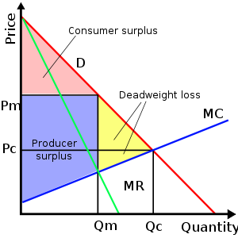

- Monopolies Can Practice Price Discrimination
- Separate markets for consumers based on different price elasticities of demand.
  - If you have higher price elasticity you have more substitute choices
  - If you have lower price elasticity you have fewer substitute choices
  - Firms must be able to face different markets at a reasonable cost
    - checking age for senior citizens discounts
    - checking student IDs for special theater prices
- No opportunities for resale
- Price differences are not based on cost differences
- Firm does face a downward demand curve, but they are still price makers trying to realize more profits.

