Name ______________________________________ Women’s Suffrage Notes

(The National Woman Suffrage Association)

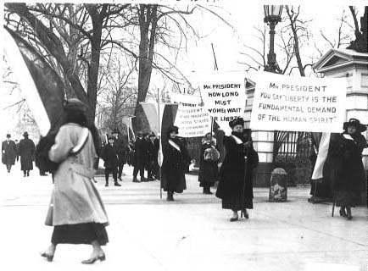
NAWSA was founded in 1869, but by the 1890's it became the most mainstream and nationally seen pro-suffrage group. The strategy of this association was to push for suffrage at the state level, believing that state-by-state support would eventually force the federal government to ratify an amendment granting women the right to vote.. NAWSA represented millions of women and acted as the parent organization of hundreds of smaller local and state groups. NAWSA held and also participated in huge suffrage parades, and held major annual conventions that helped to keep its members determined.
**Details on this topic can be found in the textbook on pages 283-284, and 855-856
Key People:
- Carrie Chapman Catt- She was a women's suffrage leader who campaigned for the 19th Amendment to the U.S Constitution, which gave U.S. women the right to vote in 1920. She served as president of NAWSA, and was the founder of the League of Women Voters and the International Alliance of Women.

- Alice Paul- She was an American suffragist and activist. She led a successful campaign for women's suffrage along with others that resulted in the passage of the 19th Amendment in the U.S Constitution in 1920.

- Jeanette Rankin- She was the first woman in the U.S Congress. She was elected in Montana in 1916 and again in 1940. She was elected in congress 4 years before women got the right to vote.
Background
- Only one State (New Jersey) initially gave women the right to vote. That right was revoked in 1807
- Seneca Falls Convention- 1848
  - Elizabeth Cady Stanton, Lucrietia Mott, Frederick Douglass
  - Declaration of Sentiments (Modeled after Declaration of Independence)
  - http://ecssba.rutgers.edu/docs/seneca.html (primary source document)
15th Amendment (one of the reconstruction amendments) did not include gender
Emergence of Susan B. Anthony- https://susanbanthonyhouse.org/her-story/biography.php#suff
- started “The Revolution” Newspaper in 1866
- arrested for voting in 1872
- Involved in the Temperance Movement
- Became President of NAWSA in the 1890s
Women were getting the right to vote in Western States after the Civil War
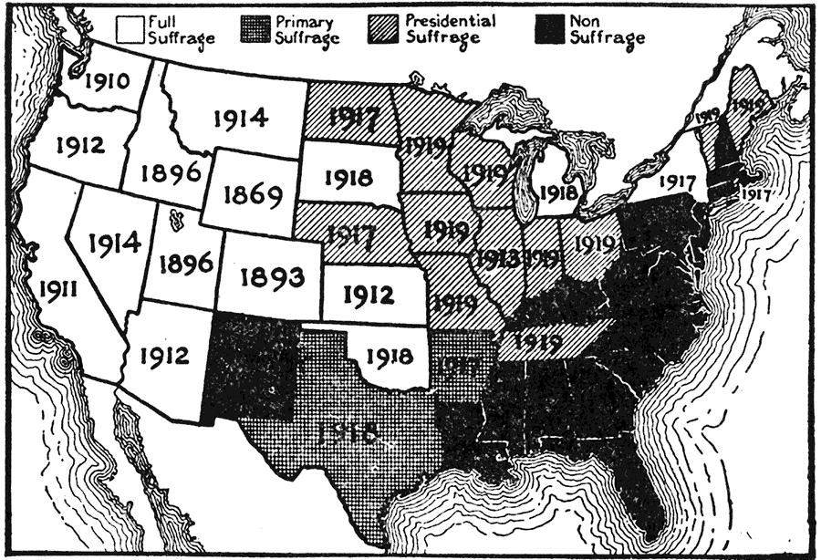

Progressive Era Events and Questions
- Would the Triangle Shirtwaist Factory Fire have occurred if women had the right to vote?
- Other Female Activists
  - Jane Addams- Hull House- helping New Immigrants Assimilate
  - Ida Tarbell- Journalists whose muckraking brought down the Standard Oil Monopoly
  - Ida B. Wells- fighting for African American rights, Anti- Lynching Campaign, Co- Founder NAACP
  - Margaret Sanger-Planned Parenthood
  - Carrie Nation- Temperance Movement (led to 18th Amendment)
President Wilson Resisted and Tried to Ignore NAWSA but ……….
The 19th Amendment was finally ratified in 1920!
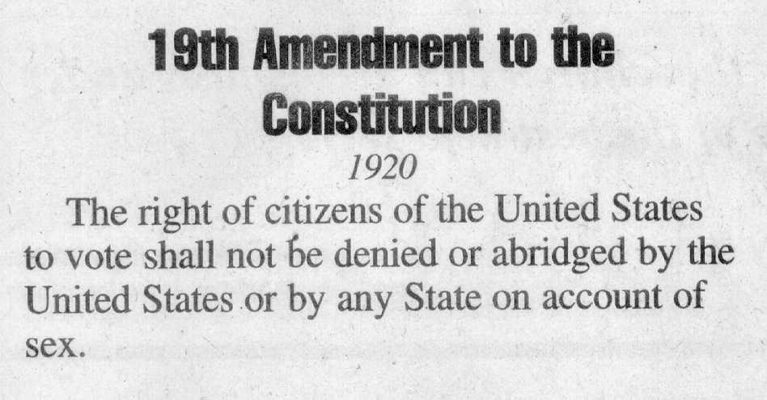

Long Term Impact
- 1920s- Flappers
- 1930s- Frances Perkins (1st female Cabinet member), Dorothea Lange (photographer)
- 1940s- “Rosie the Riveter” (WW2). Eleanor Roosevelt (UN- Declaration of Human Rights)
- 1950s- Rosa Parks, women staying in the workforce
- 1960s- Betty Friednan (The Feminine Mystique) and Gloria Steinham (Ms. Magazine), Rachel Carson (Environemntalist)- “Silent Spring”
- 1970s- National Organization of Women (NOW), Title IX (girls sports in schools), failed ERA, Roe vs Wade (right to privacy)
- 1980s- Geraldine Ferraro- 1st female Vice Presidential Candidate, Sandra Day O’Connor 1st female Supreme Court Justice
- 1990s- Madeline Albright- 1st Female Secretary of State, Janet Reno- 1st female Attorney General
- 2000s- Hillary Clinton’s Primary Campaign in 2008, Equal Pay Fight Continues, More Women in college than men, Nancy Pelosi- 1st female Speaker of the House of Representatives

Helpful links:
1.) http://www.britannica.com/EBchecked/topic/404319/National-American-Woman-Suffrage-Association-NAWSA
2.) http://www.u-s-history.com/pages/h1594.html
3.) http://www.timetoast.com/timelines/88800

