Name _______________________________ America: An Immigrant Nation Worksheet

- Compare where people moving to the United States came from during the Gilded Age to where people are moving from today.
Gilded Age Immigrants | Modern Day Immigrants

- How many people have moved to the United States and from where between

Website Used: _______________________________________________________________

  - 1800-1820 ____________________________________

  - 1890- 1910 ___________________________________

  - 1920- 1940 ___________________________________

  - 1995- 2015 ___________________________________

- Identify three reasons why people immigrated to the United States
Gilded Age Immigrants | Modern Day Immigrants

Common Reasons: _______________________________________________________________
- Discuss how the move to the United States been challenging for those who have immigrated.
Socially | Economically

- Find a case study (individual story) about an immigrant’s move to the United States (then or now) and prepare to share that story in a small group.

  - Source: __________________________________________________

  - From Where?_____________________________________________

  - Reasons for Moving:

  - Challenges Faced:

  - Other Interesting Parts:

- Immigration Policy Editorial: Source _______________________________________________
  - Main Reasons

  - Describe their supporting evidence

  - Is there something they could add to their argument?

  - What would an opposing viewpoint be to their position?
Name ____________________________ Date __________________________
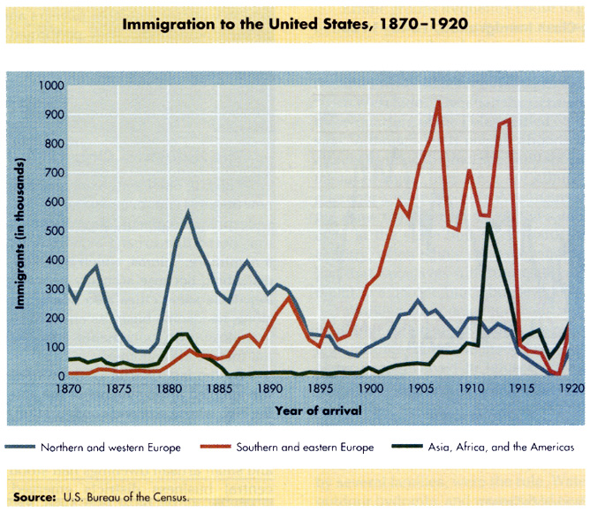

- From what area did most immigrants mover from in 1885? In 1905? ____________________________________________________________________________________________________________________________________________________________

- Around which year did Asian immigration first drop dramatically? _________________________

- Why did immigration rates skyrocket during the Gilded Age? __________________________________________________________________________________________________________________________________________________________________________________________________________________________________________

- Why did immigration among some groups drop significantly? __________________________________________________________________________________________________________________________________________________________________________________________________________________________________________

Name _______________________________ Date ___________________________
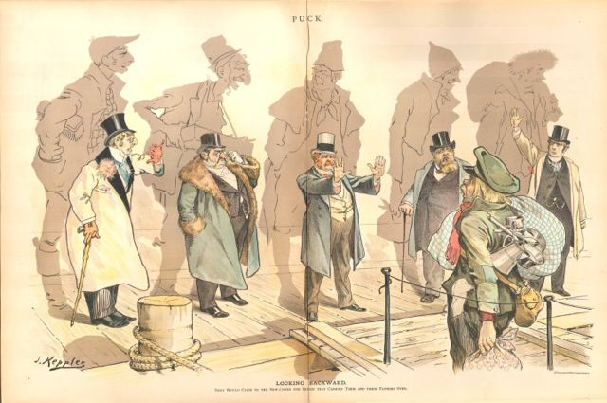

- Whom do you believe the man on the right represents? ________________________________

- Whom do you believe the men on the dock represent? ________________________________

- Where in New York City might this interaction be taking place? __________________________

- Why do you believe the political cartoonist drew the shadows of the men on the dock? __________________________________________________________________________________________________________________________________________________________________________________________________________________________________________

- What can you infer about the political cartoonist’s opinion on nativism from this illustration? (Be Specific) __________________________________________________________________________________________________________________________________________________________________________________________________________________________________________

- Create an appropriate title for this cartoon based upon your given answers

