DistanceBetweenPoints.docx Computer Science - Haas
Write a JavaScript program to find the distance between a set of two y,x points. Round your answer to 4 decimal places.
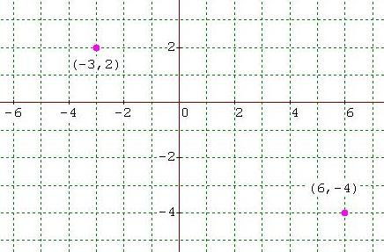

Example:
Computer >> Enter the first x value:
User>> -3
Computer >> Enter the first y value:
User>> 2
Computer >> Enter the second x value:
User>> 6
Computer >> Enter the second y value:
User>> -4
Computer >> The distance between (-3,2) and (6,-4) is 10.8167
Note that your output should restate the points entered and the distance between them rounded to four decimal places.
Show Haas and save as LastNameDistanceBetweenPoints.

