MakeChange Computer Science - Haas

Write a JavaScript program to find the least number of quarters, dimes, nickels, and pennies needed to add up to a given amount of money.
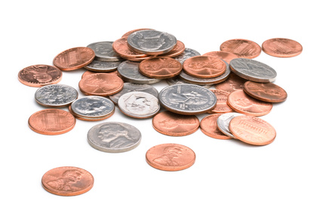
Example:

Computer >> Enter an amount of money.
User>> 2.43
Computer>> $2.43 is equal to the following. Quarters: 9, Dimes: 1, Nickels: 1, Pennies: 3

Make sure your program works for a variety of input!!! See below:

Amount $5.67 quarters = 22, dimes = 1, nickels = 1, pennies = 2
Amount $9.62 quarters = 38, dimes = 1, nickels = 0, pennies = 2
Amount $5.55 quarters = 22, dimes = 0, nickels = 1, pennies = 0

HINT: JavaScript does funny things when representing decimal numbers. To get your program to work properly you might consider multiplying the initial amount entered by 100 to convert it from dollars to cents. For example: $2.34 x 100 = 234 cents. You may also need to use one or more of the math functions below to get your program to work.
- Math.ceil(x)
- Math.floor(x)
- Math.round(x)

Show Haas and save as LastNameMakeChange.

