PennyDoubled

There is a math puzzler that goes something like this…

You are given a choice of getting one million dollars right now, or for the next 30 days getting paid as follows; 1 penny the first day, 2 pennies the second day, 4 pennies the third day, 8 pennies the fourth day, 16 pennies of the sixth day, and so on… doubling every day for the 30 days. Which would you choose?

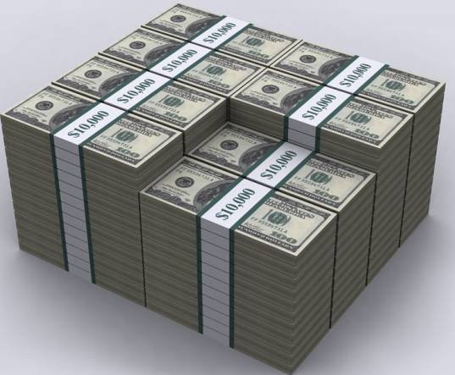

Choice of $1,000,000 -or- Day 1, Pay $0.01, Total $0.01
Day 2, Pay $0.02, Total $0.03
Day 3, Pay $0.04, Total $0.07
Day 4, Pay $0.08, Total $0.15
Day 5, Pay $0.16, Total $0.31
Day 6, Pay $0.32, Total $0.63
and so on for 30 days…

Assignment:

Assume that for the next 30 days you are getting paid as follows; 1 penny the first day, 2 pennies the second day, 4 pennies the third day, 8 pennies the fourth day, and so on…

Write a JavaScript program which uses a for-loop to print out the day, the amount of money paid on that day, and the total amount paid (the sum of the current day and all previous days).

Your program output should look like the one above except it should continue up to day 30.

Show Haas the working program and save as: LastNamePennyDoubled.

