ReplaceCharacterBlock.docx Computer Science I --- Haas

Assignment:

Make a reporter block that takes two letters and a sentence as input parameters.

It reports a new sentence which is the original sentence where the first character is replaced by the given new character.

Example:
In the sentence I like green eggs and ham, all of the ‘e’s are replaced with ‘x’s.
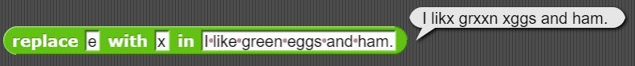

Below is a super big hint!!! You just need to complete two lines of code!!!
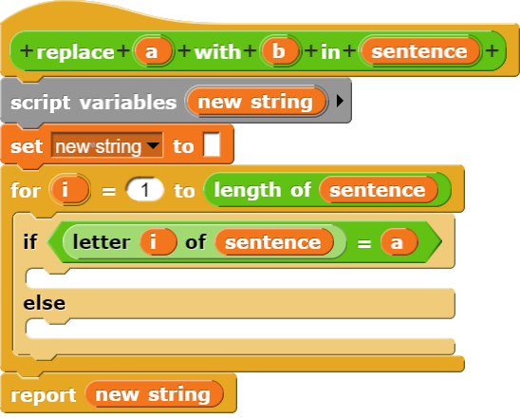

Save as ReplaceCharacterBlock and show Haas the working program.

