ShiftCode Haas Computer Science

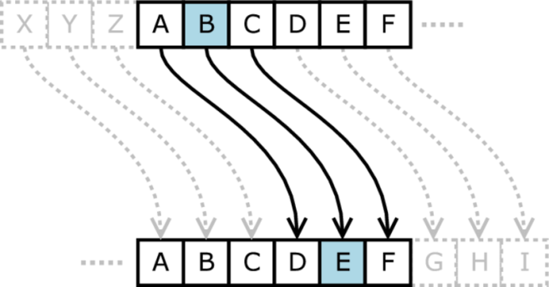
Write a JavaScript program to implement Caesar's cipher.
In cryptography the shift code, or Caesar cipher, is one of the simplest and most widely known encryption techniques. It is a type of substitution cipher in which each letter in the text is replaced by a letter some fixed number of positions down the alphabet. For example, with a shift of 3, ‘A’ would be replaced by ‘D’, ‘B’ would become ‘E’, and so on. The method was used by Julius Caesar to communicate with his generals.
The encryption step performed by a Caesar cipher is often incorporated as part of more complex schemes today.
To help keep it simple you can assume the following:
- The user will only enter a message with uppercase letters and spaces.
- Spaces do not get shifted.
- The user will only enter shift amounts between 1 and 26.
Check out a video of the running program: https://youtu.be/dsINoNyLrB0
Example:
Computer >> Enter a sentence:
User>> I LIKE PIZZA
Computer>> Enter the shift distance:
User>> 3
Computer>> Sentence: I LIKE PIZZA
Shift distance: 3
Result: L OLNH SLCCD

On the next page is some code to get you started.

<HTML>
<head>
<title>Shift Code </title>
</head>
<body>
<script language = "JavaScript">

// Here are some variables that you might need.
var shifted = ""; // The resulting shifted message.
var letter; // one letter at a time of the original message.
var position; // the position of the letter in the alphabet
var alphabet = "ABCDEFGHIJKLMNOPQRSTUVWXYZ";

var sentence = prompt("Enter sentence:","I LIKE PIZZA").toUpperCase();
var shiftBy = Number(prompt("Enter shift amount","3"));

// <<< Complete the code >>>

document.write("<br>Sentence: " + sentence);
document.write("<br>Shift distance: " + shiftBy);
document.write("<br>Result: " + shifted);
</script>
</body>
</HTML>

