SleepTime Computer Science - Haas

Most people do not get enough sleep! Do you?

Lack of sleep can have many negative consequences. See below.
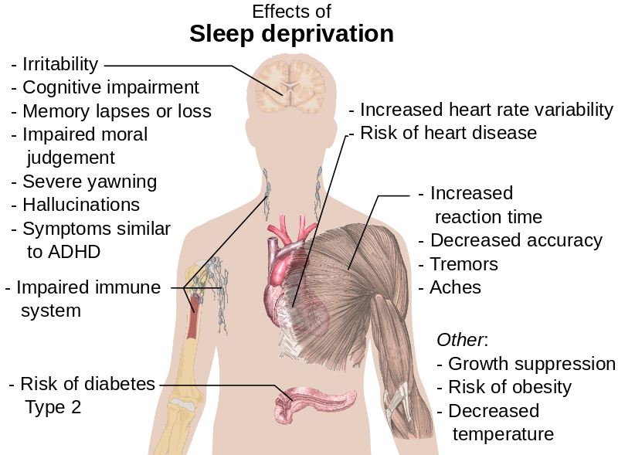
Write a JavaScript program to determine if someone is sleeping the recommended number of hours. Use the information below as a guide.

1) Prompt the user for their age, and how many hours of sleep they get per night on average.

2) Then inform them if they are getting more, less, or the recommended number of hours of sleep.

Sleep recommendations for age groups 3 and up.
- Preschoolers (ages 3 to 5): 10 to 13 hours.
- School-age children (ages 6 to 13): 9 to 11 hours.
- Teenagers (ages 14 to 17): 8 to 10 hours.
- Adults (ages 18 to 64): 7 to 9 hours.
- Older adults (ages 65 and older): 7 to 8 hours.

If someone enters an age less than 3 you should tell them that they are too young to use this program. Also, make sure your program works if the user enters decimal numbers like 5.5 for age, or 13.25 for sleep amount. Also, consider how age is usually rounded – someone who is 5 and ¾ years old is still 5!

Test your program thoroughly!!!!
Run it on all examples on the next page.

Example 1:
Computer> Enter your age.
User> 2
Computer> Enter the number of hours of sleep you get per night.
User> 10
Computer> You are too young to use this program!

Example 2:
Computer> Enter your age.
User> 5.75
Computer> Enter the number of hours of sleep you get per night.
User> 9.5
Computer> That's not enough sleep!

Example 3:
Computer> Enter your age.
User> 13.5
Computer> Enter the number of hours of sleep you get per night.
User> 10.5
Computer> You are getting the recommended amount of sleep. Good for you!

Example 4:
Computer> Enter your age.
User> 18
Computer> Enter the number of hours of sleep you get per night.
User> 9.25
Computer> That's too much sleep!

Example 5:
Computer> Enter your age.
User> 6
Computer> Enter the number of hours of sleep you get per night.
User> 8.75
Computer> That's not enough sleep!

Example 6:
Computer> Enter your age.
User> 64.9
Computer> Enter the number of hours of sleep you get per night.
User> 9
Computer> You are getting the recommended amount of sleep. Good for you!

