hotDogRolls Computer Science - Haas

Let’s assume that your favorite hot dog brand comes in packages of 10 and that hot dog buns are in packages of 8.
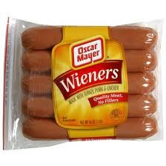

Write a JavaScript program to calculate the number of packages of hot dog rolls needed for any number of packages of hot dogs. It is OK to have some rolls left over, but be sure to tell the user how many extra rolls they will have.

Again - Assume that hot dogs come in packages of 10, and rolls are in packages of 8.

For the given number of hot dog packages your program must tell the user:
- the total number of hot dogs
- the number of bags of rolls needed
- the total number of rolls
- the number of rolls left over

Example:

Computer >> How many packages of hot dogs do you need?

User>> 3

Computer>> 3 packs of hot dogs is 30 hot dogs. You need 4 bags of rolls which
is 32 rolls. So you will have 2 rolls left over.

Test out you program for different numbers of hot dog packs to make sure it works!!!

Show Haas the program and save as LastNameHotDogRolls.

