kaleidoscope Computer Science I --- Haas

Kaleidoscope Assignment Part 1

Your job is to make a kaleidoscope, like this: https://youtu.be/UXDzeEDAHT4
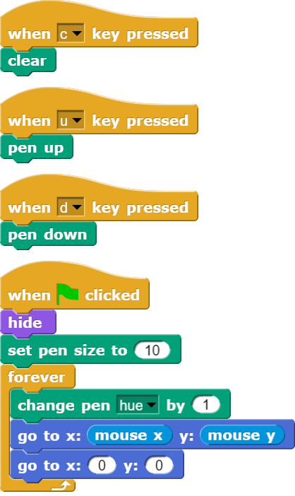
Use the script below as a starting point:

Save as Kaleidoscope1 and show Haas the working program.

Kaleidoscope Assignment Part 2

Now make an even cooler version of your kaleidoscope. Check out the video below!

https://youtu.be/KghyU4f2BZ0

If you need another hint with kaleidoscope assignment part 2 – watch the video below.

https://youtu.be/qZZXaimqgEI

Save as Kaleidoscope2 and show Haas the working program.

