Operations Name_______________________
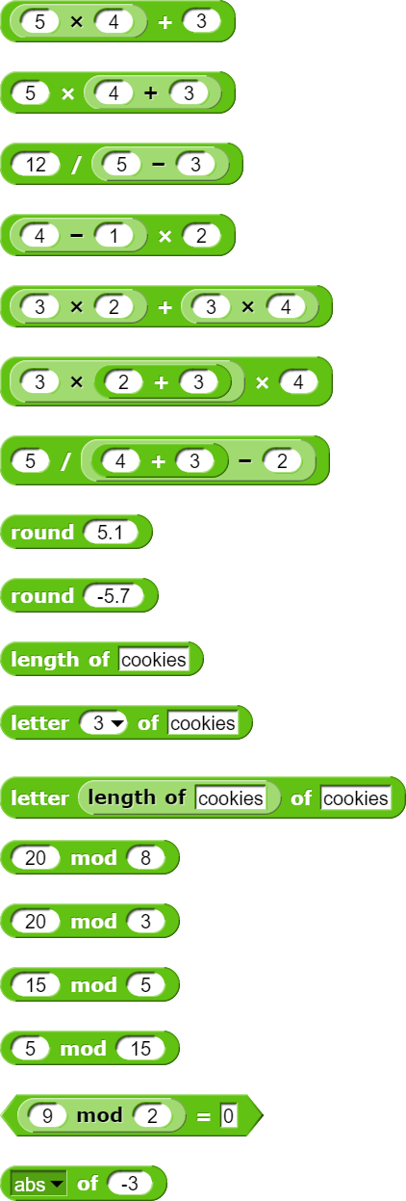
Without using Snap, figure out what you expect each of these expressions to report. Then check your answers using Snap! Show Haas your solutions!

