Caroline Aurigemma 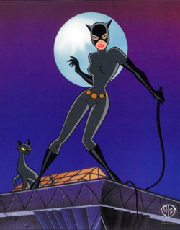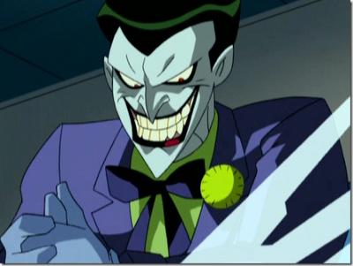
VS.

I chose these pictures because I feel that in this part of the play, we don’t know which family is good or bad. I am assuming that they both are annoying each other, so “bad”.

I like to think that they are the same. That is why I chose this picture. Because the Joker, and Cat woman are both villains that try to kill their enemy. This is basically what is going on in the play.

