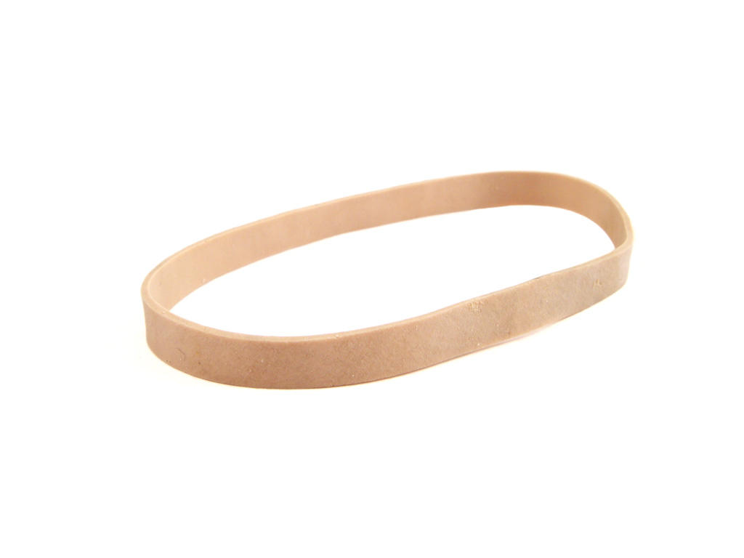
Karma Lama
I have picked a rubber band for act 3 scene 3. I have picked a rubber band because I feel that it represents Romeo and Julia’s love for each other. Their love and only stretch so much that it will eventually snap and they may just forget about each other. An example of the rubber band stretching is Romeo getting exiled. Romeo getting exiled shows that their love is being torn apart in a big way.

