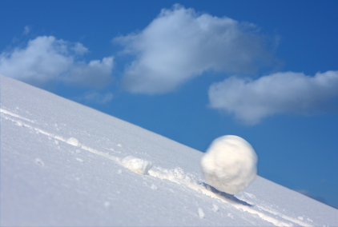

In act 3, Scene 1, the hatred and rivalry between the Montagues and Capulets "snowballs" and grows to immense proportions. This new hatred comes with the deaths of Mercutio and Tybalt. In my picture to represent this portion of the play, I had a snowball rolling down a mountain, I feel this represents the deteriorating relationship between the two feuding families. In act 3, Scene 1 Tybalt kills Mercutio, then is later killed by a furious Romeo. I feel the snowball picture represents this situation well because as the ball rolls down the mountain, it grows, and as the story progresses, the hatred between the Montagues and Capulets increase. Just as a snowball will continue to roll down a mountain once pushed, the relationship between these two families will continue to "go downhill." Also the actions within the scene can be easily compared to this same image i previously mentioned. Tybalt initiates and provokes Mercutio (this would be when the now small snow ball is first pushed.) Soon after, while in a duel Mercutio is killed by Tybalt (this would be the size of the ball increasing,) then, Romeo avenges Mercutio and kills Tybalt(once again increasing the size of the ball.) The on part of the "equation" that is missing is the halting of the snowball, although it has been hinted toward, I wonder what it would take to stop this feud.

