Name _________________________

Unit 3 Document-Based Question

Discuss the 17th C theories about the origin of government power and the rights and duties of the citizens and the government. Explain how these theories reflect the political opinions and events of 17th C England.

Do the best you can! You may use this area to plan!

Document 1

Source: James I, Speech before Parliament, 1609

“The state of monarchy is the supremest thing upon earth; for kings are not only God’s lieutenants upon earth, and sit upon God’s throne, but even by God Himself they are called gods… they may make and unmake their subjects, they have power of raising and casting down, of life and death, judges over all their subjects and in all causes and yet accountable to none but God only.”

Document 2
Source: The Political Testament, Cardinal Richelieu, 1638

“Those nobles who fail to serve the crown constantly and courageously with both their swords and their lives, as the laws of the state require, deserve the loss of the privileges of their birth and should be reduced to sharing the burdens of the common people. All students of politics agree that when the common people are too well off it is impossible to keep them peaceable. Many princes have lost their countries and ruined their subjects by failing to maintain sufficient military forces for their protection, fearing to tax them too heavily. The public interest ought to be the sole objective of the prince and his councilors.”

Document 3
Source: Cover of Leviathan, Thomas Hobbes, 1651
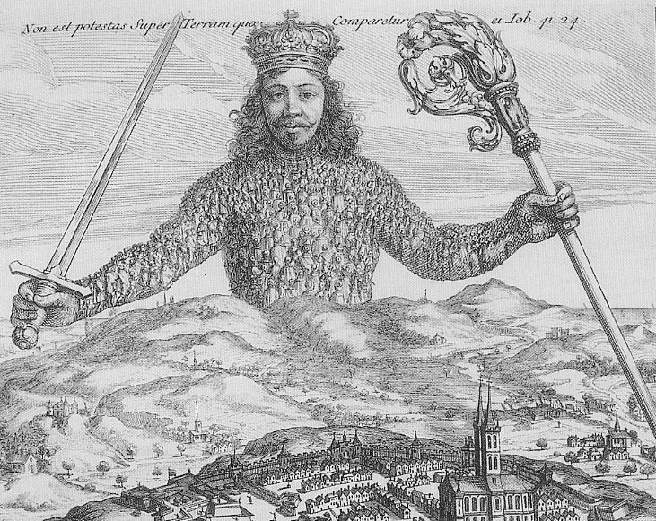

Document 4
Source: Leviathan, Thomas Hobbes, 1651

“The only way to erect such a common power, as may be able to defend them [the people] from the invasion of foreigners, and the injuries of one another, and thereby to secure them in such sort, as that by their own industry, and by the fruits of the earth, they may nourish themselves and live contentedly; is to confer all their power and strength upon one man, or upon one assembly of men… there can happen no breaking of covenant (contract) on the part of the sovereign; and consequently none of his subjects, by any pretense of forfeiture (a break), can be freed from his subjugation…”

Document 5
Source: Lenten Sermons, Bishop Jacques Bossuet, circa 1660

“Princes are gods and participate somehow in divine independence… There is only God who may judge over their judgments and their persons… The prince may correct himself when he knows that he has done evil, but against his authority there is no remedy other than his own authority… The prince as prince is not regarded as an individual; he is a public personage… Let God withdraw His hand, and the world will fall into nothing; let authority cease in the realm, and all will be in confusion.”

Document 6
Source: Two Treatises on Civil Government, John Locke, 1690

“A man…cannot subject himself to the arbitrary power of another; and having, in the state of Nature, no arbitrary power over the life, liberty, or possession of another, but only so much as the law of Nature gave him for the preservation of himself and the rest of mankind, this is all he doth, or can give up to the commonwealth, and by it to the legislative power, so that the legislative can have no more than this. Their power in the utmost bounds of it is limited to the public good of society. It is a power that hath no other end but preservation, and therefore can never have a right to destroy, enslave, or designedly to impoverish the subjects…”

Document 7

Source: English Bill of Rights 1689

An Act Declaring the Rights and Liberties of the Subject and Settling the Succession of the Crown
….Whereas the late King James the Second, by the assistance of diverse evil counsellors, judges and ministers employed by him, did endeavour to subvert and extirpate (destroy) the Protestant religion and the laws and liberties of this kingdom;
- By assuming and exercising a power of dispensing with and suspending of laws and the execution of laws without consent of Parliament; ….
- By raising and keeping a standing army within this kingdom in time of peace without consent of Parliament, and quartering soldiers contrary to law; …
- By causing several good subjects being Protestants to be disarmed at the same time when papists were both armed and employed contrary to law; …
- By violating the freedom of election of members to serve in Parliament; ….
- And excessive fines have been imposed;
- And illegal and cruel punishments inflicted; ….
- All which are utterly and directly contrary to the known laws and statutes and freedom of this realm;

