## **Definition of Concession**

Concession is a literary device used in argumentative writing, where one acknowledges a point made by one’s opponent. It allows for different opinions and approaches toward an issue, indicating an understanding of what causes the actual debate or controversy. It demonstrates that the writer is a mature thinker, and has considered the issue from all angles.

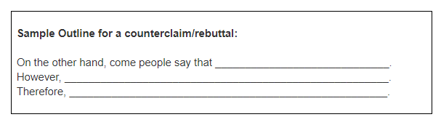

**Counter Argument Sentence Starters…**

* *Some will say that (my thesis) is not true because…*
* *Some people might say that…*
* *Some will argue…*
* *Those on the other side of the issue may say that.*
* *It’s true that…*
* *While it is true that…*
* *Admittedly…*

**Concession and Rebuttal Sentence Starters…**

* *That is not the case. As we see (bring up new evidence)…*
* *While that may be the case, (my thesis) is still true because…*
* *That point is true, but it is unimportant because…*
* *Nevertheless, my point still stands because…*
* *However, that point is not important because…*
* *Transition words: but, yet, however, nevertheless, still*

***Using Counterarguments in Writing***

***Counterargument:***

*A counterargument is an argument (point/reason/view/evidence) that your opponent would make*

***Rebuttal:***

*A rebuttal is when you respond directly to your opponent’s argument/point to explain/show how/why they are wrong*

