Foreshortening
The reason why foreshortening is so difficult to grasp is that people tend to draw what their mind tells them is correct [that a head is always bigger than a hand],not what they see [that when a hand is closer to the viewer than a head, the hand is larger]. But when you have become accustomed to drawing what you see, regardless of how extraordinary it appears ,foreshortening should come to you more easily and add a new dimension to your work. The following tips should help you to be more at ease with foreshortening: Don't be afraid of poses in which the model is foreshortened; before you start drawing, mark out a large box in your sketchbook to create a frame in which to work, and control your sketch; then carefully study the figure, and roughly divide it into sections. Decide which section is closest to you and which is furthest away, then mark their positions in the box; it is a good idea at this stage to use the pencil and thumb measuring technique to gauge the size of these two extreme sections of the body, in relation to each other.

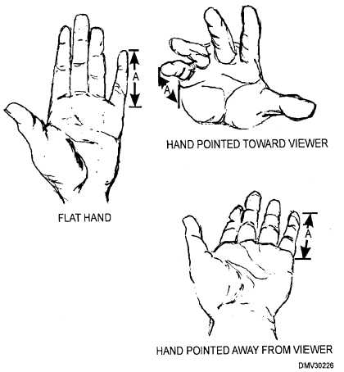

A few tips:
- Sit still and straight! A gradual slouch of only an inch can drastically affect the drawing of a foreshortened limb. Make a mental note of the relationship of a near and distant static object to reference your head position.
- Draw what you see, not what you think it should look like. Yes it looks odd at first, but properly finished off it should all make sense.
- Observe how further elements (such as the horses' hindquarters or the person's shoulders) seem to disappear in behind closer elements (the horse's head, or the person's hand). Allow your lines to reflect this.
- Note that elements closer to you will seem proportionately larger than further away.
- Use line weight - something drawn boldly and using contrast will 'jump' from the page.
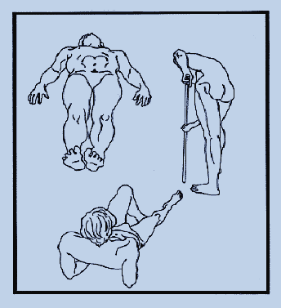

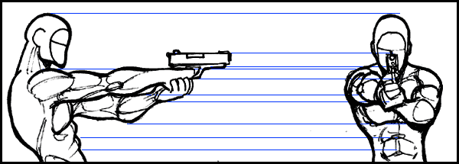
A tip on Foreshortening:
Foreshortening is never really easy and it's something you will have to get comfortable with over time with practice...but here's a tip. If you're really stuck, try drawing your character from the side then use a ruler to draw lines from key parts off the side. Use these lines as a guide to draw your character from the front

