Studio Sculpture
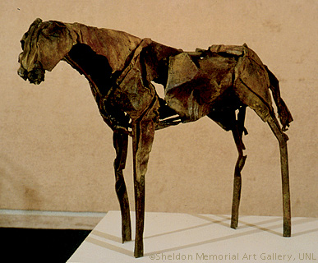
Artist: Deborah Butterfield
Mrs. Pountain
lpountain@newpaltz.k12.ny.us
256-4175 ext. 69541

“Art is idea. It is not enough to draw, paint and sculpt. An artist should be able to think.”
- Gurdon Woods

Webster’s dictionary defines Sculpture as the art of carving, modeling, welding or otherwise producing figurative or abstract works of art in three dimensions, as in relief, intaglio, or in the round. In this course you will learn about the different types of sculpture. As a class we will talk about the importance of sculpture in various cultures, and you will create your own original works.

As a student in this class you are expected to:
- Arrive to class on time.
- Be prepared for class with all necessary tools for the current project. (A pencil and sketchbook are required every day.)
- Be responsible for the care and maintenance of all equipment, tools and the classroom as a whole.
- Complete all class assignments as well as homework on time. Lateness will be penalized. (Absence or special circumstances will be discussed on an individual basis with me.)
- Use Open Studio Hours. You have an ongoing homework assignment this semester. It is to come to Open Studio on Tuesdays after school if you run out of class time.
- Use class time to its fullest extent, as well as participate in discussions and critiques.
- Make use of library and classroom resources in conjunction with various projects.
- RESPECT YOURSELF, YOUR CLASSMATES, AND YOUR TEACHER!
- THINK! Do not be afraid to “think outside the box”.

Your grade for this class will be based on participation, creativeness, class work, effort, neatness, and the overall quality of work.

Sketchbook and homework: You will need to keep a sketchbook for this class. In it you will keep all class notes homework assignments and rough sketches of your projects. You will have assignments which will be designed to encourage creative thinking. This book should be one that is bound and will not easily fall apart.

Sculptures will be created through various processes including:
Construction Casting
Carving Modeling

Media may include:
Clay Plaster Found Objects
Metal Cardboard Mixed Media
Wire Wood

Two class trips will be planned for this semester. One to the Storm King Sculpture Gardens and the other to the Hudson Valley Materials Exchange.

Why do Artists/People Create Sculpture?

____________________________________________________________________________________________________________________________________________________________________________________________________________________________________________________________________________________________________________________________________________________________________________________________________________________________________________________________________________________________________________________________________________________________________________________________________________________________________________________________________________________________________________________________________________________________
____________________________________________________________________________________________________________________________________________________________________________________________________________________________________________________

Physical Reasons:

Intellectual Reasons:

Spiritual Reasons:

Expressive Reasons:

As we look at the slides, please make thumbnail sketches and notes.

- Venus of Willendorf  - Bison  - Egyptian  Statuette of Amun | - Greek  - Roman  - Totems
- Pietà  - Auguste Rodin  - Edgar Degas  - Constantin Brancusi  - Henry Moore | - Marcel Duchamp  - Alberto Giacometti  - Duane Hanson /George Segal  - Robert Rauschenberg  - Earthworks

