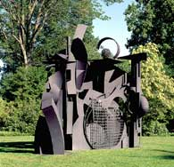 |   Mrs. Pountain  Studio Sculpture  Do as much of the assignment as you can on location, some parts can be finished on the bus, or at a later date if you run out of time.

- Select one sculpture from the grounds which is intriguing to you. (you may like or dislike the piece).
- View the work for several minutes and from several angles.
- Sketch it from 2 different angles (quickly in your sketch book; thumbnails).
- Record the title and the artist.

- What materials were used to create the piece? How was it created? (cast, assemblage, carved etc.)

- Why were you drawn to this piece?

- How did it make you feel?

- What do you think the artist was trying to say?

