Studio Sculpture  Wire and Aluminum  Mrs. Pountain

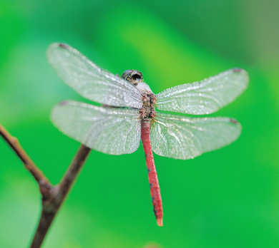 | Assignment:  Using one or more aluminum soda cans and wire, create a “never-before-seen-by-human-eyes, fantastically creative insect.”
General Information:  Insects have six legs, three body parts, and two sets of wings. (There are a myriad of solutions that fit within these parameters, be creative!!!)  Materials:  Aluminum cans, Wire, Scissors, Pliers | 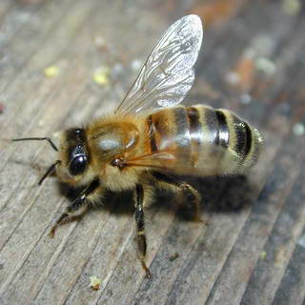
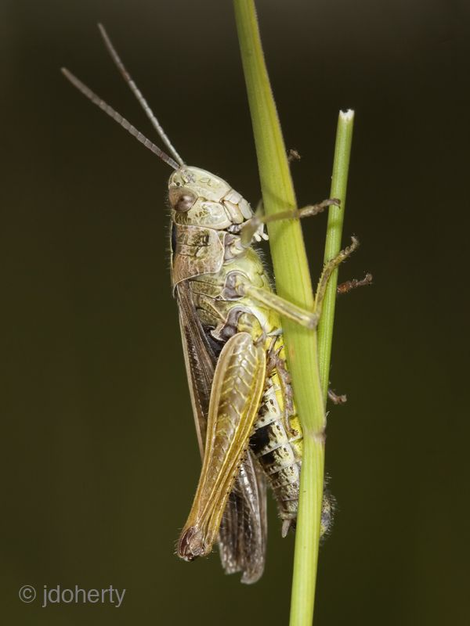 | Requirements:  You must have research in your sketchbook. Including images of at least 3 different insects that are interesting to you (sketch or print), notes about the insects, as well as plans and sketches of your new insect.  You may destroy, mangle, cut, and manipulate cans as needed.
Finished Sculpture:  Your finished insect may stand on its own, or hang using fishing line. You may also choose to use spray paint, or leave the cans in their original state. | 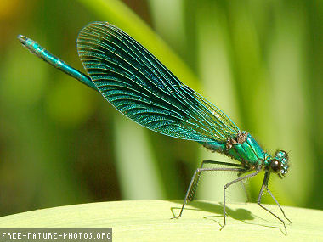

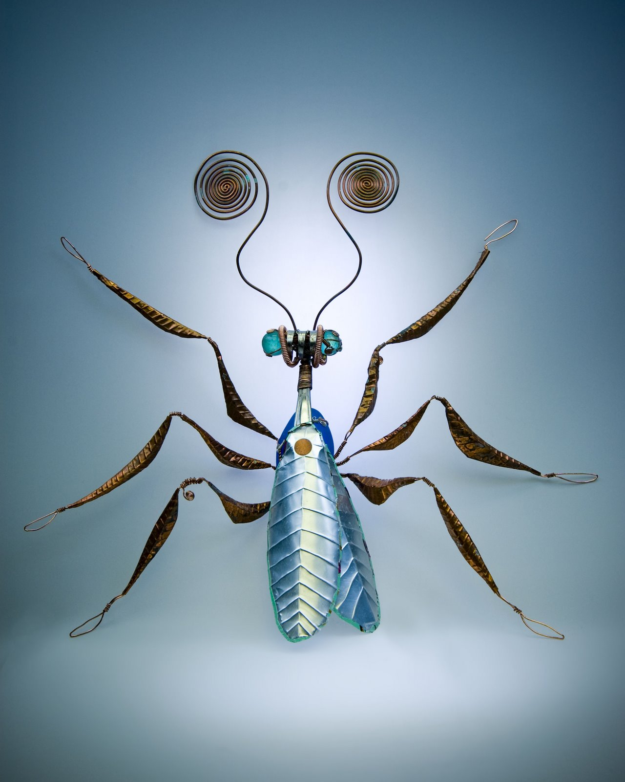 | 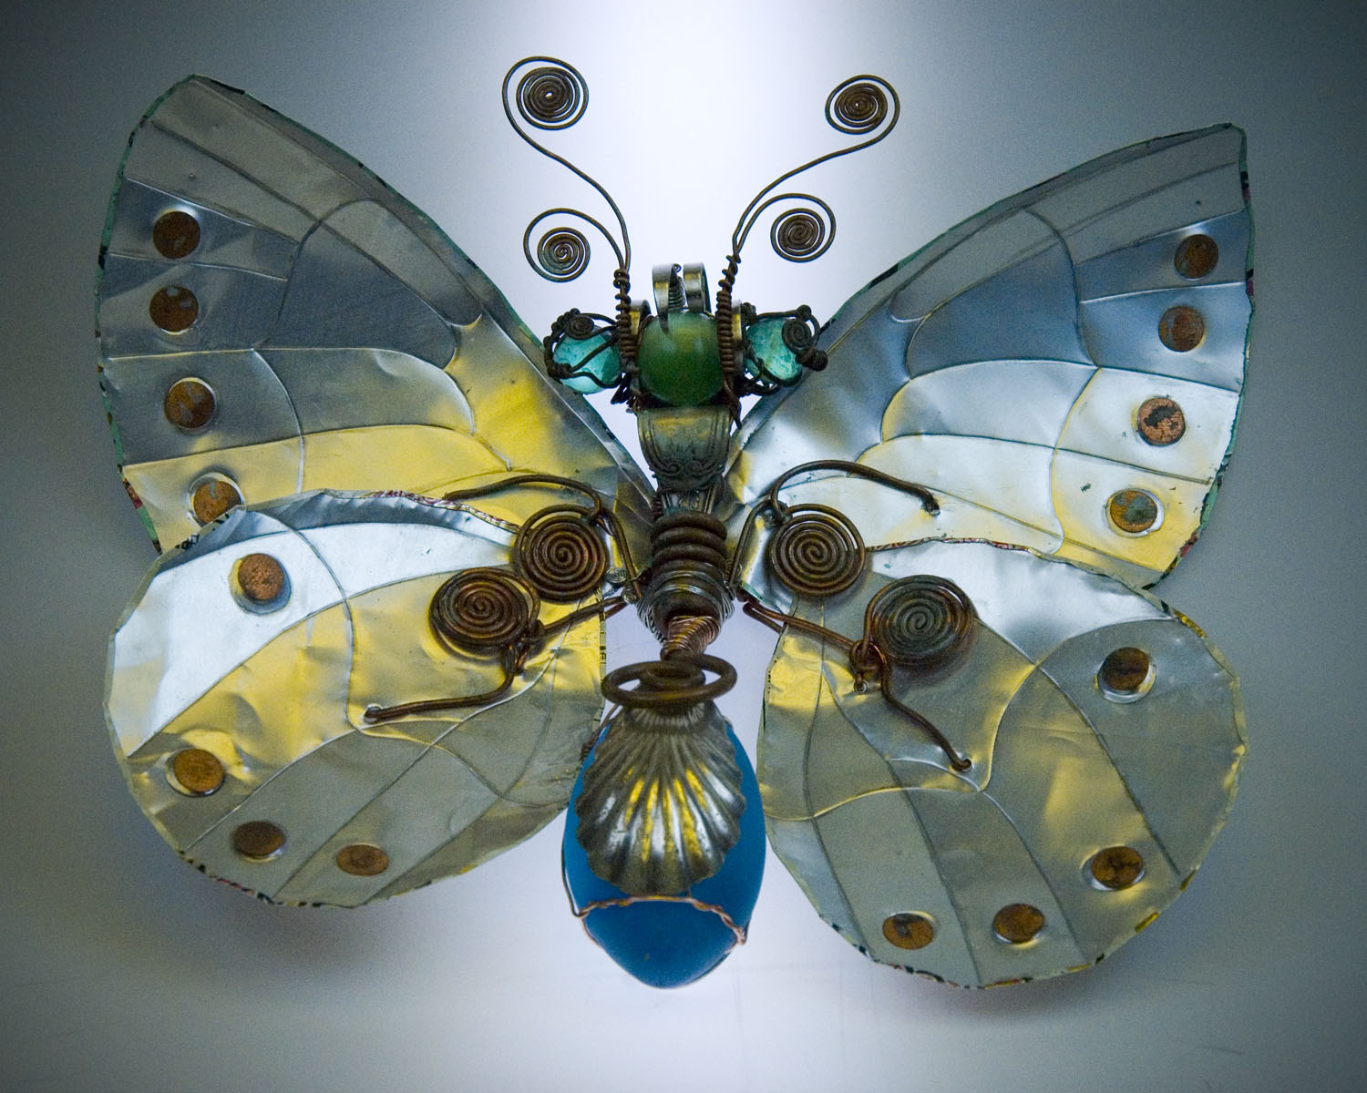
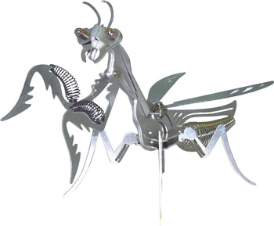 | 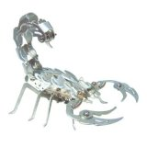
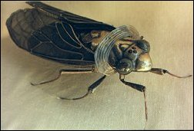 | 