Heroes  Myths  Legends
Studio in Printmaking

For the next printmaking plate, find a story that you can illustrate or depict. Myths are more than mere stories and serve a profound purpose in ancient and modern cultures. Myths are tales that explain the world and man's experience. They instruct, inspire, console, and warn. They embody the wisdom of a culture and serve to pass that wisdom to the next generation.
Please choose a reference through research – collect visuals. Places you might look:
- Ancient Mythology – Greek, Egyptian etc.
- Folk Tales from around the World (Celtic, Russian, Native American etc..)
- Ancient Creatures
Begin making sketches and keep in mind not to use shading, but use line for values, texture etc.
The etching plate will be no larger than 5x7.
Printmaking Vocabulary to be covered:
Intaglio, Etching, Drypoint, Engraving
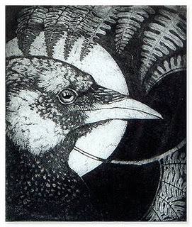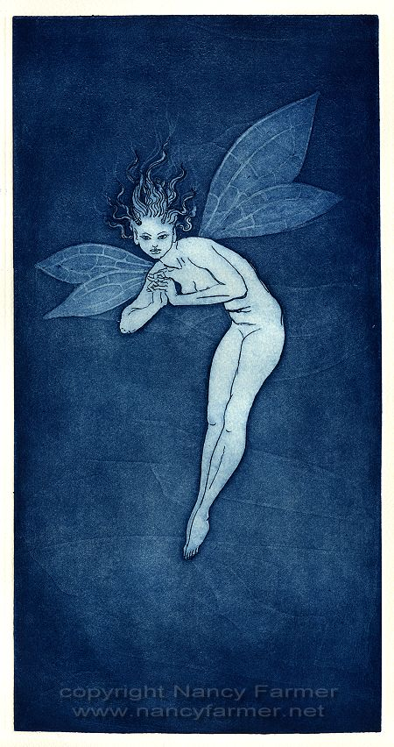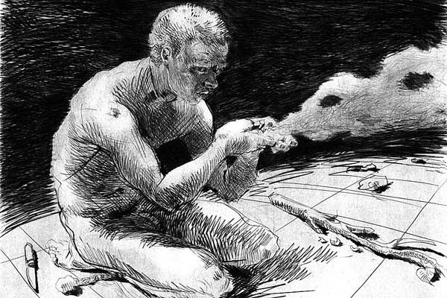
http://artistspotlights.milliande.com/2011_06_01_archive.html

