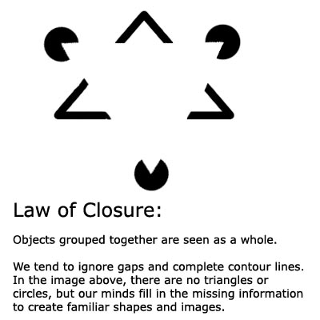

law of closure [¦lȯ əv ′klō·zhər]
(psychology)
In Gestalt psychology, a law of organization that assumes an innate tendency to perceive incomplete objects as complete, to close up or fill in gaps in sensory inputs, and to view asymmetric and unbalanced stimuli as symmetric and balanced.

"The whole is greater than the sum of the parts" is used when explaining Gestalt theory.

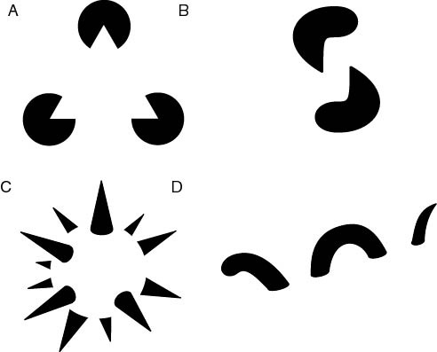

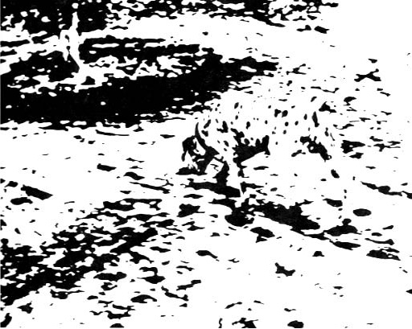



The principle of closure applies when our minds react to patterns that are familiar, even though we often receive incomplete information. It is speculated this is a survival instinct, allowing us to complete the form of a predator even with incomplete information.

It is not just about feeling good about the image.
People remember images that they had to spend time thinking about.

