Midterm Review

Elements of Art

Space, Color, Value, Form, Shape, Line, Texture

Principles of design

Balance, Unity, Proportion, Emphasis/Dominance, Pattern, Contrast, Rhythm, Movement

History Terms
You will have an essay… know these different types of art... Be able to identify them by sight… slides
Stone Age Art | Impressionism
Egyptian Art | Hudson River School
Japanese Art | Cubism
Greek Art | Fauvism
Roman Art | Expressionism
African Art | Surrealism and Dada
Medieval Art | Pop Art
Art of Ancient America (Inca, Maya, Aztec) | Harlem Renaissance
Renaissance | Minimalism
Baroque Art | Color Field Painting
Classicism | Photorealism
Romanticism | Earth Art
Realism

Perspective

Birds eye view

Worms eye view

Eye Level view

Horizon line Vanishing points Vanishing lines
Diminution Foreshortening Overlapping

Foreground Middle-ground Background
Leonardo da Vinci
1 point and 2 point perspective…. Know how to draw objects in perspective!!!!
Graphite pencil: 4H,2H,HB,2B,4B What does this mean? How do you use them?

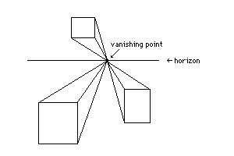 | 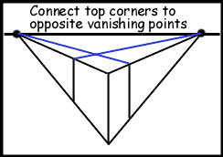

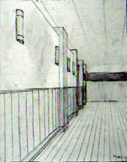 | 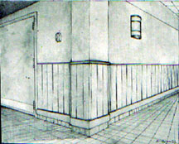
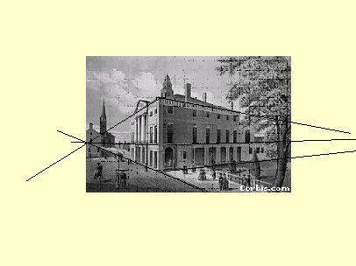

Scratch board
Line, Value, Texture, Line weight
Be able to use line and texture in order to create value.
Be able to use line in order to create mood/feeling.

Tessellations
Islamic countries and know about Islamic art
5 basic characteristics to look for in the Islamic work
Mc Escher

Link to the following website for more information:

http://www.alifetimeofcolor.com/main.taf?p=3,1

