HOMOPHONES

Words that
have exactly the same sound
(pronunciation) but different meanings and (usually) spelling.

Why did the boy bring a napkin and fork to math class?

He heard there was
going to be pi.

Ha ha ha ha!!!!!!

beet | beat
bare | bear
brake | break
cent | scent
cereal | serial
coarse | course
dear | deer
die | dye
fair | fare
fir | 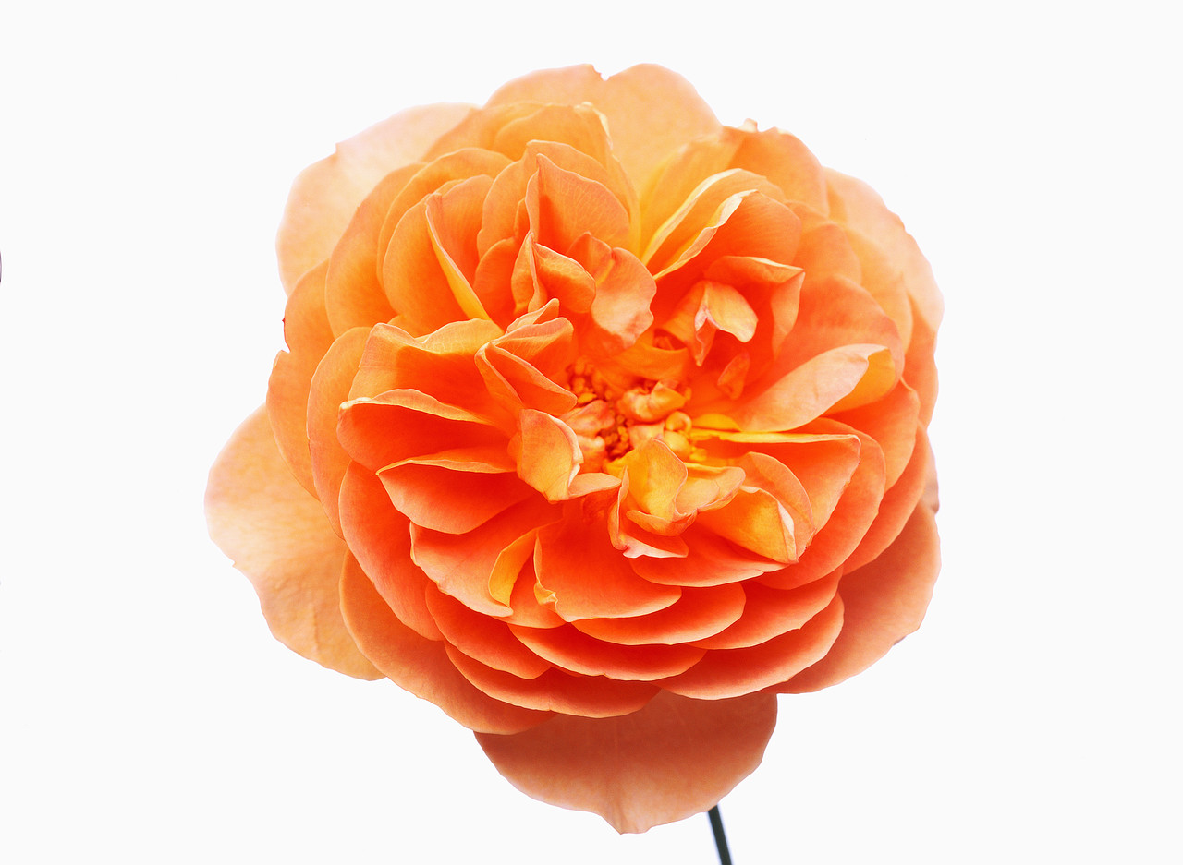  fur
flour | flower
for | four (4)
$hair | hare
heal | heel
hear |   here
hole | whole
hour | our
idle | idol
in | inn
knight | night
knot | not
know | no
made | maid
pail | pale
pair | pear
peace | piece
plain | plane
poor | pour
pray | prey
principal |   principle
profit | prophet
real |   reel
right | write
root | route
sail | sale
sea | see
seam | seem
sight | site
sole | soul
some | sum (=)
waist | waste
wait | weight
way | weigh
weak | week
wear | where (?)
wring |   ring

buy | by | bye
there | their | they’re
to | too | two (2)
sew | so | sow

