[](http://www.google.com/url?sa=i&rct=j&q=&esrc=s&frm=1&source=images&cd=&cad=rja&uact=8&docid=AqUuLEJ_HQhy_M&tbnid=30FGr_4nVpcwXM:&ved=0CAUQjRw&url=http://www.kyrene.org/Page/22454&ei=pTMPVOS3A4nLggTg04HAAQ&bvm=bv.74649129,d.cWc&psig=AFQjCNFX1YrM0D6YWVft7bpa-X_mxnAuxQ&ust=1410368774144944)Name: ____________ Date:

Homework 5-3

1) Determine the domain and range of each relation below. Then determine if the relation is or isn’t a function.

a) (1,3) (2,5) (2,4) (3,0) (4,4) b) 

Domain:__________ Range:_________ Domain:_________ Range:________

Is this a function? Explain. Is this a function? Explain.

c) d)

1 2 3 4 5 6

Domain:___________ Range:___________ Domain:___________Range:____________

Is this a function? Explain. Is this a function? Explain.

|  |  |
| --- | --- |
| **x** | **y** |
| -2 | 5 |
| 0 | 5 |
| 2 | 5 |
| 4 | 5 |

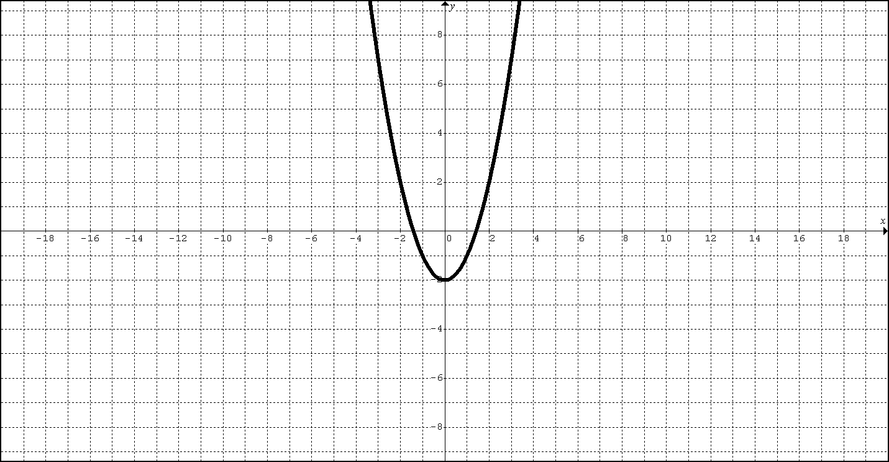e) f)

Domain:___________ Range:_________ Domain:___________Range:____________

Is this a function? Explain Is this a function? Explain.

|  |  |
| --- | --- |
| 1. **The graph of the line f(x)=-3x-9 is shown.**   **Determine its x-intercept, slope and the y intercept, Domain and range**   * **Acceptable Formats** * an integer, like 6 * an *exact* decimal, like 0.75 * a *simplified proper* fraction, like 3/5 * a *simplified improper* fraction, like 7/4 * a mixed number, like 1 3/4   https://ka-perseus-graphie.s3.amazonaws.com/5fe7074e185d7e2e92c41c829b3154dd6c258903.png | **2) Given** H(x) = ${1.5}^{x}$ Identify what type:  Domain:  Range:  http://mathbits.com/MathBits/StudentResources/GraphPaper/10x10.gifEvaluate H(3)  Graph it: |
| **3)**  Graph f(x) = ${-x}^{2}$ **Name the function**  **Find the Domain and range.**  http://mathbits.com/MathBits/StudentResources/GraphPaper/10x10.gif | **4)**  **Graph G(x)** =  **Name the function**  **Find the Domain and range**  http://mathbits.com/MathBits/StudentResources/GraphPaper/10x10.gif |