**Mathematician: _________________**

**HW 5-4**

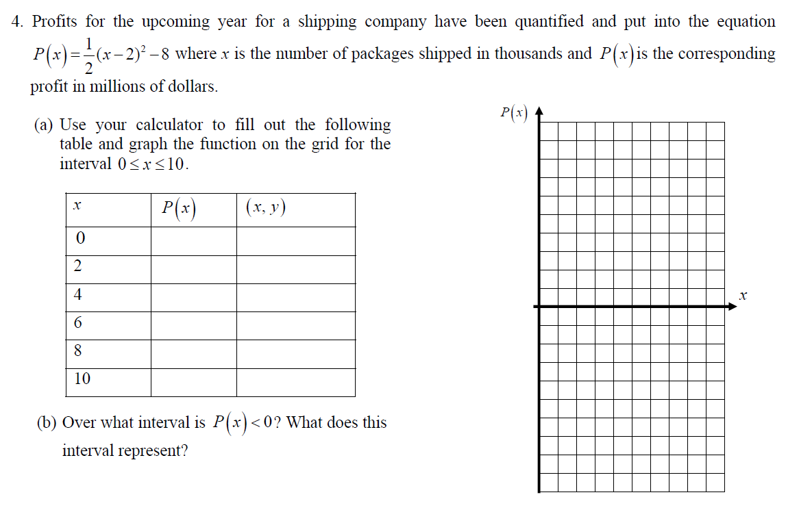

( c) What is the minimum of this function?

(D) What is the Domain of this function? Explain.

(E) Find the average rate of change over the interval $6≤x≤10$. List the formula you used.

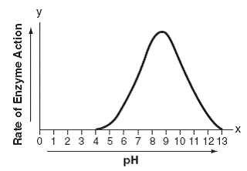2)The effect of pH on the action of a certain enzyme is shown on the accompanying graph.

What is the domain of this function?

1) 4 lteq*x* lteq13

2) 4 lteq*y* lteq13

*3) x* gteq0

*4) y* gteq0

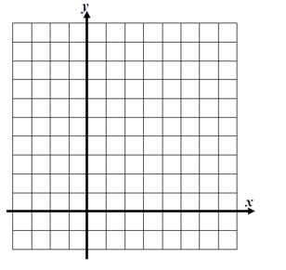**3)** Graph the function then what is the domain of the function  ?

1. 

2. 

3. 

4. 

**4) Find the domain and range for each**

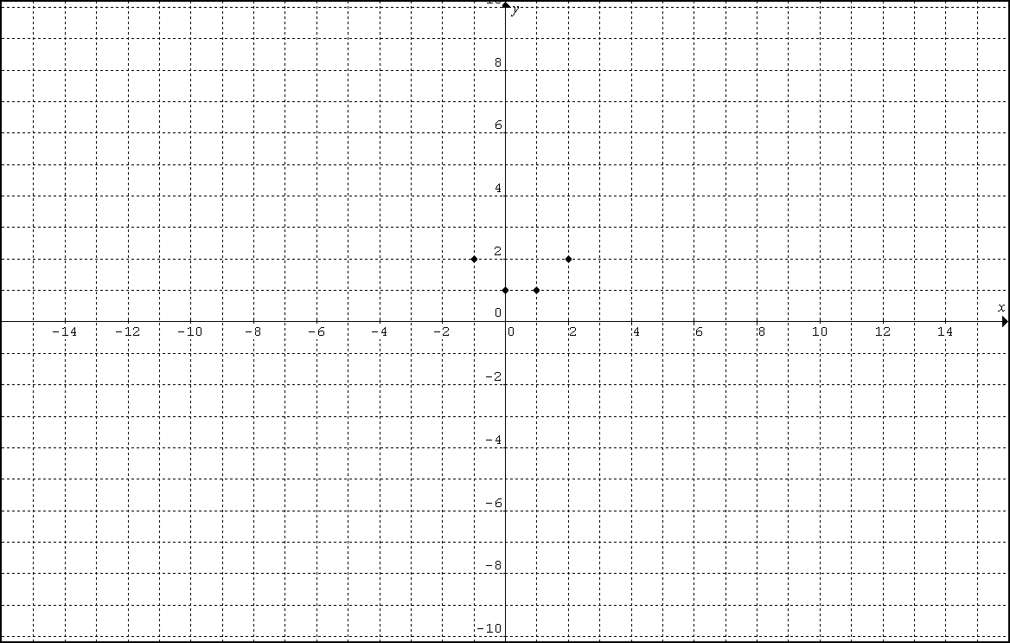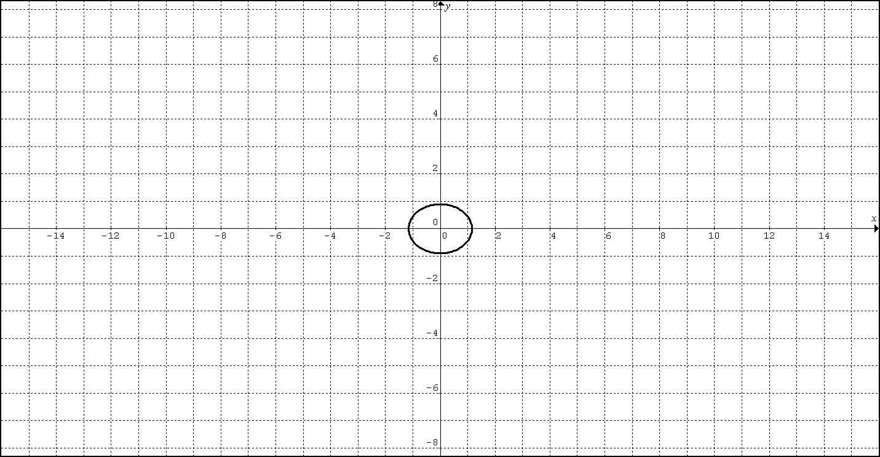

5) Evaluate each expression below given that  and 

a) Evaluate . b) Evaluate .