Name: ___________ Date: ______
Homework work 5-6 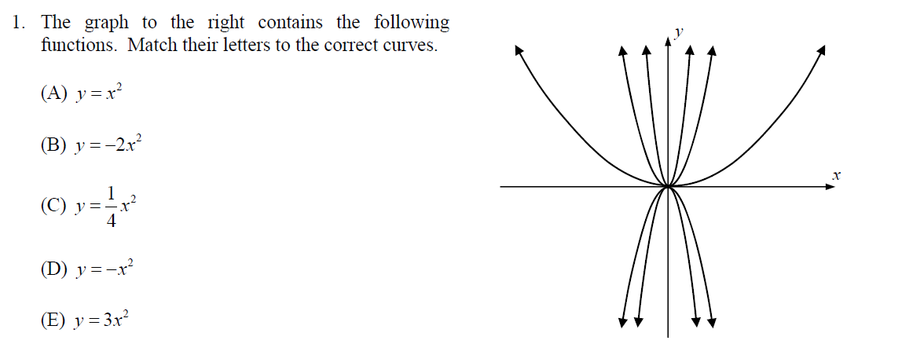

- Graph the following functions on the same coordinate plane and describe the transformations:
x | f(x)
$$f\left( x\right)= \sqrt{x} , k\left( x\right)=-\sqrt{x} h\left(x\right)=\sqrt{x}+3 g\left(x\right)=\sqrt{x+5}$$
x | k(x)
x | h(x)
x | g(x)
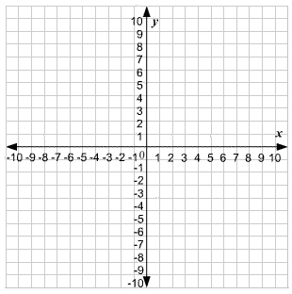

Identify the parent function and its transformation to for each of the following functions. Sketch both
3.
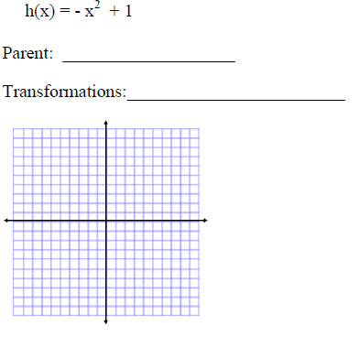
4.
