**Unit 6: Factoring**

**Lesson 1: Factoring – Greatest Common**

**Objectives:**

* **Students can factor algebraic expressions using GCF+ DOPS method**

**Agenda:**

* **Answer Questions Last Home work**
* **GCF/DOPS notes**
* **Practice**

**Vocabulary:**

* **Greatest Common Factor**

**Focus Questions:**

1. **What is the method of factoring you always check for first?**
2. **How do you factor using the difference of perfect squares method?**
3. **How do you identify that you should use DOPS?**

**Homework: Worksheet 6-1.**

**Factoring using GCF 1:** [**https://www.youtube.com/watch?v=UxBO7GXFh_Y**](https://www.youtube.com/watch?v=UxBO7GXFh_Y)

GCF 2: <https://www.youtube.com/watch?v=t71H2R68TZc>

Factoring using DOPS: <https://www.youtube.com/watch?v=AcCN_isD3PY>

DOPS2: <https://www.youtube.com/watch?v=H21qt027H48>

Factoring for fun song:

<http://www.youtube.com/watch?v=OFSrINhfNsQ&safety_mode=true&persist_safety_mode=1&safe=active>

**Do Now**

**Alex throws a ball into the air. The ball travels on a parabolic path represented by the equation , where h is the height, in feet, and t is the time, in seconds. Use your graphing calculator to compete the following activity**

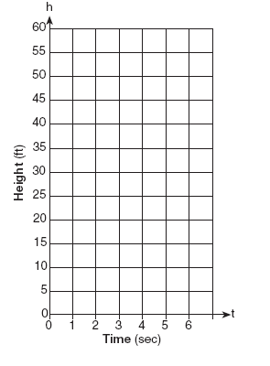

1. On the accompanying set of axes, graph the equation from t = 0 to 6 seconds, including all integral values of t from 0 to 6.
2. How many seconds does it take the ball to reach the ground?
3. How high did the ball go before returning to the ground?
4. Did this parabola have a maximum or minimum? Explain:

|  |  |
| --- | --- |
| **t** | **h** |
|  |  |
|  |  |
|  |  |
|  |  |
|  |  |
|  |  |
|  |  |

1. Calculate the average rate of change over the interval [0, 3]

2) The length of a rectangle is represented by and the width is represented by . Express the area of the rectangle as a binomial in terms of a.

**Blast from a recent past:**

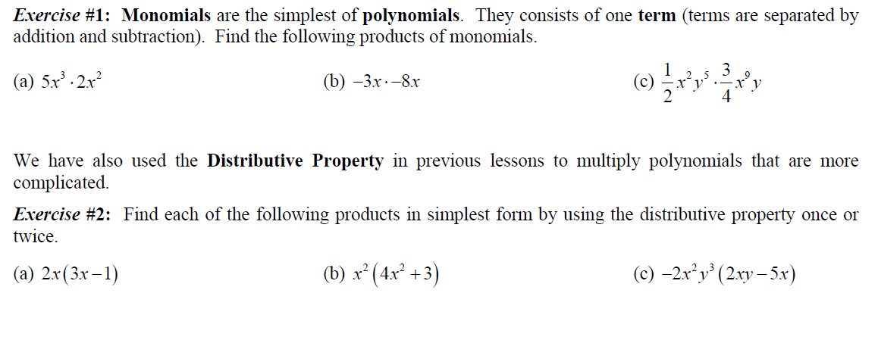

**One more time:**

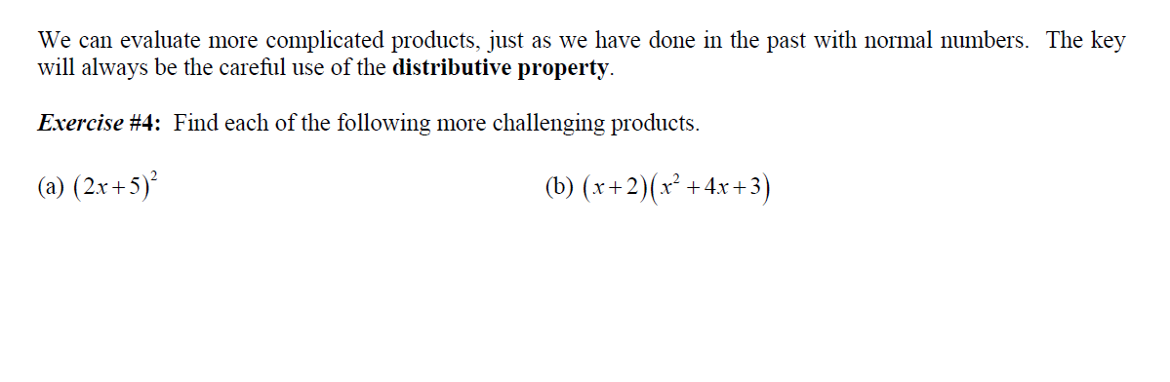

5) The length of a rectangular window is 5 feet more than its width, w. The area of the window is 36 square feet. Write an equation could be used to find the dimensions of the window?

**Working back words from Multiplying:**

**Leader:**

 Factor:

1. GCF = 
2. 
3. 
4. Look for the **Greatest Common Factor (GCF)**

**Example: ** 

**You try:**

1. Factor:  2) Work backwards:

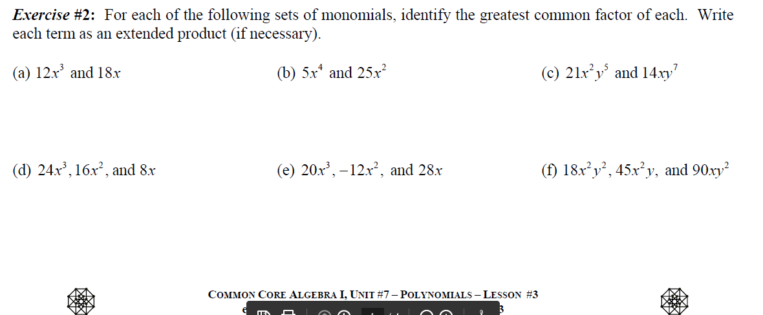

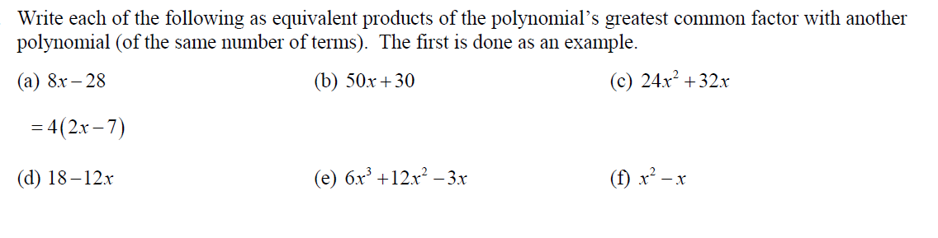

|  |  |  |
| --- | --- | --- |
| 4r - 6r |  |  |

**Difference of Two Perfect Squares: Play the video for DOPS first:**

**Abbreviated as “DOPS”**

List the perfect squares from 1 – 200:

_____________________________________________________________________

**Formula:** 

**Example**: 

Be Careful!

**DOPS** does **NOT** apply to *a* 2 **+** *b* 2.

It is **not** the **SUM** of 2 perfect Squares!

So…write “not factorable”

Practice:

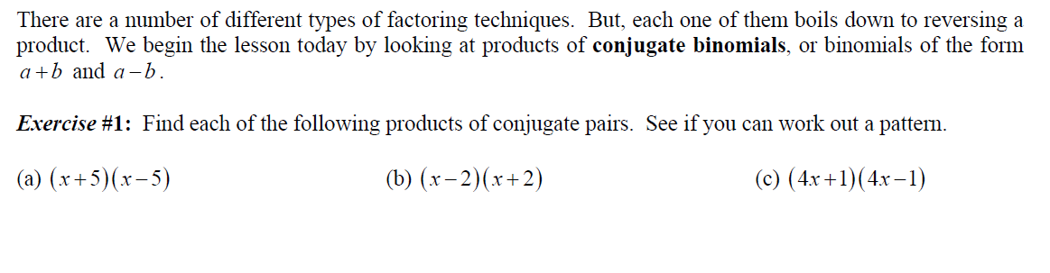

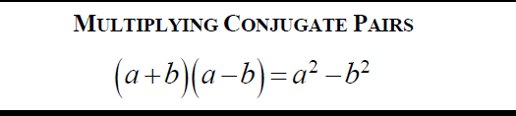





One more time:

|  |  |  |
| --- | --- | --- |
| x2- 9 | x2- 16 | x2- 64 |
| x2- 81 | x2- 100 | x2- 1 |

[](http://vivebydesign.com/?event=free-latin-dance-practice-time-no-class-for-3-weeks-5)Name: ____ Date: ___

Homework 6-1 Factoring and distributive property

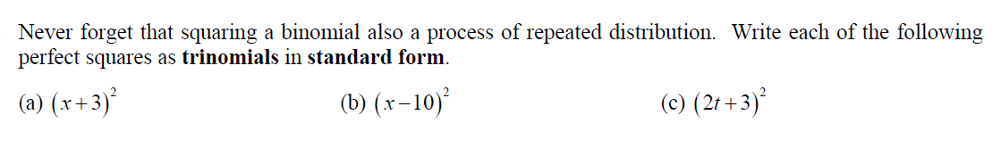

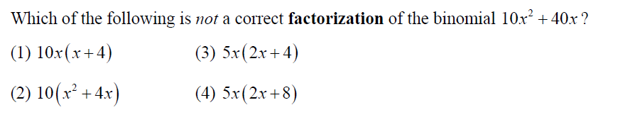

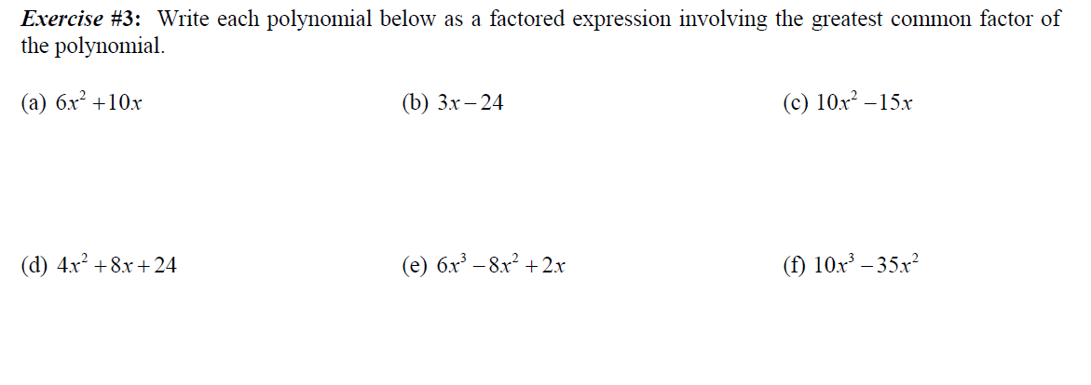

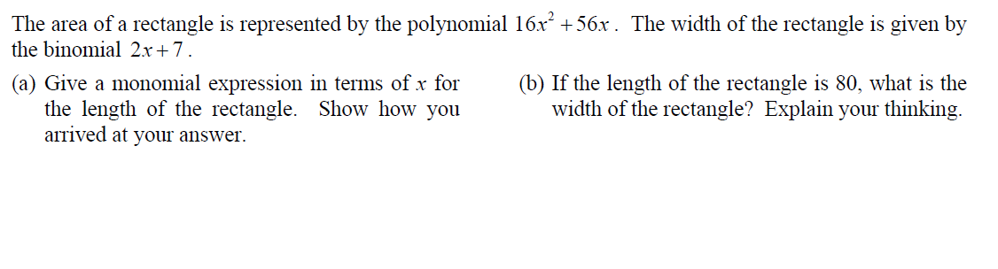

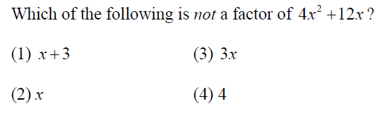

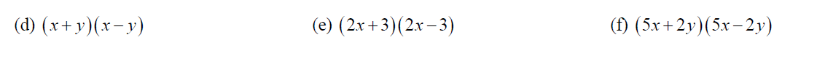

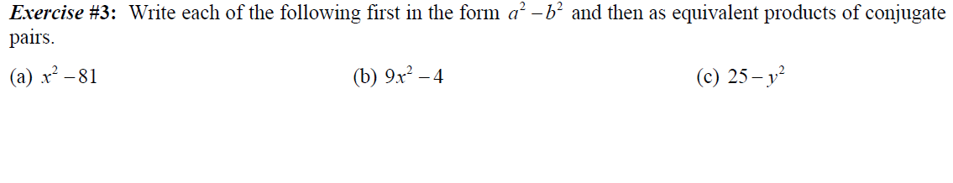

d) x2- 25 e) x2- 144 f) x2- 169

Extra stuff:Factor! Student’s Activity:

**( X + 4) ( ) =**



**( X – 3) ( ) =**





Factor Difference of Perfect Squares



Factor Quadratics GCF



Factor Quadratics GCF



Factor Quadratics GCF

**Challenge:**

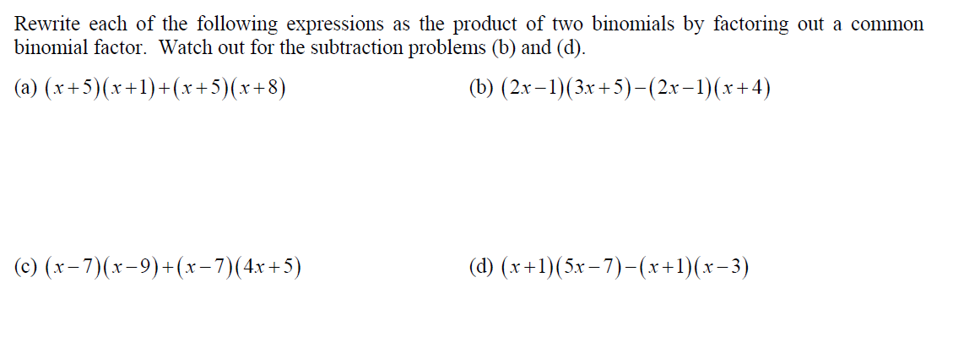

Stop here:



Factor trinomial, a=1



Factor trinomial, a=1



Factor trinomial, a not 1



Factor trinomial, a=1





Factor trinomial, a not 1



