**Module 1: Basic Skills of Algebraic Expressions**

**Lesson 5: Solving Inequalities**

**Objectives:**

* **Students can solve algebraic inequalities.**
* **Students can identify the solution set for inequalities**
* **Students can solve real–life applications on inequalities Agenda:**

**Agenda:**

* **Warm Up: Inequalities signs**
* **Notes: Solving inequalities.**
* **Practice: Worksheet 2-5**

**Vocabulary:**

* **Inequalities signs, At most, At least, less than, more than, The maximum, the minimum**

**Focus Questions:**

1. **What is the solution set for solving an inequality?**
2. **How is solving an inequality is different than solving an equation?**

**For your entertainment:**

**Remember the power puff girls! They are singing for the inequalities**

<http://www.youtube.com/watch?v=FpWm_wL73LY>

**Homework: HW 2-5**

**Quiz on consecutive integers and coin problems at the end of the week.**

**White Board Activities.**

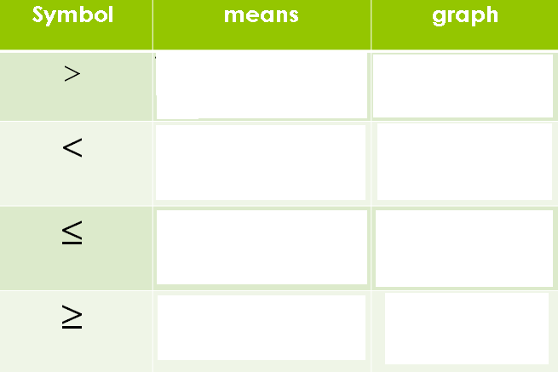

1. $x≥5$ 3.



1. 4. $x>\frac{1}{2}$



**What about presenting these situations on the number line?**

1. The temperature outside is at most 85°F
2. This ride is for children under 6 years old
3. Rated R movies for individuals 17 years of age or older.
4. The library has at least 500 books.

**Module 1: Basic Skills of Algebraic Expressions**

**Lesson 5: Solving Inequalities**

**Try and solve these Inequalities and justify your work using the properties of real numbers:**

1. 2.



3. 4.



5. 6.

What do you think the difference between solving equations and solving inequalities?

Think about these problems now:

1. Nora is planning a birthday party for her little sister, Lena. Nora’s budget will allow her to spend $50 for the party supplies. Eight children, including Lena will attend the party, and Nora wants to determine how much she could spend on party favors for each child. She will also purchase a cake for $10.

a. Write an equation that represents the situation, and much each favor should cost.

1. How does the equation change if I told you that Nora needs to spend $50 at most?
2. How does the situation change if I told you that Nora can spend at least $50?
3. Steven is trying to find the maximum amount of time he can spend practicing the five scales of piano music he is supposed to be working on. He has 60 minutes to practice piano and would like to spend at least 35 minutes playing songs instead of practicing scales. What is the minimum number of minutes that Steven should spend practicing on each scale?
4. Dana has a cell phone plan that charges $0.07 per minute plus a monthly fee of $19.00. She budgets $29.50 per month for total cell phone expenses without taxes. What is the maximum number of minutes Dana could use her phone each month in order to stay within her budget?

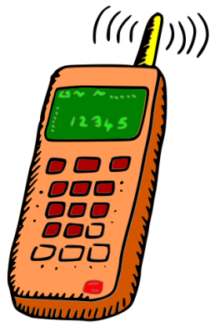

Which inequality do you think should represent the following statements?

The maximum, The minimum, At least, At most, Less than, More than.

Mathematician:_______________________

**Homework: 2-5**

**Solve the following inequalities and justify your work by the properties of real numbers.**

|  |  |
| --- | --- |
| $\frac{4}{3}(6x+9)<4$ | $-2(\frac{1}{4}x+2)≥5$ |
| $x+1>-5(7-2x)$ | $3+\frac{1}{2}(3-x)<7$ |

**Solve the following word problems**

1. An online music club has a one-time registration fee of $13.95 and charges $0.49 to buy each song. If Donna has $50.00 to join the club and buy songs, what is the maximum number of songs she can buy?



1. Patrick’s part-time job pays him $155 a week. If he has already saved $375. What is the minimum number of weeks he needs to work in order to have enough money to buy a dirt bike for $900?



1. Explain in own words the difference between solving equations and solving inequalities and give an example of each