Name _________________________________ Date Due:
Algebra Regents Review #10
Directions: Choose the best answer. Answer ALL questions. Show ALL work in column 2. If there is no mathematical work to be shown, write an explanation or definition to support your answer!

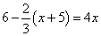
- Solve the equation below algebraically for the exact value of x.

- Given the set {x| –2 ≤ x ≤ 2, where x is an integer}, what is the solution of –2(x – 5) < 10?  - 0, 1, 2 3. 1, 2  - –2, –1, 0 4. –2, –1 | Show work
- Boyle’s Law involves the pressure and volume of gas in a container. It can be represented by the formula P₁V₁ = P₂V₂. When the formula is solved for P₂, the result is  - P₁V₁V₂ 3. 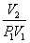  - 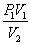 4. 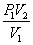 | Show work
8 The 4) solution of the equation is  1)  2)  3)  4) | Explain
5)In attempting to solve the system of equations y = 3x − 2 and 6x − 2y = 4, John graphed the two equations on his graphing calculator. Because he saw only one line, John wrote that the answer to the system is the empty set. Is he correct? Explain your answer.

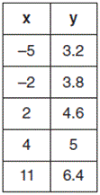  - The line represented by the equation 4y + 2x = 33.6 shares a solution point with the line represented by the table below. The solution for this system is  - (−14.0, −1.4)  - (−6.8,5.0)  - (1.9,4.6)  - (6.0,5.4) | Show work
- First consider the system of equations y = –$\frac{1}{2}$x + 1 and y = x – 5. Then consider the system of inequalities y > –$\frac{1}{2}$x + 1 and y < x – 5. When comparing the number of solutions in each of these systems, which statement is true?  - Both systems have an infinite number of solutions.  - The system of equations has more solutions.  - The system of inequalities has more solutions.  - Both systems have only one solution. | Explain
- Which function has the greatest y-intercept?  - f(x) = 3x  - 2x + 3y = 12  - the line that has a slope of 2 and passes through (1, −4)  - 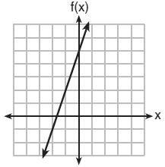 | Explain
- Which function is shown in the table below?  x -2 -1 0 1 2 3  f(x) 1 3 9 27  - f(x) = 3x 3. f(x) = x + 3  - f(x) = −x³ 4. f(x) = 3^{x} | Explain
- The cost of belonging to a gym can be modeled by C(m) = 50m + 79.50, where C(m) is the total cost for m months of membership. State the meaning of the slope and y-intercept of this function with respect to the costs associated with the gym membership.

- Which representations are functions? Explain
 | (1, 1), (2, 1), (3, 2), (4, 3), (5, 5), (6, 8), (7, 13) |  | y = 2x
I | II | III | IV
- I and II
- II and IV
- III, only
- IV, only
- Is the sum of 3 and 4 rational or irrational? Explain your answer. Must write down the sum

- Which equation and ordered pair represent the correct vertex form and vertex for j(x) = x² − 12x + 7?  - j(x) = (x − 6)² + 43, (6, 43)  - j(x) = (x − 6)² + 43, (−6, 43)  - j(x) = (x − 6)² − 29, (6, −29)  - j(x) = (x − 6)² − 29, (−6, −29) | Show your work
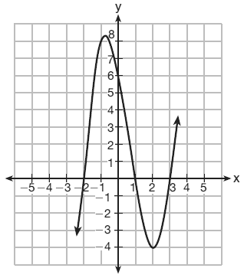  - Which equation(s) represent the graph below?  I y = (x + 2)(x² – 4 x – 12)  II y = (x – 3)(x² + x – 2)  III y = (x – 1)(x² – 5x – 6)  - I, only  - II, only  - I and II  - II and III | Explain
- Which polynomial function has zeros at −3, 0, and 4?  - f(x) = (x + 3)(x² + 4)  - f(x) = (x² − 3)(x − 4)  - f(x) = x(x + 3)(x − 4)  - f(x) = x(x − 3)(x + 4) | Show your work
- Which function has zeros of −4 and 2?  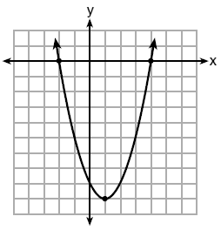  - 1. f(x) = x² + 7x – 8 3. g(x) = x² − 7x – 8  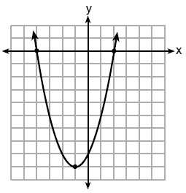  - 2. 4. | Show your work
- A population of rabbits in a lab, p(x), can be modeled by the function p(x) = 20(1.014)^{x}, where x represents the number of days since the population was first counted. (4 points)
PART A: Explain what 20 and 1.014 represent in the context of the problem.

18)PART B: Determine, to the nearest tenth, the average rate of change from day 50 to day 100.

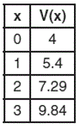
19)Jill invests $400 in a savings bond. The value of the bond, V(x), in hundreds of dollars after x years is illustrated in the table below. Which equation and statement illustrate the approximate value of the bond in hundreds of dollars over time in years?
- V(x) = 4(0.65)^{x}, and it grows.
- V(x) = 4(0.65)^{x}, and it decays.
- V(x) = 4(1.35)^{x}, and it grows.
- V(x) = 4(1.35)^{x}, and it decays.
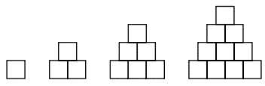
20)A sequence of blocks is shown in the diagram below.

This sequence can be defined by the recursive function a₁ ₌ 1 and a_{n =} a_{n −} ₁ + n. Assuming the pattern continues, how many blocks will there be when n = 7?
- 13 3. 21
- 28 4. 36

