Name _________________________________ Date Due:
Algebra 1 Regents Review Packet #6
Directions: Choose the best answer. Answer ALL questions. Show ALL work in column 2. If there is no mathematical work to be shown, write an explanation or definition to support your answer!
- Boyle’s Law involves the pressure and volume of gas in a container. It can be represented by the formula P₁V₁ = P₂V₂. When the formula is solved for P₂, the result is
- P₁V₁V2 3. 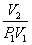
- 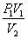 4. 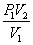
- A typical cell phone plan has a fixed base fee that includes a certain amount of data and an overage charge for data use beyond the plan. A cell phone plan charges a base fee of $62 and an overage charge of $30 per gigabyte of data that exceed 2 gigabytes. If C represents the cost and g represents the total number of gigabytes of data, which equation could represent this plan when more than 2 gigabytes are used?
- C = 30 + 62(2 - g)
- C = 30 + 62(g - 2)
- C = 62 + 30(2 - g)
- C = 62 + 30(g - 2)
- Joey enlarged a 3-inch by 5-inch photograph on a copy machine. He enlarged it four times. The table below shows the area of the photograph after each enlargement.
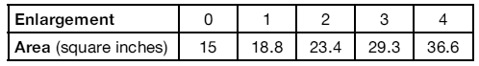
What is the average rate of change of the area from the original photograph to the fourth enlargement, to the nearest tenth?
- 4.3 3. 4.5
- 5.4 4. 6.0

4.The expression is equivalent to

- 2 3) 10
- 100 4) 2
- In attempting to solve the system of equations y = 3x − 2 and 6x − 2y = 4, John graphed the two equations on his graphing calculator. Because he saw only one line, John wrote that the answer to the system is the empty set. Is he correct? Explain your answer.

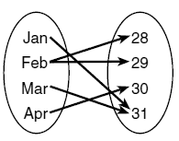  - A mapping is shown in the diagram below.  This mapping is  - a function, because Feb has two outputs, 28 and 29  - a function, because two inputs, Jan and Mar, result in the output 31  - not a function, because Feb has two outputs, 28 and 29  - not a function, because two inputs, Jan and Mar, result in the output 31 | Define a function
- Let f be a function such that f(x) = 2x − 4 is defined on the domain 2 ≤ x ≤ 6. The range of this function is  - 0 ≤ y ≤ 8 3. 0 ≤ y < ∞  - 2 ≤ y ≤ 6 4. −∞ < y < ∞ | Provide a table
- The function h(t) = -16t² +144 represents the height, h(t), in feet, of an object from the ground at t seconds after it is dropped. A realistic domain for this function is
- -3 ≤ t ≤ 3 3. 0 ≤ t ≤ 3
- 0 ≤ h(t) ≤ 144 4. all real numbers

- If f (x) = 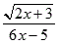, then f () =
- 1 3. −2
- −1 4. −
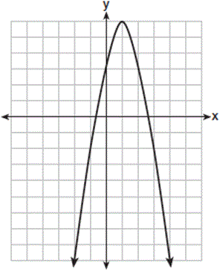  - Let f be the function represented by the graph below.  Let g be a function such that  g(x) = −x² + 4x + 3.  Determine which function has the larger maximum value. Justify your answer. | Must find the vertex for g(x)

11.Which trinomial is equivalent to  $3{(x-2)}^{2}$ -2(x-1)?  $$1){3x}^{2}-2x-10 3){3x}^{2}-14x+10$$  $$2) {3x}^{2}-2x-14 4){3x}^{2}-14x+14$$ | Provide a table of values
12.Factor: 2x² – 5x + 2
- (2x – 1)(x – 2) 3) (x – 1)(2x – 2)
- (2x + 1)(x – 2) 4) (x – 1)(2x + 2)

13.The coordinates of the turning point of the graph of y = 2x² − 4x + 1 Algebraically is:
- (1, −1)
- (1, 1)
- (−1, 5)
- (2, 1)

14.Given the graph of the line represented by the equation f(x) = -2x + b, if b is increased by 4 units, the graph of the new line would be shifted 4 units:

1) right 3) left
2) up 4) down

Factor all:
15) DOPS 16. GCF. 5x – 30

17. Trino 18. GCF, DOPS x³ – 9x

19. The length of a rectangular door is 5 feet more than its width, w. The area of the door is 36 square feet. Write an equation which could be used to find the dimensions of the door?

20. If $C= 3x^{3}+4x^{2}-6$ and $z= 2x^{3}+5x^{2}-6x+7$, What it z - c:

[1] $-x^{3}+ x^{2}-6x+13$
[2] $x^{3}- x^{2}+6x-13$
[3] $-x^{6}+ x^{4}-6x+13$
[4] $-x^{3}+ x^{2}-6x+1$

