**Unit 8: Quadratics**

**Lesson 1: Introduction to Quadratic Equations and Functions**

**Objectives:**

* I can graph quadratic functions.
* I can identify the domain and range of a quadratic function over and interval.
* I can identify the x-intercepts, y-intercept, vertex and axis of symmetry.
* I can identify functions in real-life.

**Agenda:**

* Video
* Practice
* Application

**Focus Questions:**

* What is the standard form of a quadratic equation?
* What are the solutions to quadratic equations called?

**Vocabulary:**

* Quadratic equation, Parabola, Axis of symmetry, Vertex, Roots

**Homework: HW 8-1**

**Web support:**

* <https://www.youtube.com/watch?v=ogHveFSZVKE>
* <https://www.youtube.com/watch?v=ReHwNtoRMrY>
* <https://www.youtube.com/watch?v=tDd0v359qiw>
* <https://www.youtube.com/watch?v=jefKqvS4yvE>

**Web Practice:**

* [**https://www.ixl.com/math/precalculus/find-properties-of-parabolas**](https://www.ixl.com/math/precalculus/find-properties-of-parabolas)
* [**https://www.khanacademy.org/math/algebra/quadratics/features-of-quadratic-functions/e/identifying-and-using-quadratic-forms**](https://www.khanacademy.org/math/algebra/quadratics/features-of-quadratic-functions/e/identifying-and-using-quadratic-forms)
* [**https://www.khanacademy.org/math/algebra/quadratics/features-of-quadratic-functions/e/rewriting-expressions-to-reveal-information**](https://www.khanacademy.org/math/algebra/quadratics/features-of-quadratic-functions/e/rewriting-expressions-to-reveal-information)
* [**https://www.khanacademy.org/math/algebra/quadratics/features-of-quadratic-functions/e/rewriting-expressions-to-reveal-information**](https://www.khanacademy.org/math/algebra/quadratics/features-of-quadratic-functions/e/rewriting-expressions-to-reveal-information)

**Use your Skills:**

**Label the coefficients of each quadratic equation**

|  |  |  |  |
| --- | --- | --- | --- |
| **1)**  **a=______**  **b=______**  **c=______** | **2)**  **a=______**  **b=______**  **c=______** | **3)**  **a=______**  **b=______**  **c=______** | **4)**  **a=______**  **b=______**  **c=______** |

**Graph and fill the table.**

1. Graph the following function $f\left(x\right)= x^{2}-2x-3$ Over the interval [-2,4]

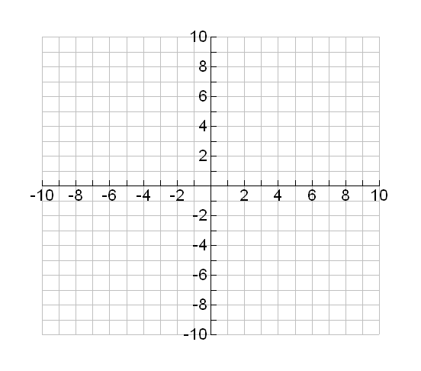Domain:

|  |  |
| --- | --- |
| a, b, and c |  |
| Vertex |  |
| Axis of symmetry |  |
| zeros |  |
| y-intercept |  |

Range:

1. Graph the following function $f(x)=-x^{2}+4x+5$ Over the interval [-1, 5]

|  |  |
| --- | --- |
| a, b, and c |  |
| Vertex |  |
| Axis of symmetry |  |
| zeros |  |
| y-intercept |  |

Domain:

Range:

**[](http://www.google.com/url?sa=i&rct=j&q=&esrc=s&frm=1&source=images&cd=&cad=rja&uact=8&ved=0CAcQjRw&url=http://www.thisnext.com/item/E6B5EEEA/Texas-Instruments-TI-84-Plus&ei=BP-BVNeyNYOsyQSKuICIBw&bvm=bv.80642063,d.aWw&psig=AFQjCNF2rRG5B65a3WFIbUuaSdVMXSBlCw&ust=1417891855273184)Use all your Skills:**

1. Alex throws a ball into the air. The ball travels on a parabolic path represented by the equation , where h is the height, in feet, and t is the time, in seconds. Use your graphing calculator to compete the following activity.
2. 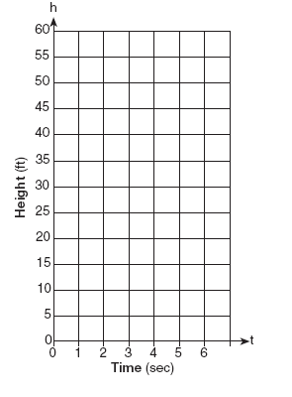On the accompanying set of axes, graph the equation from t = 0 to 6 seconds, including all values of t from 0 to 6.

|  |  |
| --- | --- |
| **t** | **h(t)** |
|  |  |
|  |  |
|  |  |
|  |  |
|  |  |
|  |  |
|  |  |

1. How many seconds does it take the ball to reach the ground?
2. How high did the ball go before returning to the ground?
3. Did this parabola have a maximum or minimum? Explain:
4. Calculate the average rate of change over the interval [0,3]
5. Put the function in the standard form.
6. 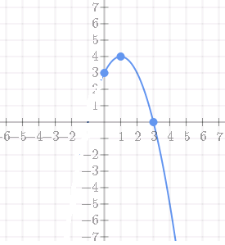A high school baseball player throws a ball straight up into the air for his math class. The math class was able to determine that the relationship between the height of the ball and the time since it was thrown could be modeled by the function, $h=-t^{2}+4t+3$, where 𝒕 represents the time (in seconds) since the ball was thrown and 𝒉, the height (in feet) of the ball above the ground.
7. How many feet above the ground was the ball at t=0?
8. What was the maximum height that the ball reached?
9. How long did the ball take to reach its maximum height?
10. After how many seconds did the ball reach the ground?
11. Read the following: After the release of a DVD, there are four periods in its life cycle.

* Stage 1: Sales increase rapidly. With a new DVD, the number of purchases grows rapidly soon after the DVD is released.
* Stage 2: The sales are still growing, but the increase from week to week is not as great as in the early phase.
* Stage 3: The product is still selling, but now, each week’s sales are a little lower than the week before.
* Stage 4: The market is saturated and now the sales are dropping rapidly.

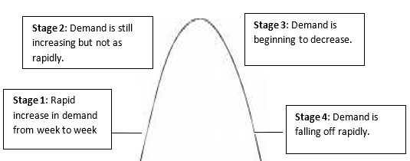

|  |  |
| --- | --- |
| **x** | S(n) |
| **0** |  |
| **1** |  |
| **2** |  |
| **4** |  |
| **6** |  |
| **8** |  |
| **12** |  |

Assume that a producer knows that the demand for the next CD by One Direction can be modeled by the equation , where n represents the number of weeks since the release of the CD and S(n) is the dollar value in thousands of the CDs sold. Graph the above model using appropriate windows on the calculator.

0

100

200

300

400

500

600

700

800

900

1000

1. [](http://www.google.com/url?sa=i&rct=j&q=&esrc=s&frm=1&source=images&cd=&cad=rja&uact=8&ved=0CAcQjRw&url=http://www.thisnext.com/item/E6B5EEEA/Texas-Instruments-TI-84-Plus&ei=BP-BVNeyNYOsyQSKuICIBw&bvm=bv.80642063,d.aWw&psig=AFQjCNF2rRG5B65a3WFIbUuaSdVMXSBlCw&ust=1417891855273184)When do we expect the sales of the CD to peak?
2. After the sales have peaked, when does this model predict that the sales will sink below $100,000 per week?



Mathematician: __________



Homework 8-1

1. **Identify the following properties for each parabola:**

|  |  |
| --- | --- |
| Vertex |  |
| Axis of symmetry |  |
| zeros |  |
| y-intercept |  |

1. 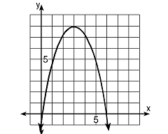

|  |  |
| --- | --- |
| Vertex |  |
| Axis of symmetry |  |
| zeros |  |
| y-intercept |  |

1. [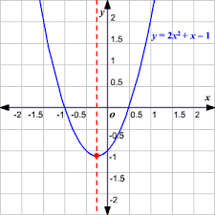](http://www.google.com/url?sa=i&rct=j&q=&esrc=s&frm=1&source=images&cd=&cad=rja&uact=8&ved=0CAcQjRw&url=http://hotmath.com/hotmath_help/topics/quadratic-function.html&ei=ZemBVKjvI4aYyASvt4HoAw&bvm=bv.80642063,d.aWw&psig=AFQjCNHwnrjXEUjhrPWYRIUPn-FCMwyGkA&ust=1417886427504186)
2. **Identify the appropriate window to graph the following parabolas:**
3. $f\left(x\right)=x^{2}-8x-22$ Sketch it.

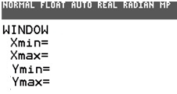

[](http://www.google.com/url?sa=i&rct=j&q=&esrc=s&frm=1&source=images&cd=&cad=rja&uact=8&ved=0CAcQjRw&url=http://www.thisnext.com/item/E6B5EEEA/Texas-Instruments-TI-84-Plus&ei=BP-BVNeyNYOsyQSKuICIBw&bvm=bv.80642063,d.aWw&psig=AFQjCNF2rRG5B65a3WFIbUuaSdVMXSBlCw&ust=1417891855273184)

1. Sketch it.



|  |  |
| --- | --- |
| x | y |
| 0 |  |
| 1 |  |
| 2 |  |
| 3 |  |
| 4 |  |
| 5 |  |
| 6 |  |

1. 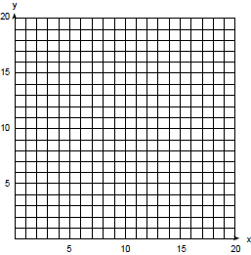An arch is built so that it is 6 feet wide at the base. Its shape can be represented by a parabola with the equation $h\left(x\right)=-2x^{2}+12x$, where h(x) is the height of the arch in feet.
2. Graph the parabola over the domain [0, 6] on the coordinate grid.
3. Determine the maximum height of the arch**.**
4. An equation for a rocket fired straight up from the ground is  where h is the height of the rocket and t is the time in seconds.
5. Explain the meaning of 20 in this contest.
6. Show an appropriate window and provide a sketch:
7. Graph the function $Graph the function f\left(x\right)=({x-2)}^{2}+1$ using the graphing calculator and determine the Maximum, or Minimum, 0 roots and axis of symmetry of the parabola.



Extras:



Discovery Activity

**Using the y= on your calculator, sketch the following 4 equations on the graph:**

Standard form of quadratic equation: 

**Back to Transformations**

|  |  |  |
| --- | --- | --- |
| **Set A)**          Find the patterns of the “a” coefficient of. | **Set B)**        Find the patterns of the “b” coefficient of. | **Set C)**        Find the patterns of the “c”, the constant. |

**Discovering 0 – Roots ( x-intercepts)**

**Graph the following** , ,  and answer the following questions

What are the roots of a parabola?

Where are they located on the graph?

How many ways can a parabola intersect the x-axis?

[](http://www.google.com/url?sa=i&rct=j&q=&esrc=s&frm=1&source=images&cd=&cad=rja&uact=8&ved=0CAcQjRw&url=http://www.thisnext.com/item/E6B5EEEA/Texas-Instruments-TI-84-Plus&ei=BP-BVNeyNYOsyQSKuICIBw&bvm=bv.80642063,d.aWw&psig=AFQjCNF2rRG5B65a3WFIbUuaSdVMXSBlCw&ust=1417891855273184)

# roots = ______# roots = ____ # roots = ______